**“Developing an Extension and Applied Research Weed Science Program for Arizona”**

***Pratap Devkota, Ph.D***

***Biography:***

I grew up in Nepal where I received Bachelor’s in Agriculture Science (major: Agricultural Economics) from Tribhuvan University. I earned graduate degrees in Weed Science: Master’s from University of Arkansas in 2012, and Ph.D from Purdue University in 2016. After graduation, I worked as the Cooperative Extension Weed Science Advisor with University of California Agriculture and Natural Resources for about 2 years. As an extension farm advisor, I conducted research and extension programs for addressing weed management challenges in agronomic and vegetable crop systems at Imperial and Riverside counties. I am currently an Assistant Professor (Weed Science Specialist) at the Institute of Food and Agriculture Sciences, University of Florida. My research program (60%) focuses on developing integrated weed management programs in agronomic, forage/pasture, and emerging/alternative crops. With the extension program (40%), I provide weed science expertise, training, and educational support to county agents; growers; pesticide applicators; and state agencies who seek solutions to the weed management issues. During my weed science career, I have authored 18 peer-reviewed journal publications, 45 peer-reviewed extension publications, 5 trade magazines articles, 31 extension newsletters, 60 conference abstracts, and presented at more than 30 extension meetings. Graduate student training is a rewarding aspect of my career where I have served as Chair, Co-chair, and member for 4 Master’s and 3 Doctoral committees. I am actively involved with weed science societies at national, regional, and state level by serving at various committees, chairing oral and poster sessions, judging graduate student contests, and reviewing numerous peer-reviewed manuscripts. I have secured about $490K in external funding as a PI or Co-PI from USDA, regional and state agencies, and agrochemical industries. I have also won several awards at national and regional weed contests and annual conferences, and the Outstanding Ph.D Student award at the Department of Botany and Plant Pathology at Purdue University.

***Abstract:***

I have dedicated academic and professional career in weed science realm for over a decade. Through applied research and extension programs, I have strived for developing and implementing integrated weed management (IWM) strategies for sustainable crop production. For the past 4 years, I have been leading research projects focusing on chemical and non-chemical weed management strategies. My extension program has disseminated information on weed management strategies and brought positive impacts on weed management practices of crop producers in Florida and California. At Arizona, I will focus on solution-oriented weed management strategies which addresses current and emerging weed problems across various cropping systems. Overall, the research program goal will be to develop integrated weed management system with primary focus on strategies for managing herbicide-resistant weeds; optimizing herbicide efficacy to reduce chemical input; adjusting cultural practices to provide crop competitiveness; understanding weed emergence pattern, weed-crop competition, and seedbank dynamics for limiting weed interference on crops; evaluating crop rotations and weed population shifts. At present, mechanical weed control techniques such as see and spray system, variable rate sprayer, use of drones for field scouting and spraying are emerging research topics. I am highly interested in expanding research program in these areas. Finally, I will make every effort in conducting economic analysis and environmental sustainability of the weed control systems. I envision my research and extension programs complementing each other. The research results will provide input for the extension activities, while the extension program will assess the weed management needs and drive the research projects. The extension program will focus on identifying needs, formulating SMART objectives, developing comprehensive outreach activities, and delivering research-based information to facilitate 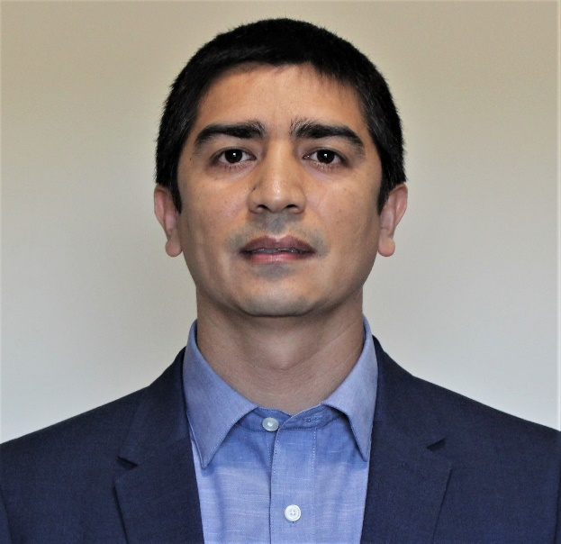adoption of integrated weed management practices and bring positive outcomes on the clientele groups.