Antiracism in STEM

Dr. Daniel Solorzano from UCLA and Dr. Sonia Zarate from Howard Hughes Medical Institute will present on the history of racism in STEM and provide training on how to make STEM curriculum and classrooms more inclusive.

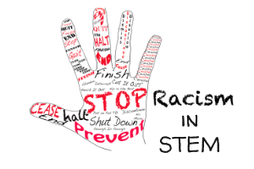

**February 4th 2021  
12:00 – 3:00 PM**

LACCD faculty: [Please register in VRC for zoom link.](https://cccpln.csod.com/samldefault.aspx?ouid=19&returnurl=%252fDeepLink%252fProcessRedirect.aspx%253fmodule%253dlodetails%2526lo%253d68629b3f-245a-41d1-81a2-481a737e4afb)

Non-LACCD participants:  <https://laccd.zoom.us/j/99094504928>

For more information contact Bamdad Samii ([samiib@lamission.edu](mailto:samiib@lamission.edu)) or

Par Mohammadian (mohammp@lamission.edu)

Award Abstract #1832348