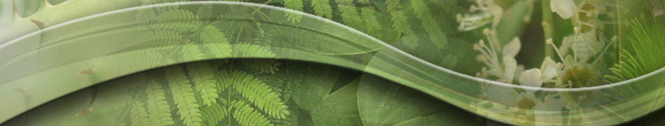
The School of Plant Sciences
Dr. Karen C. Cone

Program Director, Genetic Mechanisms
Division of Molecular and Cellular Biosciences
National Science Foundation


"Plant Sciences: Opportunities and Strategies for the Future”

Tuesday May 8, 2018
2:00 pm – 3:30 pm

ENR2 210

Dr. Cone is a candidate for Director of the School of Plant Sciences

Host: Dr. Parker Antin

pba@email.arizona.edu

