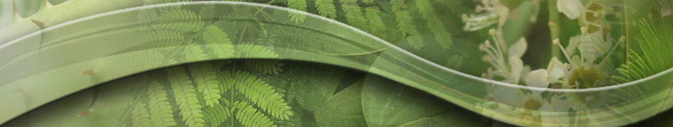
Interdisciplinary Seminar Series
The School of Plant Sciences

Dr. Anna Dobritsa
Assistant Professor
Department of Molecular Genetics
The Ohio State University

“Pattern Formation on Pollen Surface:
The Case of Aperatures.”


Tuesday, December 6, 2016
4:00 - 4:50 pm

Marley 230

Host: Ravi Palanivelu

More information @ http://cals.arizona.edu/spls/seminars

