Electronic signup for a conference room is now available. There are multiple ways to do this, here are two.

1. If you know a specific data and time, you can directly send an email request
2. If you want to check availability first, you can open the calendar for the room, look at when the room is reserved, highlight a date and time that is open, and then send an email request

**To send an email request:**

1. In Outlook Calendar, click on “New Meeting”
2. On the right, click on the button for “rooms”
3. Rooms will be listed as follows: 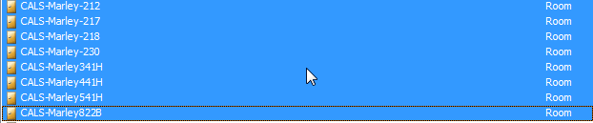Just scroll down the list until you find the correct room. Double click on the room, then click on OK
4. This will put the room in the “Location” and the “To” section: 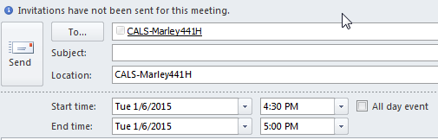
5. Fill in the “Start time” and “End time” and click “Send”
6. To check on room availablity before you send the email, you can click on “Scheduling Assistant”

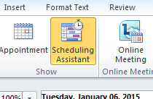

1. An email will be sent to you indicating that you have reserved the room or that the room is unavailable

**To reserve a room using the calendar:**

* 1. Access the calendar for the first time by opening the calendar

1. Click on Open calendar:

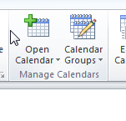

1. Click on “From room list”

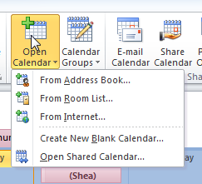

1. Scroll down until you find the room, double click on room and then on ok. This will add the room calendar to your available calendars: 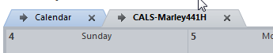
   1. Open the room calendar from your calendar list on the left
   2. Highlight the date and time that you want to reserve the room
   3. Right click on the highlighted section; click “New Meeting Request”. An email will be generated with the room in the “Location” and the “To” section and the start and end time will be the highlighted section.
   4. Click “Send”
   5. An email will be sent to you indicating that you have reserved the room or that the room is unavailable

If you have any questions, please contact the School of Plant Sciences Business Office for help.