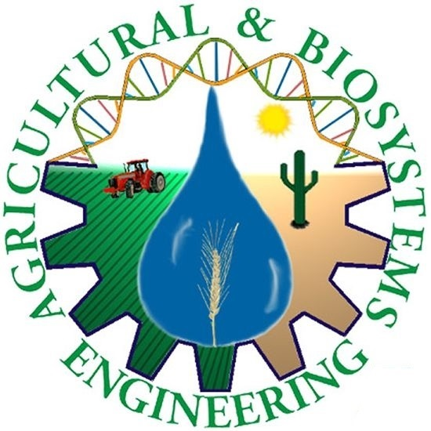
Department of Agricultural and
Biosystems Engineering

DOCTOR OF SCIENCE DISSERTATION DEFENSE

Stacy Tollefson, PhD Candidate, ABE

“Compost Water Extracts and Suppression of Root Rot (F. Solani f. sp. pisi) in Pea: Factors of suppression and a potential new mechanism”

Compost water extracts (CWE) are mixtures of compost and water incubated for a defined period of time, either with our without aeration, and with or without additives intended to increase microbial populations. Much anecdotal, but very little scientific evidence exists describing CWE effect on suppressing soil-borne pathogens. This series of studies investigates the effects of a CWE on the suppression of F. Solani f. sp. pisi on root rot. Study 1 examines the effects of a CWE on growth and disease suppression in pouch assays and in seedlings studies using different types of growing media. Study 2 describes the effect of two different CWE on border cell dispersion, and its relation to its ability to suppress F. Solani, and the implications for CWE effect on rhizosphere community structures and disease management. Study 3 describes the effect of changing one factor at a time in the production or use of a CWE on the suppression of F. solani. These studies are important contributions to understanding the factors and potential mechanisms involved in the suppression of disease by CWE.

Wednesday Nov 19
at 10:00 – 11:00 a.m. Open to Public
in CEA Classroom,
CEAC 1951 E. Roger Rd.

Questions contact Dava Jondall 621-1753 or Terry Albertson, 626-9566

