Multilingual SEVA Vet AI Chatbot launched in Bengaluru, commemorating World Veterinary Day 2025

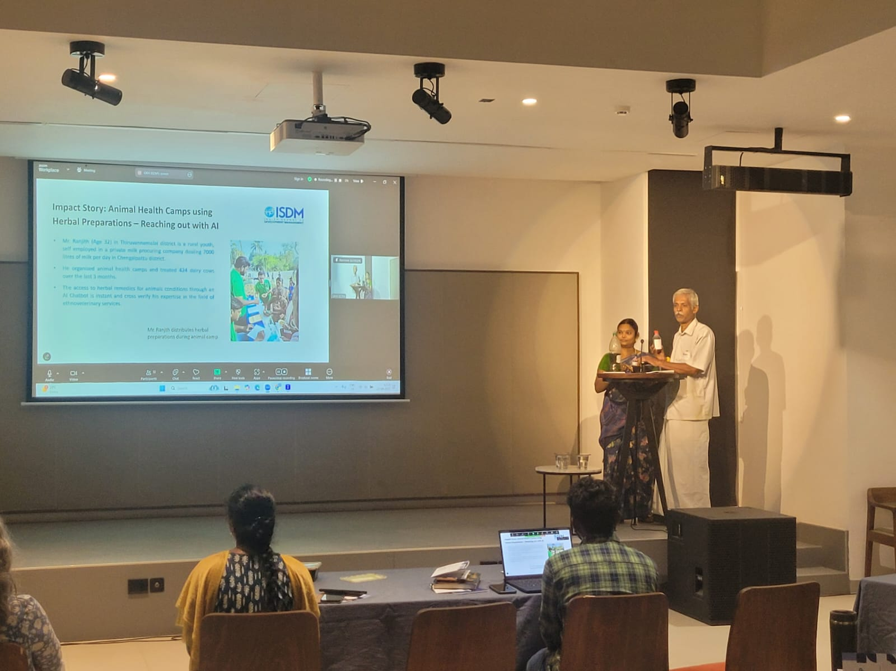
SEVA Vet App launch event in Bengaluru commemorating World Veterinary Day 2025.

Madurai-based Sustainable Agriculture and Environment Voluntary Action, alternatively SEVA, launched the ‘SEVA Vet’ AI Chatbot App in multiple languages at the Bangalore International Centre on April 25, 2025. The app was launched during the Indian School of Development Management Fellowship Showcase in Bengaluru. The launch of the app facility to use Artificial Intelligence for curing animal illnesses, including livestock and poultry in Tamil, Kannada, and English, commemorates the celebration of World Veterinary Day 2025, themed ‘Animal health takes a team’.
“By documenting traditional knowledge in livestock management over the last three decades, SEVA launched the SEVA Vetbot App, which would help livestock owners find herbal treatments for common animal illnesses in cattle, buffalo, sheep, goat, and poultry. The App will support farmers in rural areas of India who lack access to affordable veterinary care. The users can ask questions in Tamil, Kannada, or English using text or voice. The platform uses Artificial Intelligence (AI) to suggest treatment from the database of traditional practices for livestock and chicken. This AI veterinary assistant facility is available through a chatbot; it is currently being tested with over 500 field workers, and plans are in place to reach one million users in more regional languages, achieving the UN SDGs towards the year 2030,” said Shri P. Vivekanandan, Executive Director, SEVA and Chair, Regional International Year of Rangelands and Pastoralists 2026 Support Group of South Asia.
The AI chatbot can be accessed online through https://www.livestockseva.org/. The feedback from the users can be sent to vivekseva@gmail.com.

