MONGOLIAN NATIONAL RANGELAND FORUM VII

Invitation

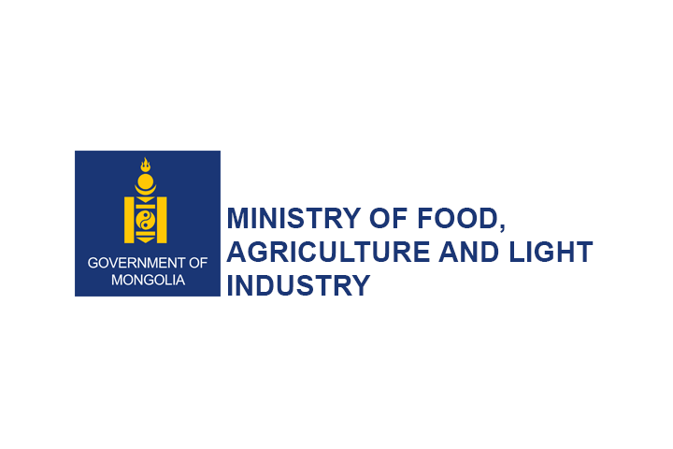




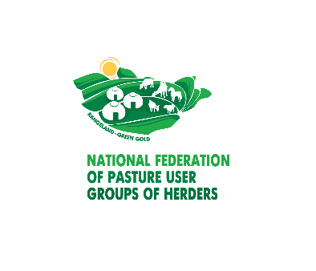


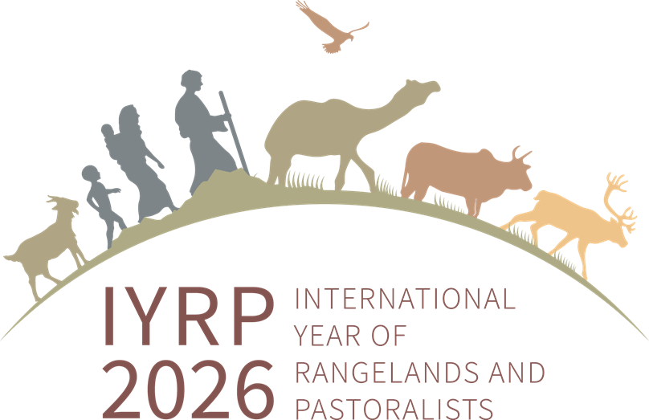

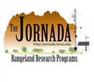
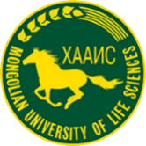




VII MONGOLIAN NATIONAL RANGELAND FORUM
Climate Change - New cooperative - Green Finance - Rangeland carbon market development
Ulaanbaatar, Mongolia
02-03 October, 2024

Government Palace Date: 2024.10.02

Time | Activities | Responsible Party | Notes
08:00-09:00 | Registration | MNFPUG
09:00-09:30 | Opening speeches | D. Amarbayasgalan, Chairman of the Parliament  T. Jambaltseren, Secretary of State, Ministry of Food, Agriculture and Light Industry
09:30-09:40 | Greetings from the International Rangeland Congress | Dr David Phleps, President of the International Rangeland Congress Continuing Committee | Video greeting
09:30-09:40 | Greetings from the IYRP | Dr Dana Kelly, Secretariat for the International Rangeland Congress; Chair of the Australasian International Year of Rangelands and Pastoralists | Video greeting
09:40-10:40 | PLENARY SESSION:
 | - Improving climate change adaptation and resilience capacity of traditional nomadic livestock husbandry of Mongolia with the support of New Cooperative program and Green Finance  - Contribution from livestock sector to achieve Mongolia’ commitments under Paris agreement for climate change adaptation and mitigation agenda.  - Quantifying soil carbon sequestration for rangeland resilience  - The role of improving legal environment to address rangeland degradation and desertification challenges of Mongolia  QUESTIONS & ANSWERS | D. Amarbayasgalan, Chairman of the Parliament  Dr. Ts. Munkhnasan, Senior Officer, Ministry of Food, Agriculture and Light Industry  Dr. Brandon Bestelmeyer and Alexandra Heller, USDA  Dr, professor M. Suvd, Otgontenger university, school of law
10:40-10:50 | GROUP PHOTO SESSION
10:50-11:20 | COFFEE BREAK
11:20-12:20 | SESSION 1: DIVERSIFYING LIVELIHOODS AND EXPANDING ECONOMIC OPPORTUNITIES IN RANGELANDS
 | - Leveraging Soil Carbon Management for Livelihood Sustainability  - Best practice: Good experiences from pilot projects of herders accessing the voluntary carbon market while improving their rangeland management practices.  - Access and services from nationwide rangeland health monitoring network and latest technological advancement. | Alexandra Heller, Researcher, USDA  Ts. Oyun, APUG leader, Undurshireet soum, Tuv aimag  B. Dul, Department Head of Land monitoring, General Agency For Land Administration And Management, Geodesy And Cartography
DISCUSSION:
Facilitators: Dr. D.Bulgamaa, Director of Research and Development Department, MNFPUG,
U. Budbaatar, Consultant, FAO
Panelist: Alexandra Heller, Ts. Oyun, B. Dul, Michelle Venter
12:20-13:00 | SESSION 2: “RESPONSIBLE NOMADS” STANDARD FOR SUSTAINABLE CODE OF PRACTICES OF NOMADIC LIVESTOCK PRODUCTION IN MONGOLIA- IMPROVING THE IMAGE AND COMPETITIVENESS OF LIVESTOCK PRODUCTS AND RAW MATERIALS IN THE INTERNATIONAL MARKET
 | - “RESPONSIBLE NOMADS”-Results from developing and introducing a digital traceability system for livestock driven raw materials from Mongolia.  - Certification of animal driven products comply with “RESPONSIBLE NOMADS” Standard; Lessons Learned  - “RESPONSIBLE NOMADS”- Best practices from introducing monitoring over raw material origin and quality | J. Batsaikhan, Department Head of Information, Technology and Statistics of MoFALI  L. Gantsogt, CEO, Nomadic Legacy of the Steppe  N.Sarangua, CEO, Inaru brand LLC
DISCUSSION:
Facilitators: N.Gankhuyag, MNFPUG,
G.Enkhbold, Executive director, AFPUG Khuvsgul
Panelist: J. Batsaikhan, L. Gantsogt, N.Sarangua, Manon Lelarge
13:00-14:00 | LUNCH
14:00-14:40 | SESSION 3: INTERNATIONAL YEAR OF RANGELANDS AND PASTORALIST AND YOUTH
 | - Introduction and International year of rangeland and pastoralist and ILC  - Youth participation in rangeland sector in central Asia  - Leadership of young herders – “New cooperatives” movement | Anu Verma, Asia Women's Land Rights Specialist, International Land Coalition Asia ,Center for International Forestry Research (CIFOR)  kunduz, kyrkiz Jaiti  O. Bayanmunkh, Herder, Selenge aimag
DISCUSSION:
Facilitators: Dr. D.Burmaa, Executive director, MNFPUG
J. Tserendolgor, Specialist, MNFPUG
Panelist: Anu Verma, kunduz, O. Bayanmunkh, Kunduz Adylbekova
14:40-15:20 | SESSION 4: RANGELAND RESOURCE CONSERVATION FINANCING
 | - Green Taxonomy: Criteria and verification modality for livestock sector  - Using soft loans as an incentive to promote sustainable rangeland management practices and herd management among herders.  - International best practices of using financial mechanisms to promote climate change mitigation and adaptation practices" | G.Delgermaa, Director Credit, Mongolia Green Finance Corporation (MGFC)  O.Javkhlan, Green financing specialist, Khan Bank  Dr. Ts.Enkh-Amgalan, Senior Climate Change Officer ADB Resident Mission Office in Mongolia (MNRM)
DISCUSSION:
Facilitators: Azjargal, consultant for new cooperative initiative
Panelist: G.Delgermaa, O.Javkhlan, Ts.Enkh-Amgalan, D.Gurbazar
15:20-16:00 | “RESPONSIBLE NOMADS” CODE OF SUSTAINABLE DEVELOPMENT STANDARD - POSTER SESSION
16:00-16:40 | COFFEE BREAK
16:40-17:30 | COMPETITION ON PLANT IDENTIFICATION AND RANGELAND LITERACY | School of Animal Husbandry and Biotechnology, Mongolian University of Life Science
09:00-16:40 | EXHIBITION OF PRODUCTS PRODUCED UNDER THE “RESPONSIBLE NOMADS” CODE OF SUSTAINABLE DEVELOPMENT STANDARD
17:30-18:00 | Closing remarks | MNFPUG

Date: 2024.10.03
Demonstration training – Location: Undurshireet soum, Tuv aimag
Time | Activities | Responsible Party | Notes
08:00 | DEPARTURE FROM THE SUKHBAATAR SQUARE
11:00-13:00 | IMPLEMENTATION AND PROGRESSES IN “RESPONSIBLE NOMADS” CODE OF SUSTAINABLE DEVELOPMENT STANDARD
 | Demonstrations of the development of Herder Institutes:
 | - A key driver in the functioning of PUGs and Sustainable Rangeland and Herd Management Practices  - PUG based management, importance of the rangeland use agreement and local regulations in grazing management  - Success stories in improved resource and quality of green forage  - Livestock products with QR code traceability  - Functioning of Cooperatives based on PUGs  - PUG based Environmental Conservation Program  - PUG based Carbon Market | Kh. Myagmarsuren, Executive director, AFPUG Tuv  T. Batdorj, Executive director, AFPUG Arkhangai  Dr. B. Baasanjalbuu, Teacher, School of Animal husbandry and Biotechnology, MULS  L. Gantsogt, CEO, Nomadic Legacy of the Steppe,  Ts. Tsolmon, APUG leader Erdenesant soum, Tuv aimag  Ts. Oyun, APUG leader, Undurshireet soum, Tuv aimag
13:00-13:30 | LUNCH
13:30-15:30 | Implement measures to enhance livestock sales and market turnover through the supplementary feeding of young animals and the adoption of best practices
 | - Additional fodder preparation and opportunities for double harvesting  - Onsite consultancy on livestock productivity and herders` income enhancement  - Functioning of the Breeding and Technological center | Dr. B. Baasanjalbuu, Teacher, School of Animal husbandry and Biotechnology, MULS  T. Ariunbold, Lecturer, School of Animal husbandry and Biotechnology, MULS  D. Bat Erdene, Research Institute of Animal Husbandry, MULS
15:30 | DEPARTURE TO ULAANBAATAR

