 | 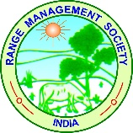 | 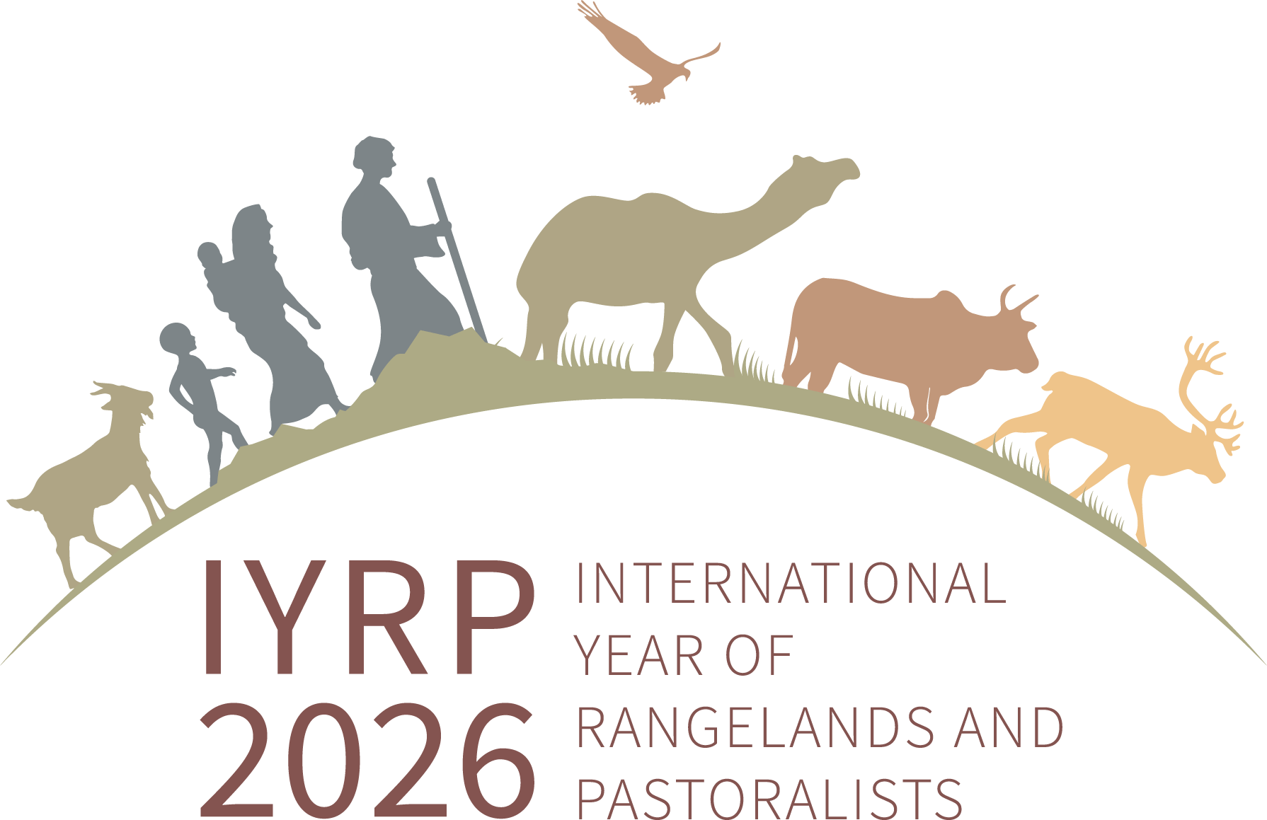 |  | 
Rangelands Awards 2023
Criteria for Selection:
- Awards for individuals, communities, local institutions for protection of Common Property Resources (CPR) / Pasture land 2023 is being organized by SEVA in association with volunteers of Honey Bee Network, LIFE Network, Range Management Society of India, Regional IYRP Support Group (RISG) for South Asia, Centre for Pastoralism- Sahjeevan and Foundation for Ecological Security. For selected 10 individuals / communities/ groups who directly or indirectly responsible for protection and regeneration of range lands, Award prize of Rs. 10,000/- and certificate will be given. The award function place and date will be held during Feb. / March 2024.
  - The merit of each individual /community role in contribution for protection and restoring common property resources / pastureland management / best practices or innovation will be the criteria for evaluating entries.

Last date for Submission :
The entries should be submitted only in the ‘Model proforma’ format enclosed. The last date for receipt of the completed applications is 31, Jan. 2024.

Selection Committee :

  - Selection committee will include experts, experienced professionals including nominee from IGFRI, Jhansi and other institutes . The decision of the selection committee will be final and binding.
  - Verification of claims will be undertaken for selected cases if it is needed with the help of few independent experts / scientists etc.

Proforma for Documentation of Commons &
Pastureland development

- Name of individual/ community/ local institution and Identity number
- Address & contact phone number
- No. of animals owned species wise & breed name
- Land area owned and crops grown.
- How many generations involved in livestock keeping
- How he /they contributed in CPR/ pasture land development
- Area of CPR / pasture land
- Name of CPR / Pasture land - specific name as called by local
communities & classification of land
- How many animals graze this area? How many families dependent on this area?
- Legal authority for the land / ownership
- What are all fodder species available ?
- Who manages the pasture land and how ?
- Any traditional / social institution/rules / regulations in the management of lands
- How he/they have contributed in the regeneration of CPR / pasture land
–brief description needed (one page along with pictures)
- Status of pasture land after his/their intervention and number of animals being grazed and families benefitted.
- Any knowledge on herbal remedies for animals, nutritional value of fodder species, and management of CPR / Pasture land etc.
- Two references for his/their role in CPR / pasture land development

Name & Signature of Person who prepares the application Signature of applicant

Address for submission of Applications and Further queries:

- Mr. P. Vivekanandan,
Co -Chair-RISG- South Asia
SEVA,
45, T.P.M. Nagar,
Virattipathu, Madurai - 625 010.
Tamil Nadu. India
Mobile: 7708852334
E-mail: vivekseva@gmail.com

- Dr. D. R. Palsaniya,
Secretary,
Range Management Society of India,
ICAR-Indian Grassland and Fodder Research Jhansi – 284003.
Mob – 6388147179, Ph.- 91-510-2730213 Ex-343(O)
Email : drpalsaniya@gmail.com

