IYRP WORKING GROUP ON PASTORALISM AND WATER

Introduction
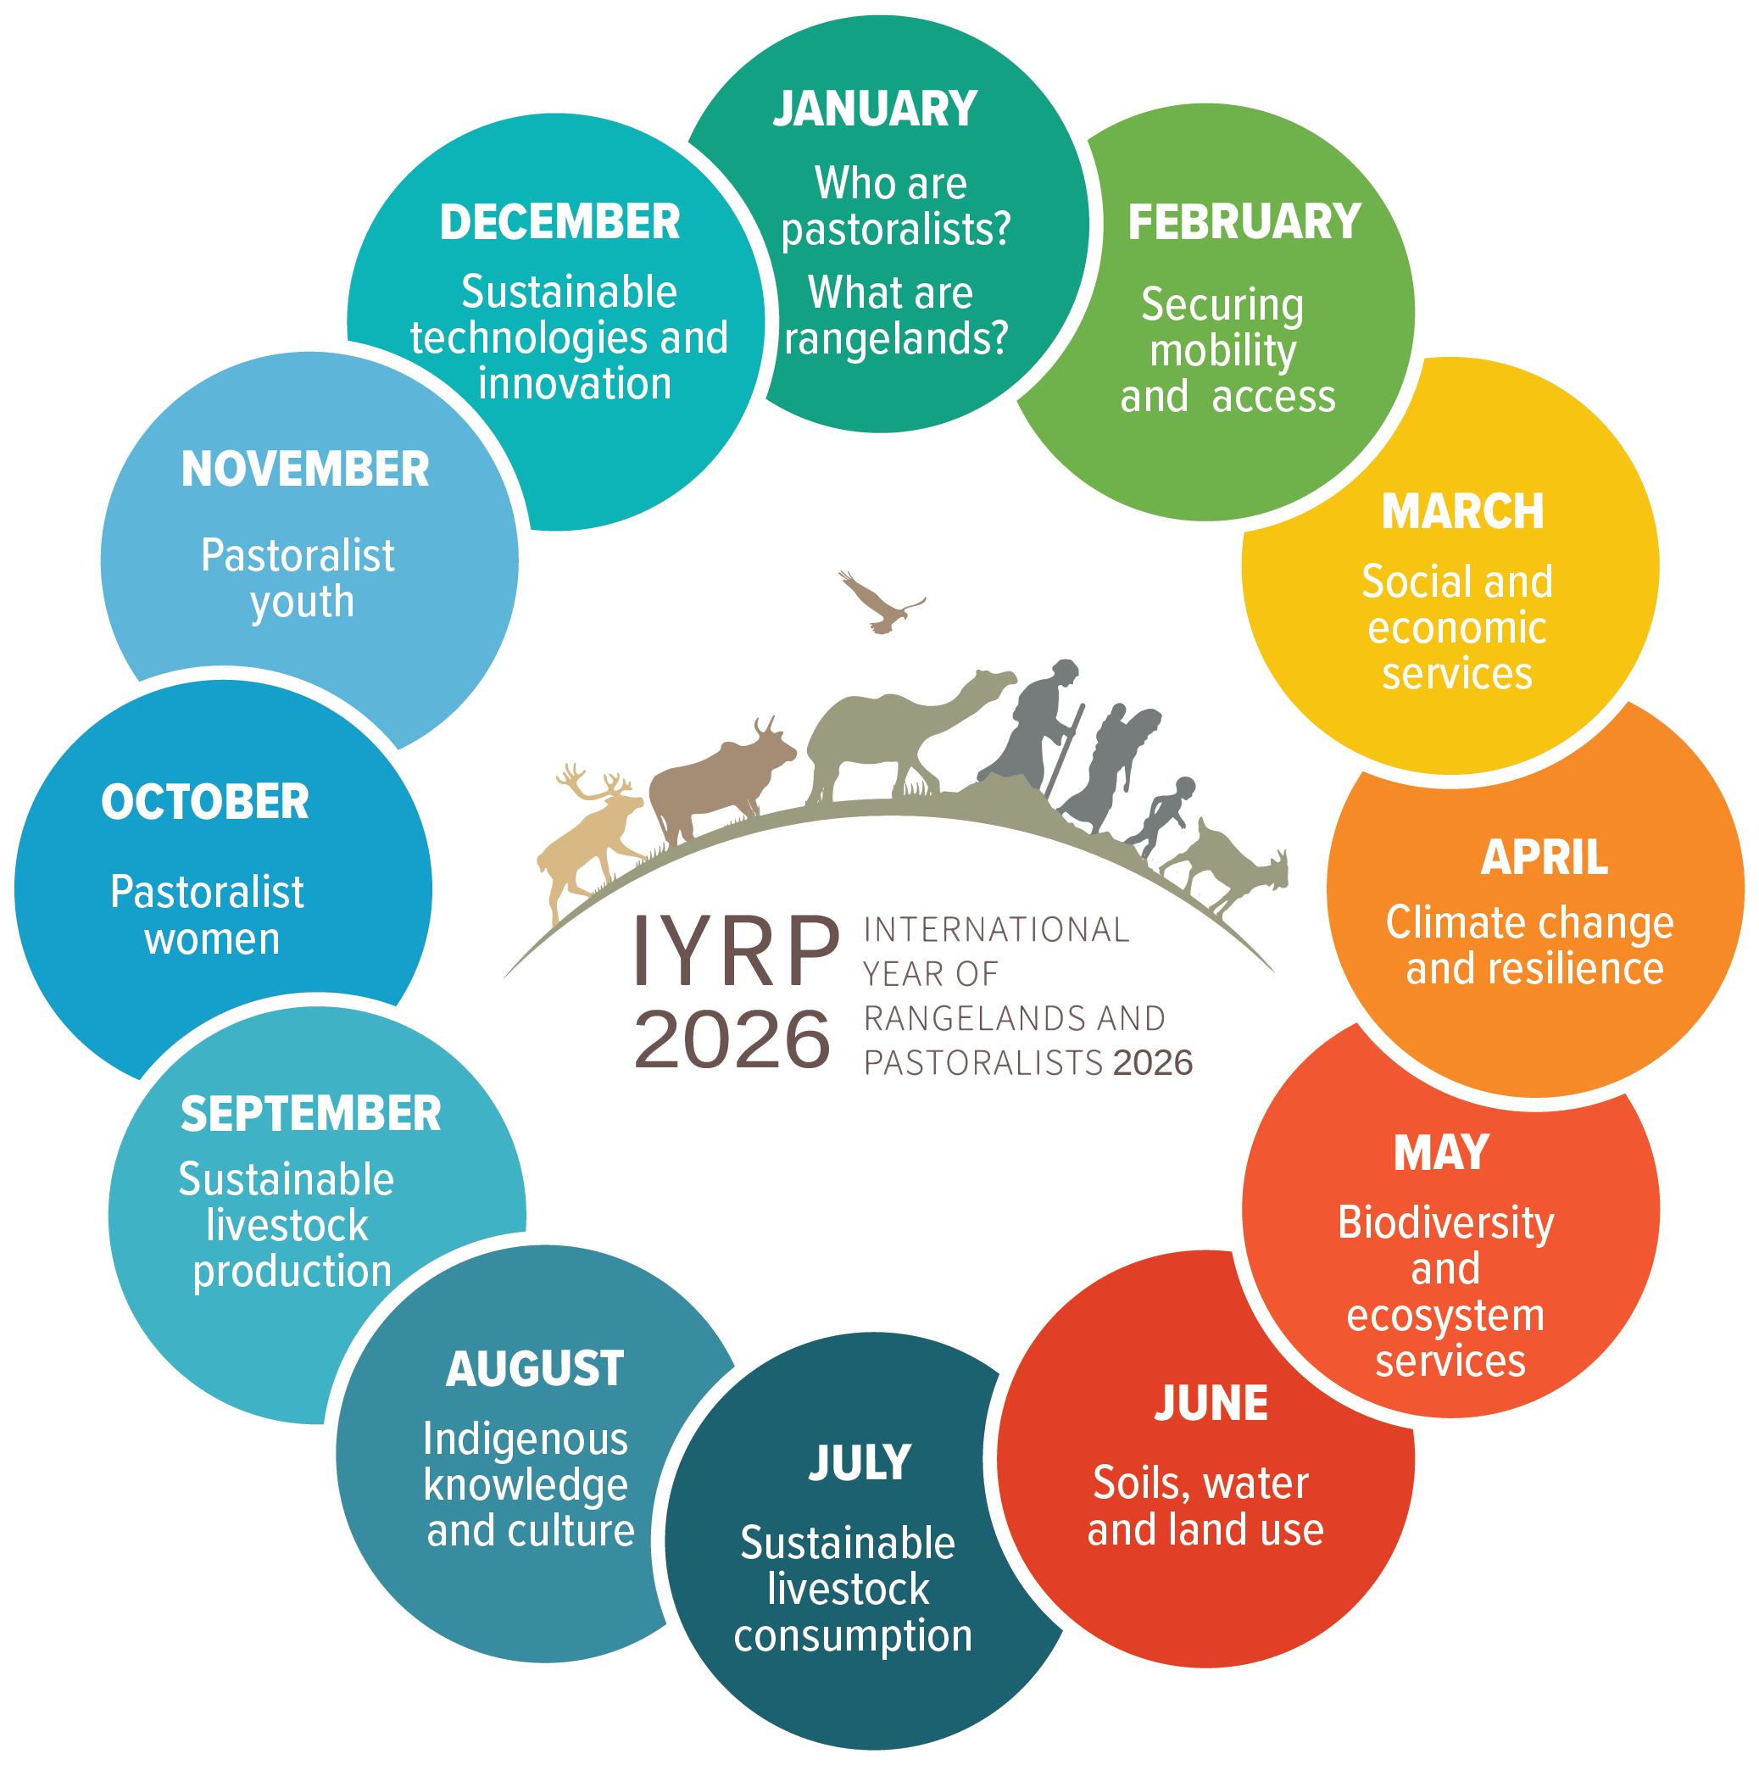
The International Year of Rangelands and Pastoralists (IYRP) will be observed in 2026 to increase worldwide understanding of the importance of rangelands and pastoralists for global food security and environmental services, and to direct attention to the relevance of their sustainable management for achieving sustainable development. These objectives will be reached through diverse activities by and with key stakeholders at local, regional and global levels aimed at generating, collating and disseminating knowledge on the importance, opportunities and challenges of rangelands and pastoralists with regards to sustainable development.
In the run-up to the IYRP, a number of Working Groups (WGs) are being constituted to spearhead research, analysis and advocacy on different issues important to reaching its objectives. The WGs are critical frameworks for mobilising, creating awareness and networking among key stakeholders – including rangeland communities, governments, researchers, civil society and UN agencies – to create the critical mass needed to influence policies and processes at the different levels to ensure success of the IYRP. Activities of the WGs and their outputs will feed into the 12 themes that actors shall engage with during the IYRP (one theme per month).

The case for a WG on Pastoralism and Water
Water is essential to life in the rangelands and its availability and distribution have a direct bearing on how livestock keepers and their livestock access and use the rangelands. Thus, water shapes grazing patterns and the use of rangeland resources (Gomes 2006, Opiyo et al 2011). Moreover, there is a close correlation between water and land rights for pastoralists, as control of access to a water point often goes hand in hand with control of access to the surrounding land and its resources.
For these reasons, “Soils, water and land use” has been identified as one of the 12 themes for the IYRP. During the month of June 2026, efforts will be made to increase awareness about lessons learned in water resource development in the world’s rangelands and to agree on strategies for applying good practice to ensure improved livelihood outcomes for pastoralist communities. Proposed strategies will integrate environmental, social, economic and political dimensions of soils, water and land use.
It is therefore proposed to establish a WG on Pastoralism and Water to spearhead research, reflection and development of advocacy messages that will be disseminated through the “Soils, water and land use” theme. The WG shall focus on water governance, defined as the manner and processes by which decisions about access to, distribution, use and conservation of water are made, including the institutional arrangements through which such decisions are processed and mediated.
The WG is motivated by the vision of equitable water governance for sustainable rangelands. The extent to which water governance is equitable depends on “how decisions are made, by whom, at what geographical scales, and for whose benefit” (IWRA 2019:3). The WG will seek to promote the role of customary and local pastoral institutions in water resource development and management as, although their role is well documented, it is often overlooked by actors in water resource development. This lack of engagement is considered one of the primary causes of the high rate of failure of water development projects in pastoral areas.

Scope of Work for the WG
The overall purpose of the WG is to promote equitable governance of water resources as a means of ensuring sustainable rangeland management to secure improved livelihood outcomes for pastoralists. The WG will therefore consider experiences of water “development” in pastoral areas to capture and document lessons learned – including what worked well, what worked less well and what didn’t work at all – with a view to articulating strategies and policy options for more equitable approaches to water development.
Specifically, the WG shall undertake research and analysis, conduct case studies and disseminate knowledge products in the form of policy briefs, animated videos, webinars etc. to:
- increase levels of understanding among policymakers about water tenure, supply, management and governance issues in pastoral areas; and
- increase levels of understanding among development planners working in pastoral areas about pastoral production systems and the central role of water in improving lives and livelihoods of pastoralists.

Membership of the WG
Membership of the WG is open to any member of IYRP Support Group interested in the theme generally and water governance in particular. It is anticipated that “Fellow Pastoralists & Water Teammates” – the RWSN (Rural Water Supply Network) Interest Group – will join the WG and thereby strengthen the partnership between the RWSN and the IYRP Support Group.
In the run-up to the IYRP, members of the WG shall actively engage with fora and events that offer opportunities for reflection on the theme, such as the Society for Range Management (SRM) conference to be held in Boise, USA, in February 2023; the !9th Biannual IASC (International Association for the Study of the Commons) Conference to be held in Nairobi, Kenya, in June 2023; and the 18th World Water Congress to be held in Beijing, China, in September 2023.
Communication within the WG will be mainly through email and video-conferencing, but where several members are participating in a conference, they may take advantage of such an opportunity to convene a face-to-face meeting.
All IYRP Support Group and RWSN members who are interested in joining this WG are invited to contact Michael Odhiambo (ochiengodhiambo@gmail.com) or Adrian Cullis (adriancullis19@gmail.com).
References
Gomes N. 2006. Access to water, pastoral resource management and pastoralists’ livelihoods: lessons learned from water development in selected areas of Eastern Africa (Kenya, Ethiopia, Somalia). FAO Livelihood Support Programme Working Paper 26.
IWRA (International Water Resources Association). 2019. Towards equitable water governance. Policy Brief Water International, No. 11.
Opiyo F E O, Mureithi S M & Ngugi R K. 2011. The influence of water availability on pastoralist’s resource use in Mwingi and Kitui Districts in Kenya. Journal of Human Ecology 35(1): 43–52.

