Dana Declaration+20 Press Release

The 20th anniversary of the Dana Declaration on Mobile Peoples and Conservation was marked in Wadi Dana, Jordan, on 7–10 September 2022 with the event titled Dana+20: Mobile Indigenous Peoples, Conservation, Sustainable Development and Climate Change Two Decades after the Dana Declaration. Working with the Royal Society for the Conservation of Nature (RSCN, Jordan), representatives of the World Alliance of Mobile Indigenous Peoples (WAMIP), concerned practitioners and academics, and representatives of Mobile Peoples from around the world – including Mongolia, Malaysia, India, Iran, Jordan, Sweden, Nigeria, Cameroon, Kenya, Tanzania, Namibia and Peru – came together to discuss shared concerns. What emerged was the Dana+20 Manifesto on Mobile Peoples, a call to action for governments, conservationists, environmentalists, corporations and international stakeholders to recognise and respect the rights of Mobile Peoples and to deepen mutual understanding about the place of mobile ways of life in the future of our world.

Under the patronage of the HRH Princess Basma bint Talal of Jordan, the Dana Declaration on Mobile Peoples and Conservation, emerged in Wadi Dana, Jordan 2002 in response to forced evictions of Mobile Peoples globally – including Indigenous, traditional, nomadic and tribal peoples – from their homelands in the name of environmental conservation. It established key principles to ensure that conservation policies respect the rights of Mobile Peoples and work together with such Indigenous and traditional communities to maintain the earth’s ecosystems and biodiversity.

Now, twenty years later, delegates met in Wadi Dana, Jordan, to take stock of progress as well as the continuation and exacerbation of challenges to their territories of life and mobile lifeways, including ongoing forced evictions, land grabbing and enclosures due to mineral extraction, agri-business, renewable energy development, conservation, tourism, international conflicts and the securitisation of borders. New challenges were addressed, including the impacts of climate change, exacerbated by ongoing emissions from the global use of fossil fuels. The event also critically engaged with the role of research and the nature of research collaborations with Mobile Peoples, with an emphasis on the development of equitable partnerships. In addition to the Dana+20 Manifesto on Mobile Peoples, participants developed a detailed action plan to contribute to the International Year of Rangeland and Pastoralists and to develop a broader coalition for Mobile Indigenous Peoples – including those living in forests – to work towards shared objectives.

The Refugees Studies Centre together with the School of Geography and the Environment at Oxford University, co-organised the event in collaboration with Mobile Peoples delegates representing organisations such as the Confederation of Traditional Stockbreeders Organisations (CORET), the World Alliance on Mobile Indigenous Peoples (WAMIP), the Sámi Youth Association, the Union of Indigenous Nomadic Pastoralists (UNINOMAD – Iran), Lokhit Pashu-Palak Sansthan (LPPS – India), CENESTA, Steps without Borders (Mongolia), the Mbororo Social & Cultural Development Association (MBOSCUDA – Cameroon), Traditional Ecosystems Survival Tanzania (TEST), the Indigenous Livelihoods Enhancement Partnership (ILEPA – Kenya), the PASTROAMERICAS Network, as well as tribes and Indigenous groups from across the world. These delegates were joined by participants from the Forest Peoples Programme (UK), the University of Roehampton (UK), the University of Colorado (USA), the Rights and Resources Institute (RRI), the Royal Society for the Conservation of Nature (RSCN) and JOHUD (Jordan).

The event was made possible through funding from the Centre for British Research in the Levant (CBRL), Misereor, the International Year of Rangelands and Pastoralists, the Wenner Gren Foundation, Oxford’s Department of International Development, PASTRES, the Rights and Resources Initiative (RRI) and the University of Nevada’s College of Agriculture, Biotechnology and Natural Resources.

Further information on the Dana Declaration: https://www.danadeclaration.org
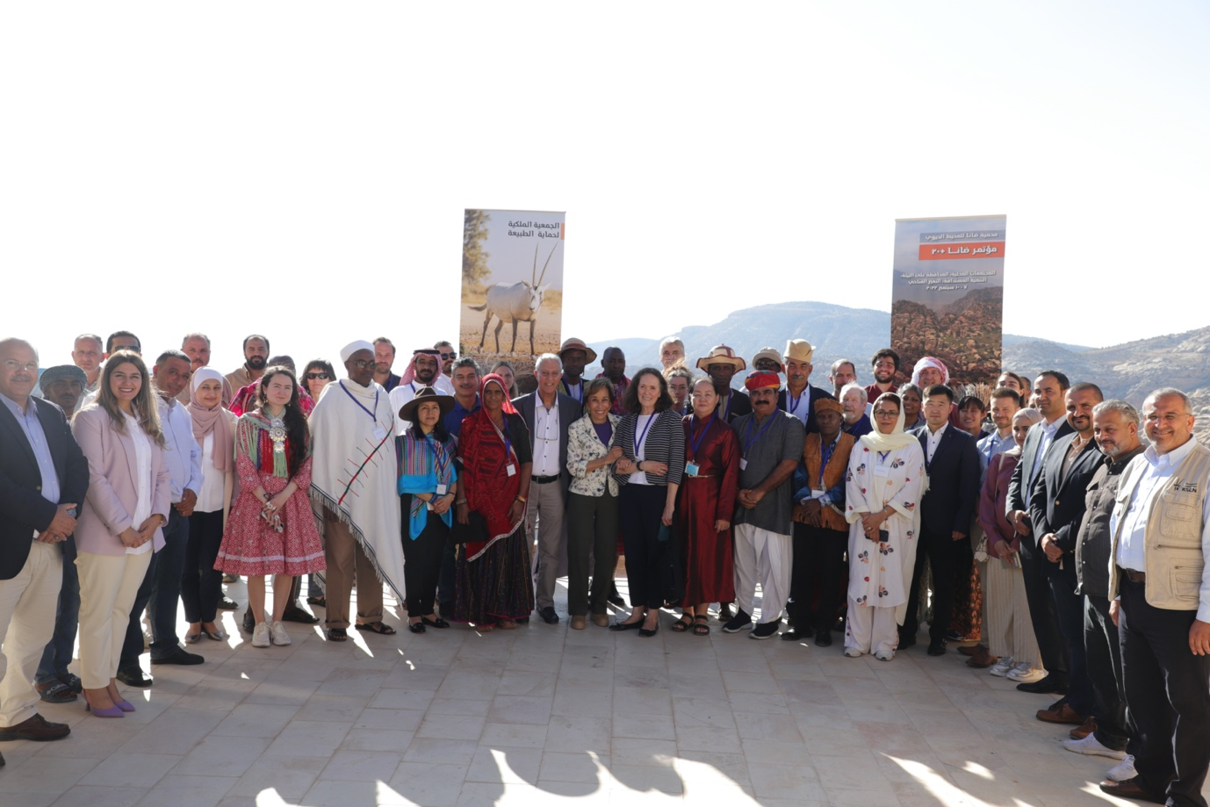
Figure 1: Group photo of Mobile Peoples delegates and participants with HRH Princess Basma bint Talal.

