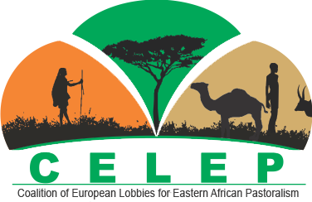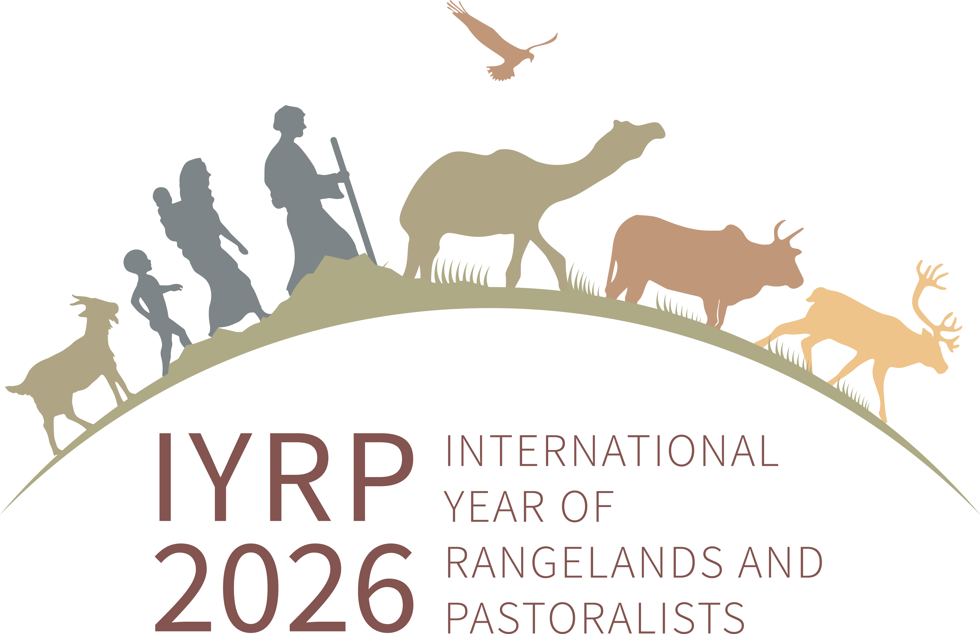

Launch of the 2nd edition of the
“Perspectives on Pastoralism Film Festival”
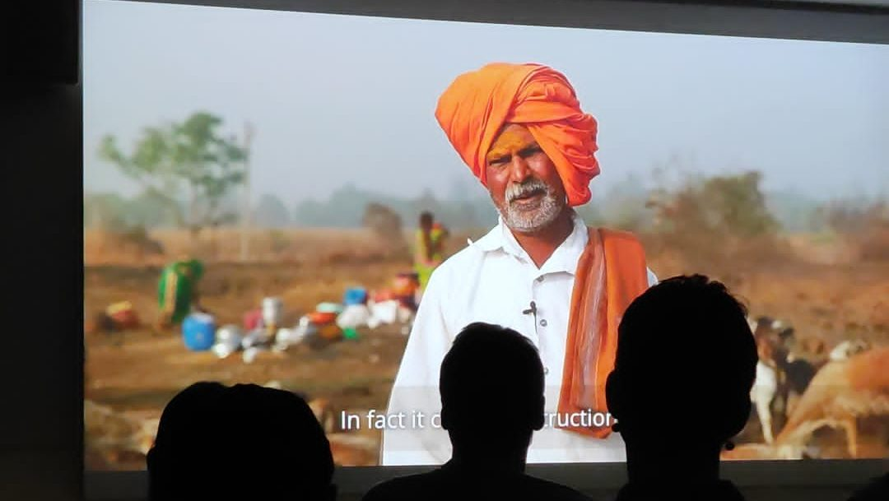
The second edition of the Perspectives on Pastoralism Film Festival was launched on 14–15 September 2022 at the Tropentag conference in Prague, Czech Republic. A sub-selection of the total films selected was compiled to match the Tropentag 2022 theme “Can agroecological farming feed the world? Farmers' and academia's views”. We aimed to highlight films that promoted awareness about pastoralism as a sustainable nature-based production system to show how pastoralism is a form of agroecology ideally suited for drylands and mountainous regions – and for the climatic and economic uncertainties of today. The films focused on ecologically appropriate use of natural resources, the rights of pastoralists to continue to use and steward these resources, and the challenges they face in doing so.
Screening at Tropentag 2022 - Wednesday 14 September
More about the Tropentag event: Tropentag Blog, Rural21
Upcoming screenings
A next screening of the “Perspectives on Pastoralism Film Festival” will be on 8 December 2022 at the Cinema Galeries in Brussels, Belgium, combined with a photo exhibit by the PASTRES (Pastoralism, Uncertainty and Resilience: Global Lessons from the Margins) research programme (https://pastres.org).
Notifications about other future screenings will be posted on the film-festival website (www.pastoralistfilmfestival.com).
Films selected for the 2nd edition of the film festival
The selected films are listed below. More information about the film festival and each film can be found on the film-festival website, together with the films selected for the 1st edition.
Title of film | Country of filming | Film-maker/-commissioner | Length (hh:mm:ss)
A common right in Mongolia – Nomadic custodians of our environment | Mongolia | Jason Taylor / ILC | 00:06:00
An afternoon on the pasture | Hungary | Zsolt Molnár & Sándor Karácsony | 03:10:00
Arreo | Argentina | Tato Moreno | 01:33:00
Conservation and traditional survival | South Africa | Humair Hayat | 00:21:45
Cowherds of the savannah | Uganda | Marc Michel / Neue Celluloid Fabrik | 00:26:00
Days of the wolf | Italy | Dario Novellino | 00:16:43
Emancipated dissonances  (special mention: sound collage) | Ethiopia | Anna Sauter & Besianë Hetemi | 00:05:24
Fatuma and Assya: two Afar girls | Ethiopia | Francesco Sincich | 00:59:26
Goat breakfast | Tanzania | Vanessa Wijngaarden | 00:30:00
Guardians of the grasslands | Canada | Sarah Wray | 00:12:00
Home on the range | Kyrgyzstan | Mirlan Abdulaev / ILC | 00:03:42
Pastoralism challenges in Tanzania | Tanzania | Elie Chansa / PINGO's Forum, IWGIA | 00:10:22
Pastoralism is the future | Global | CELEP | 00:02:23
Sharing the land | Spain | Ofelia de Pablo, Javier Zurita | 00:13:58
Shepherds of the Deccan | India | ANTHRA | 00:14:23
The Buckleboo Station | Australia | Pandy Morphett | 00:15:11
The last of their kind – Turkey’s nomads | Turkey | Nevin Sungur & Gunnar Köhne / DW | 00:12:25
Traditional ecological knowledge of Hungarian herders | Hungary | Zsolt Molnár & Dávid Pelé Sütö | 00:17:00
Transhumance – coming and going | Spain | Katy Gomez | 00:05:14
Watch the film festival trailer!
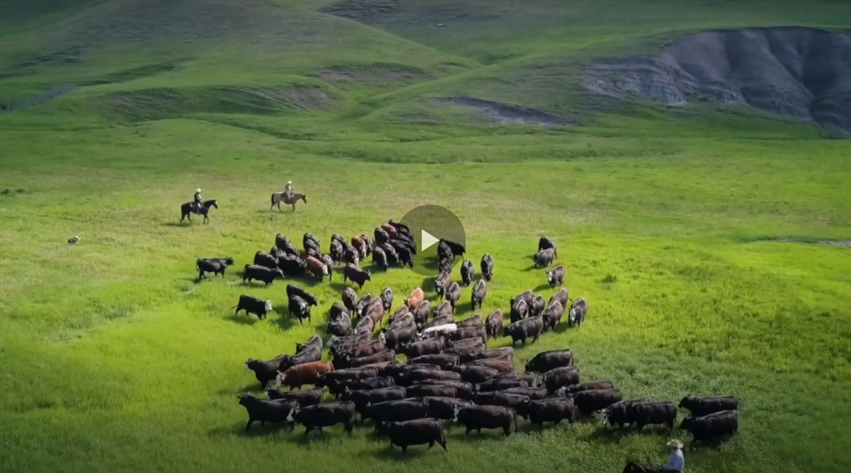
Trailer compiled by Patrick Augenstein / SEE International
The Perspectives on Pastoralism Film Festival forms part of the initiative for the International Year of Rangelands & Pastoralists (IYRP; www.iyrp.info), approved by the United Nations to be celebrated in 2026. The film-selection team is made up of people from CELEP as well as from the Regional IYRP Support Group in Eastern and Southern Africa: Agrecol Association for AgriCulture & Ecology and the German Institute for Tropical and Subtropical Agriculture (DITSL) in Germany; Veterinarians without Borders (Vétérinaires Sans Frontières, VSF) in Belgium; the Centre for Research & Development in Drylands (CRDD) in Kenya; the Africa Wildlife Foundation (AWF) in Uganda; and the Agricultural Research Council (ARC) in South Africa.

