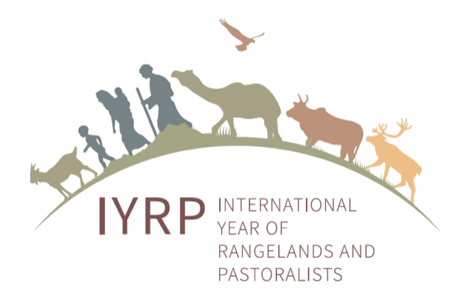
DRAFT
Joint IGC-IRC 2021 Proposed Resolutions for the IYRP 2026 Initiative
Version for review: 22 September 2021

Resolution 1.
Individual Continuing Committee (CC) members of the International Rangeland Congress (IRC) will be responsible for working with International Year of Rangeland and Pastoralists (IYRP) Global and Regional Support Groups to gain country-level commitments to support the IYRP 2026 initiative through letters and other acknowledgements submitted to the Mongolian Government in reference to their IYRP 2026 proposal to the United Nations.
Resolution 2.
Individual CC members of the International Rangeland Congress will be responsible for mobilizing scientists and rangeland practitioners in the countries and regions that they represent to support and work with the Regional IYRP Support Groups in developing action plans concerning the activities that will be conducted prior to and during the Year. These activities will coincide with the 12 monthly themes developed by the International Support Group (ISG) of the IYRP and that will be discussed at the Society for Range Management Conference in February 2022.
Resolution 3.
The CC of the IRC will establish a Sub-Committee responsible for identifying priority research efforts and comparable methodologies needed to address the knowledge gap findings of the Gap Analysis conducted by UNEP in 2018. This Sub-Committee will work with the Regional IYRP Support Groups, and report to both the CC of the IRC as well as the Global Coordinating Group of the ISG of the IYRP.

