DRAFT Action Plan for International Year of Rangelands & Pastoralists (IYRP)
Prepared by the International Support Group (ISG), Version 2 April 2021
Executive summary
The goal of the International Year of Rangelands & Pastoralists (IYRP) is to raise awareness and fill knowledge gaps globally about the value of healthy rangelands and sustainable pastoralism. It aims to do so by adopting an integrated approach based on the Sustainable Development Goals (SDGs) and the diversity of issues identified by governments and civil society, including pastoralists. It is both a celebration of an important yet misunderstood ecosystem and livelihood, as well as an opportunity to gain momentum in meeting the many challenges they face. It is a matter of global concern, as evidenced by the support so far of a coalition of 16 countries and 164 civil society organizations from across the globe.
It is a timely event, because of the current controversies surrounding the livestock sector, continuing degradation of a vital ecosystem, and challenges towards meeting the goals of the 2030 Agenda for Sustainable Development. Since 2008, various civil society partners and governments have recognized the importance of designation of an IYRP, and this draft Action Plan builds on the priorities and strategies formally identified by them. It is expected to be refined as soon as the United Nations (UN) General Assembly designates 2026 as the IYRP. While too early to provide specific activity and budgetary plans, the coalition of partners has already identified a long list of potential activities to be carried out in the period 2021–25 as well as during the year itself in 2026. A large portion of the costs of such activities is expected to be self-financed, while some will be covered through additional resource mobilization.
Goal and objectives
More than half of the Earth’s land surface is classified as rangeland, those lands on which the indigenous vegetation is predominantly grasses, forbs or shrubs that are or can be grazed, and which are used as a natural ecosystem for raising grazing livestock and wildlife. The health, productivity and environmental sustainability of these lands are directly critical to the livelihoods and cultures of more than a billion pastoralists, including agropastoralists, ranchers and animal keepers around the world.
The overall goal of the IYRP is to achieve the best possible worldwide awareness and recognition of the value and contributions of rangelands and pastoralists to global society and ecosystems, so as to influence and launch beneficial country policies, legislation, programmes, and development and research initiatives that would lead to sustainability of rangelands and pastoral systems.
The immediate objectives of the IYRP are twofold:
- to increase awareness and recognition of the importance of rangelands and pastoralists to environmental, social and economic goals; and
- to increase understanding and knowledge of healthy rangelands and sustainable pastoralism.
The IYRP International Support Group (ISG) to the Government of Mongolia has proven to be a light and efficient global coordinating body to ensure harmonized activities among nations, and the establishment of the Regional IYRP Support Groups (and future establishment of national support groups) will be able to speed up the participatory design and implementation of this Action Plan.
Global framework of 12 monthly themes
Although each country should decide how it will celebrate the IYRP, the adoption of a global framework of 12 monthly themes would help to a) highlight urgent and topical issues, and b) show how pastoralism and rangelands across the globe share similar issues and concerns.
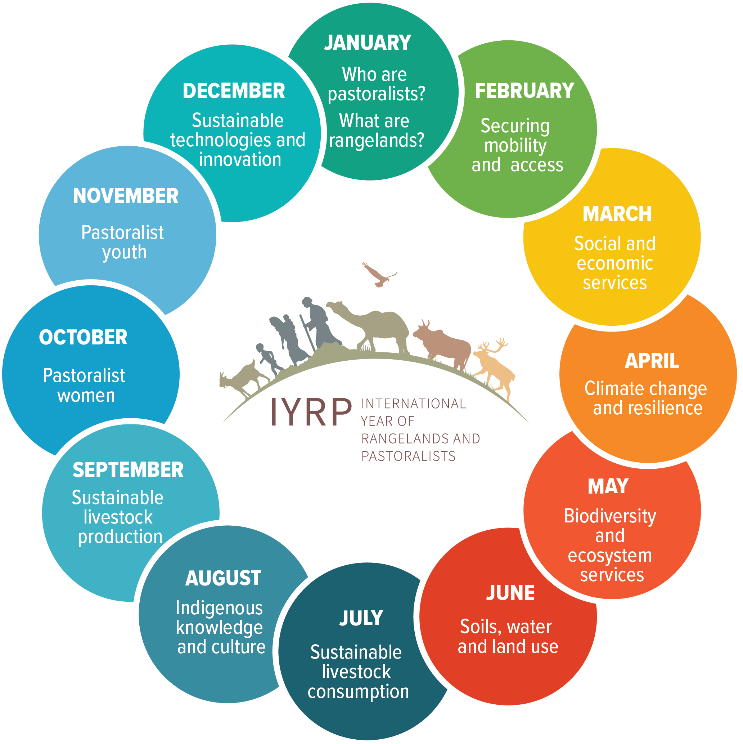
The inspiration for adoption of 12 global themes, one for each month (Figure 1) comes from many sources: United Nations Environment Assembly (UNEA)-2 and UNEA-4 Resolutions, Statements and Declarations from many stakeholders in the period 2009–18, global, and regional pastoralist gatherings, Convention on Biological Diversity Conference of the Parties (CBD COP), meetings of the International Rangeland Congress (IRC) and International Grassland Congress (IGC), UNEP Report on knowledge gaps in rangelands and pastoralism (“Benign Neglect”), as well as the Government of Mongolia proposal and the Food and Agriculture Organization (FAO) Report to the Committee on Agriculture (COAG) in 2019.

These themes help reinforce the aims and goals of the 2030 Agenda on Sustainable Development and its 17 SDGs. They also reflect the objectives of the UN Decade of Family Farming and the UN Decade on Ecosystem Restoration.
Specific priorities expressed by supporting national governments
Within the overall framework of the 12 monthly themes, the priorities for raising awareness as expressed by supporting governments can be summarized as follows. These are issues that have been identified in the Government of Mongolia’s proposal for designation of IYRP, and letters of support from 16 national governments received by March 2021.
- Rangelands and pastoralism are issues of global concern (Finland); the IYRP would lead to better exchange of experiences between countries and strengthen relations between neighbours (Hungary, Kyrgyzstan, Mongolia),
- An IYRP would raise awareness of the natural, economic, social and cultural values of sustainable rangelands and pastoralist livelihoods, and their role in achieving the SDGs and in combating climate change, biodiversity loss, desertification, land degradation and persistent drought (Australia, Bhutan, Burkina Faso, Canada, Finland, Hungary, Iran, Italy, Kyrgyzstan, Serbia, Spain, Mongolia),
- An IYRP would raise the profile of rangelands and pastoralists so as to increase funding resources to combat the many challenges they face, including land degradation, land fragmentation, drought, invasive species, water shortage, animal disease, poaching and conflict (Ethiopia, Kenya, Mongolia, Kyrgyzstan) and help recognize traditions and cultures especially among the youth (Bhutan),
- An IYRP would recognize the importance of rangelands and pastoralism for rural prosperity (Australia), domestic and international markets of livestock products (Ethiopia, Italy, Spain) and gastronomic values of pastoral products (Hungary),
- An IYRP would enhance awareness of the need for equitable sustainable development by supporting the specific needs of pastoralist livelihoods, including preserving the benefits of mobile/nature-based grazing for resilience, rural wealth and ecosystem health (Afghanistan, Burkina Faso, Ethiopia) and benefits to food security (Hungary, Kenya, Serbia),
- An IYRP would increase recognition of an important heritage of many countries (Italy, Hungary, Kyrgyzstan, Spain).
These priorities have also been expressed and reinforced in the Mongolian proposal, the second UN Environment Assembly (UNEA-2) Resolution UNEA L.24 on “Combating desertification, land degradation and drought and promoting sustainable pastoralism and rangelands”, UNEA-4 Resolution L.17 “Innovations in Sustainable Rangelands and Pastoralism” and the FAO 24th COAG Report.
Additional priorities expressed by civil society
By March 2021, a total of 164 organizations worldwide submitted letters of support for the IYRP. About 20% of these organizations have a global mandate, a quarter of them work in the southern hemisphere (Africa, Australia, Latin America), and more than half in the northern hemisphere (Asia, Europe, North America). Furthermore, about 10% are global institutions, 22% are regional research organizations and nongovernmental organizations (NGOs), almost 50% are national NGOs and 17% are pastoralist/producer organizations.
The priorities expressed by these organizations largely mirror those of the governments described above in terms of the need to recognize the value and benefits of sustainable rangelands and pastoralism for social, economic, environmental and governance goals.
In addition to these important issues, a large majority of civil society partners also call for recognizing the value of livestock mobility to maintain healthy rangelands, resilience of both livelihoods and ecosystems in the face of climate change and disasters, and reducing pollution and disease. Some point out the importance of pastoral mobility for “co-creating the grasslands” and how this has come about through centuries of pastoral conservation and development efforts. Many organizations highlight livestock genetic diversity as benefiting both pastoralist livelihoods and ecosystem resilience. Over-exploitation of rangelands for timber, fuel, and pharmacological products is a growing concern especially in Central Asia.
Many organizations recognize how pastoralism and rangelands could meet global demand for good-quality and safe products. Producer organizations in particular identify marketing, postharvest loss and product quality as important issues, while others raise the importance of livestock for local and national economies and for rural employment (including through tourism). The importance of educating the consumer on the benefits of nature-based rangeland and pastoral systems is highlighted. Some organizations believe that the IYRP should also raise specific concerns, such as the negative impacts of mining and illegal poaching on rangelands and issues of conflict between crop farmers and herders or other forms of competition over land.
A large majority of civil society partners also identifies additional social issues for the IYRP, including ensuring access by pastoralists to appropriate social and advisory services (including exchanging experiences on mobile services, and ensuring that extension services catch up with science), support to community-based institutions, good telecommunications, decentralized and renewable electricity, and other pastoral infrastructure such as water and veterinary services along transhumance routes and corridors.
Most pastoralist organizations and national NGOs focus on the importance and vibrancy of identity, culture and heritage of pastoralists, protecting their traditional knowledge incorporating it in data collection, analysis and dissemination. A large majority of organizations also believe that the IYRP could help raise pastoralist voices and empower them, strengthen their rights and secure their place in society. Increased recognition and awareness should help improve policies and legislation at the national level or help implement existing good legislation (such as the Transhumance Protocols in West Africa). Many organizations believe that the IYRP could help increase and target investments (both public and private) to restoring rangelands and improving pastoralist livelihoods and businesses. Some highlight how this awareness raising could help improve gender equity, youth participation and “generational renewal” in pastoralist societies.
A large majority of organizations identify land-tenure security as a key issue, including supporting pastoralist “territories of life”, lifting restrictions on access to traditional lands, preventing illegal privatization of land, protecting lands already allocated to them and recognizing the value of public/community management of some pastoral lands. An IYRP would help recognize the role of stewardship, custodianship and protection of rangeland that pastoralists have exercised over millennia. Civil society in Central Asia and Mongolia call for organizing the registration of herder communities in a national land use database.
Several pastoralist organizations also highlight the importance of an IYRP in strengthening capacities of pastoralists, including by recognizing traditional viable practices, knowledge transfer and access, and sharing and promoting good practice in managing animals and land.
Action Plan Preparatory Phase 2021–25
- Regional actions. The ISG has helped set up ten Regional IYRP Support Groups (RISGs). These are for: Australasia, East Asia, Central Asia &Mongolia, South Asia, Middle East & North Africa, Eastern & Southern Africa, West & Central Africa, Europe, Arctic, North America and South America. The mandate of these RISGs is to advocate for the designation of the IYRP among governments and civil society and, once it is designated, to coordinate and facilitate activities leading up to and during 2026, including leveraging funds and resources. Activities already in motion or planned are [check with all RISGs]:
  - fill knowledge gaps about rangelands and pastoralism, such as accurate maps of rangelands and pastoralism in their region (South Asia, Middle East & North Africa)
  - translate English documents into other languages (South America and West & Central Africa, Central Asia)
  - coordinate media engagement and distribution in their regions (South Asia, Europe)
  - develop and distribute a manual on pasture management and enhancing the resilience of local communities to the climate change (Central Asia),
  - special award ceremonies (South Asia, Central Asia award for livestock genetic diversity)
  - rangeland ecosystem restoration activities in connection with the UN Decade on Ecosystem Restoration (Central Asia)
  - animal husbandry products marketing and raising awareness on food security in connection with the UN Decade on Family Farmers (Central Asia).
- National action planning. Mongolia is the first country to have established a multi-stakeholder National Support Group (NSG). It is expected that many more countries will do so. [has the Iran NSG been established by now?] The role of these NSGs is to design, execute and implement actions before and during 2026 to celebrate the IYRP. [Mongolia NSG to add examples of activities]
- Global actions. Several civil society partners have indicated certain actions that they will undertake and finance in this period:
  - Joint International Rangeland Congress and International Grassland Congress in October 2021 (Nairobi) to dedicate three parallel sessions to the IYRP
  - International conference focusing on rangelands and pastoralism (Society for Range Management, Iran)
  - Focusing annual meeting of American Anthropological Association in 2021 on pastoralism, global change and transformational adaptation
  - Panels dedicated to rangelands and pastoralism at Global Landscape Forum 2022
  - International symposium dedicated to IYRP in 2025 (Society for Range Management, USA)
  - Development of global database on pastoralism (HELSUS Helsinki Institute of Sustainable Science, Finland)
  - Global Grassland and Savannah Dialogue, producer/consumer engagement campaign and monitoring system for grasslands and savannahs (WWF-International)
  - Second and third international film festival on pastoralism to be released by the Coalition of European Lobbies for Eastern African Pastoralism (CELEP) before and during 2026.
  - Series of webinars over several years on pastoralist issues in Africa (CELEP)
  - International Conference on Cultural Landscapes and Practices in 2022 with a dedicated session for IYRP (Yolda with WWF Portugal)
  - “Regional Conference on Mobile Pastoralism and Vultures” in the Balkans in 2022 recognizing the value of livestock mobility to maintain biodiversity (Yolda)
  - Joint International Rangeland Congress and International Grassland Congress in Nairobi, Kenya in 2021, with dedicated sessions on IYRP
  - International Grassland Congress in Kentucky USA in 2023
  - International Rangeland Congress in Adelaide, Australia in 2025.

In addition, discussions are underway between the ISG and the steering committees of the UN Decade of Family Farming and the UN Decade on Ecosystem Restoration to identify joint activities, both in this preparatory phase and during 2026.

Action Plan 2026: Indicative types of activities to be undertaken and their indicative financing
The Government of Mongolia has proposed indicative types of activities that could be undertaken in its IYRP proposal. The Ministry of Food, Agriculture and Light Industry has committed an indicative budgeting strategy. In addition, 42 of the civil society partners have already been able to indicate concrete measures that they would undertake.
Most of the civil society partners are prepared to undertake these activities through their own financing (direct and indirect) or through efforts to raise additional funding within their countries (specifically mentioned by the Rangeland Partnership and the Chinese Grassland Society). In addition, the Ethiopian Government letter indicates that it is “prepared to help Mongolia identify appropriate funding sources”. ILRI is prepared to avail its campus in Nairobi for meetings, including the launching meeting of the UN-appointed global multi-stakeholder steering committee for the IYRP. As we get closer to 2026, more financing will be identified and committed.
Below is an indicative list of activities either planned or potentially identified by partners to be undertaken and financed in 2026, in line with the 12-monthly themes.
National and local-level activities
- Showcase successful and sustainable pastoral practices and management systems, through publications, exhibitions, and excursions and tours (Southern Germany NGO, Yolda in Turkey, Albania and Greece; Birdlife-Americas; Confédération Paysanne Française)
- Organize Annual Regional National Pasture Forum and Herder’s Day (Mongolia, Kyrgyzstan), prepare videos and other audio-visual materials for distribution to both urban and rural communities, including indigenous peoples (RISZA, Latin America; JASIL, Mongolia; Confédération Paysanne Française; Plateau Perspectives)
- Prepare educational materials for both pastoralists and non-pastoralists (Brazilian Center for Sustainable Livestock, Profauna), document traditional knowledge (Pasto-Arabic), and strengthen capacities of pastoralists (Yolda)
- National Day of Pastoralism, such as the Ethiopian Pastoralist Day Celebrations (Pastoralist Forum Ethiopia, Partnership for Pastoralist Development), the General Assembly of Nigerien pastoralists (Association Nodde Nooto – A2N), the Irish Winterage Celebrations (Burren Programme), and the Regional/National Pastoral Forum and Herder’s Day in Central Asia and Mongolia.
- Highlight “rangelands and pastoralists” during the celebration of other International Days such as those for women, social justice, water, biodiversity, desertification etc. (Confédération Paysanne Française)
- Dedicate annual meetings of societies in 2026 to rangelands and pastoralism (Ecological Society of America)
- Enhancing knowledge with scientific research about the extent of mobile pastoralism and its links with biodiversity and how it supports human wellbeing in Turkey and Spain (Yolda)
- Organize scientific and technical seminars (Coventry University Centre for Ecology, Water & Resilience), especially in major population centres (Chinese Grassland Society, Australian Rangeland Society)
- Dedicate special issues of scientific and research journals to IYRP (Australian Rangeland Society)
- Dialogue roundtables with policymakers (Redes Chaco) and advocacy for government policy change to benefit rangelands and pastoralists (Global Diversity Foundation, Shouf Biosphere Reserve Lebanon)
- Innovation fairs to share new ideas for pastoral infrastructure, education and other social services, as well as sustainable rangeland management (American Forage and Grassland Council, Society for Range Management)

Regional-level activities
- A campaign to feature mobile pastoralism in the Mediterranean following the best practices of the “Roads Less Travelled” Initiative (Yolda, DiversEarth, and partners)
- Organize exchanges and celebrations jointly with other countries (Chinese Grassland Society, Government of Kyrgyzstan, Government of Hungary)
- A Colloquium on Mountain Pastoralism (Confédération Paysanne Française)
- Research on the full extent of mobile pastoralism in the Mediterranean, mapping migration routes, and enhancing knowledge and scientific research about the links between mobile pastoralism, biodiversity and human wellbeing in the Mediterranean (Yolda)
- Regional-scale social media campaigns (Redes Chaco)
- Launching of actions aimed at implementing the recommendations of the UN Environment Gap Analysis on knowledge and information about rangelands and pastoralists, and the UNEA-4 Resolution L.17 calling for regional assessments to be carried out by countries.
Global-level activities
- International Conference on SDGs and Rangelands and Pastoralists, to report on how they have benefited from the achievement of the SDGs
- International social media campaigns and video productions to raise awareness of producers, consumers and policymakers worldwide (Rangeland Partnership) and specifically on livestock mobility (CELEP)
- Pastoralist gatherings sponsored by several initiatives and networks, such as FAO Pastoralist Knowledge Hub to share local knowledge and strategize practical solutions

Organization

The implementation of IYRP activities will be carried out primarily at the local, national and regional levels. Countries will be encouraged to establish National Coordinating Committees as per best practice.

As soon as the IYRP is officially designated by the UN General Assembly the Government of Mongolia and the UN and global partners (especially FAO, UNEP, UNCCD, IFAD, and ILRI) are expected to establish a global multi-stakeholder steering committee. Representatives of the International Support Group (ISG) of the IYRP are expected to be included, as are representatives of key governments and civil society partners. The implementation of the IYRP will be coordinated by this global steering committee. It will establish a global communications team to support all awareness raising efforts.

ILRI has committed financing for an initial planning meeting during the preparatory phase.

Final evaluation

Procedures for the evaluation of this International Year will be established in the preparatory phase and form part of the implementation and follow-up, as per UNGA Guidelines Section IV.

Proposal by the Government of Mongolia, endorsed by the Minister Ulaan Ch., on 11 June 2019 and endorsed by the FAO COAG in October 2019.
IYRP ISG, 2018. 12 possible themes for a proposed IYRP. https://iyrp.info
The Permanent Representative of Germany to FAO made this statement on his official twitter account during the COAG of Oct2 2020: “As EU and member states we acknowledge that rangelands and pastoralism have a great potential to contribute to SDG 1, 2 and 15”.
https://wedocs.unep.org/bitstream/handle/20.500.11822/27530/GAP_Summary_EN.pdf?sequence=1&isAllowed=y

