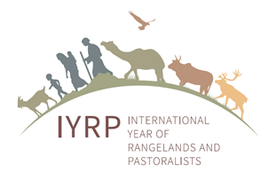
Guidance on Letters of Support for IYRP proposal - as of March 2021

The letters should describe:
- the importance of IYRP to your government/organization
- the types of activities you could carry out or participate in – both before and during the IYRP-2026
- the indicative amount of financing available from your organization, or the potential funding strategy that your organization can count on

Please address the letter to:

H.E. Mr. Mendsaikhan Zagdjav
Minister of Food, Agriculture and Light Industry of Mongolia (MoFALI)
13381 Governmental building 9th, Peace avenue 16a,
Bayanzurkh district, Ulaanbaatar, Mongolia
info@mofa.gov.mn

Please copy the letter to:

- Dr. Batmunkh Damdindorj, Director of Livestock policy implementation and coordination Department, MoFALI , and Chair of the Mongolia National task force of the IYRP (batmunh@mofa.gov.mn)
- Mr. Ganzorig, Director of International Cooperation Division of MoFALI : (ganzorig@mofa.gov.mn)

- Dr. Munkhnasan Tsevegmed, Officer at MoFALI, and Secretary of Mongolia National task force of IYRP: (munkhnasan@mofa.gov.mn, munkhnasan2025@gmail.com)

- Gregorio Velasco-Gil, AGAG, FAO: (gregorio.velascogil@fao.org)

- Maryam Niamir-Fuller, Vice-Chair ISG for the IYRP (mniafull2@gmail.com)

