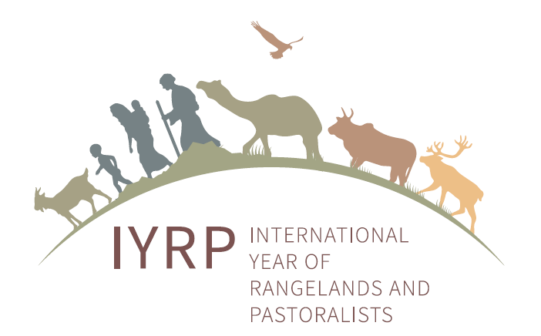

RISG chairs/facilitators and email addresses (status 18 March 2021)

Arctic: Anders Oskal (oskal@reindeercentre.org)
Australasia: (Ms) Dana Kelly (dana@danamkelly.com)
Central Asia & Mongolia: Hijaba Ykhanbai (y.hijaba@gmail.com)
East Asia: Ruijin Long (longrj@lzu.edu.cn), Han Guodong (nmghanguodong@163.com) & (Ms) Rong Yuping (rongyuping@cau.edu.cn)
Eastern & Southern Africa: Igshaan Samuels (igshaansamuels@gmail.com), (Ms) Kedibone Chueu (kedibonec@gmail.com), Ken Otieno (kenotieno@reconcile-ea.org), Loupa Pius (loupadado.org@gmail.com) & (Ms) Sadia Ahmed (sadiama@hotmail.com)
Europe: Engin Yilmaz (engin@bican.net)
Middle East & North Africa: Hossein Badripour (badripour@yahoo.com)
North America: Barry Irving (birving@ualberta.ca), Jurgen Hoth (jurgenhoth1521@gmail.com) & Layne Coppock (layne.coppock@usu.edu)
South America & Caribbean: Pablo Frere (pablofrere@gmail.com) & Pablo Manzano Baena (pablo.manzano.baena@gmail.com)
South Asia: Devinder K Sadana (sadana.dk@gmail.com)
West & Central Africa: Harouna Abarchi (ong.a2n@gmail.com)

