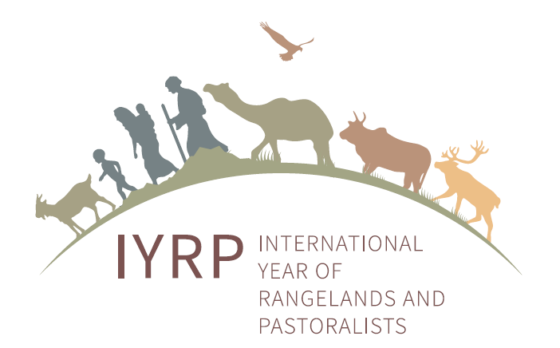

Joint meeting on 17 August 2020 of
Mongolian National Support Group and International Support Group for IYRP
On 17 August 2020, the first joint meeting of the Mongolian National Support Group (NSG) and the International Support Group (ISG) for the International Year of Rangelands and Pastoralists (IYRP) was held on Zoom. About 20 people joined the call.
Agenda Item #1: Mongolia update
Hijaba Ykhanbai reported that the Mongolian Government’s proposal to the FAO Committee on Agriculture (COAG) for an IYRP is on the agenda of the COAG meeting on 28 September–2 October 2020. Mongolia’s new Minister of Food, Agriculture and Light Industry (MoFALI), appointed last month, will send the MoFaLI letter again to the 127 active country members of FAO to request support for the proposal. The letters are meant to remind representatives before the COAG meeting and also to contact new country representatives, as many have changed since the previous ministerial letter was sent. Ganbayar Ganbold, the Permanent Representative to FAO from the Mongolian Embassy in Rome, will make sure that the Mongolian proposal for an IYRP is included in the list of documents for the COAG meeting on the FAO website.
The NSG is planning several events in Ulaanbaatar (UB) in early September, when the Ministry of Foreign Affairs (MFA), MoFALI and the Ministry of Nature, Environment and Tourism (MNET) will explain to embassies in UB about the importance of an IYRP. The NSG also plans to promote the IYRP proposal at the FAO Regional Conference for Asia and the Pacific on 1–4 September 2020.
To prepare for defending the proposal to the COAG, the NSG is determining financial commitments to the IYRP from ministries and organisations, in cooperation with international donors.
The NSG is also involved in planning for the International Rangelands and Grasslands Congress to be held in Nairobi in October 2021, during which there will be three sessions on the IYRP.
Agenda Item #2: Status of new letters of support
Several new letters of support to the Mongolian proposal and also letters of commitment to implementing the IYRP are coming in. It looks hopeful that government ministerial letters of support will be coming from Australia, Canada, China, France, Japan and South Africa, in addition to the letters already received from Afghanistan, Burkina Faso, Ethiopia and Iran. Several pastoralist organisations and rangeland associations are preparing letters of commitment. The information in these letters and attached publications could be helpful when preparing for a side event for COAG.
The Mongolians hope there will be a possibility that country representatives also give their oral support to the proposal during the COAG meeting. The Pastoralist Knowledge Hub (PKH) will find out whether this would be possible; the country representatives would then be notified accordingly.
In the provisional agenda for the COAG meeting, there are several items about livestock, e.g. Livestock sector contributions to achieving the SDGs and a proposal for establishing a COAG Subcommittee on livestock. The latter was submitted by Iran. PKH will let the NSG and ISG know which other countries are involved so that they can be approached to support also the IYRP proposal.
Agenda Item #3: COAG side event
The NSG has proposed a side event at the COAG meeting, but is still waiting for the FAO to approve this and allocate a time slot. As the COAG meeting will be virtual, the side event will also be virtual.
The idea is to include video presentations with some academic inputs (from both Mongolian and non-Mongolian scholars) about the importance of rangelands and pastoralists, local voices of pastoralists and inputs from MoFALI and possibly other ministries.
It was suggested that, rather than waiting until the FAO decides, the NSG and ISG should start preparing for the side event. A possibility would be a comprehensive video that pulls together the information we have and also includes testimonials from partners, including pastoralists. This could be presented in a 24-hour loop and could be shown in a precisely timed event.
A webpage could be set up through which the country representatives in COAG but also others worldwide could access information, testimonials, short video films and photos of rangelands and pastoralists. This should be highly visual and allow COAG representatives to see and hear pastoralists from different parts of the world. This webpage would be an investment for the future, as it could be built upon when preparing for the IYRP after the COAG meeting.
The NSG could coordinate this effort, whereby it will collect the Mongolian visual material – including generating new short testimonials – while members of the ISG will provide materials from other parts of the world. A small group was formed to define the structure and content (including languages) of the webpage, to clarify where it will be hosted and to collect and select materials to be posted. The Secretary of the NSG, Munkhnasan Tsevegmed, will be the main contact for the collaboration with the ISG to work on publicity for the IYRP. He thought the proposed visual webpage for the COAG could perhaps be hosted on the website of MoFALI or MFA. This will be explored.
One member of the small group, Barbara Hutchinson from the Rangelands Partnership, offered to collect materials and links for the group to work with. The group will start with the information and links in the letters of commitment, which would also provide sources for testimonials about why the IYRP is important for the organisations that sent the letters.
Next joint meeting of NSG and ISG
It would be good to have another meeting before 10 September, when the NSG wants to bring embassy people together in UB and ask for support during the COAG meeting. The NSG and ISG need to discuss what materials to distribute or display to embassies and delegates at the meeting.
More information about rangelands and pastoralists worldwide needs to be provided to the embassies. The Gap Analysis made for the United Nations Environment Programme [https://www.unenvironment.org/resources/report/case-benign-neglect-knowledge-gaps-about-sustainability-pastoralism-and-rangelands] offers ranges of data and recommends a global assessment of rangelands and pastoralists because appropriate data for policymaking and planning are not available.
The next joint meeting should be in the first week of September or, at latest, on Monday 7 September. Next week, after the consultation with NSG and ISG members, Hijaba will suggest dates for the meeting.

