Update on activities of the Global Alliance for the International Year of Rangelands and Pastoralists (IYRP)
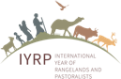
December 2024

The UN General Assembly declared 2026 the International Year of Rangelands and Pastoralists (IYRP).
- To increase worldwide understanding of the value of rangelands and pastoralism for food security, economy, environment and cultural heritage
- To fill knowledge gaps about rangelands and pastoralists through participatory research and strategic communication
- To promote informed, science-based policy and legislation for current and future generations
- To advocate for strengthening the capacity of the pastoralism sector and for increasing responsible investment in sustainable land-use practices, equitable access to markets, and the health and wellbeing of people and animals in the rangelands as a climate solution.

United Nations Convention to Combat Desertification (UNCCD) Conference of the Parties (COP) 16
3–12 December 2024
Riyadh, Kingdom of Saudi Arabia
The UNCCD COP is a crucial platform for addressing land degradation, desertification and the sustainable use of drylands globally. This convention brings together governments, scientists, local land users, Indigenous peoples and other stakeholders to discuss strategies, policies and funding to deal with the challenges faced by vulnerable ecosystems including rangelands. COP16 is pivotal in setting international agendas that integrate environmental sustainability with economic and social development goals.
Saudi Arabia’s hosting of COP16 holds particular importance, as it brings global attention to arid and semi-arid ecosystems, which are central to pastoralism and rangeland management. COP16 aligns closely with the IYRP2026 by providing an opportunity to showcase the critical role of pastoralists in maintaining biodiversity and ecosystem health. We hope that COP16 can drive commitments to protect rangelands, promote sustainable grazing practices and enhance the livelihoods of millions of pastoralists worldwide.
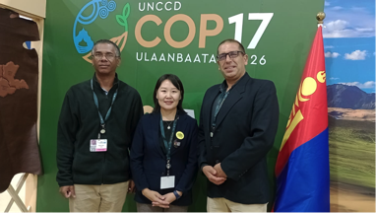
Numerous members of the IYRP Global Alliance, including all three co-chairs, are attending COP16 and will raise the profile of the IYRP, create awareness and advocate for support and commitment from stakeholders to ensure a successful IYRP in 2026. The Government of Mongolia will assume presidency of COP17, which will take place in 2026.
At COP16, the IYRP Global Alliance hosted
a side event on 7 December 2024 to
i) provide information on IYRP2026 and its lead-up; ii) encourage more governments and other stakeholders to support the IYRP; and iii) raise funds and other resources to support IYRP2026.
Igshaan Samuels (South Africa), Burma Dashbel (Mongolia) and Enrique Michaud (Peru), Co-chairs of Global Alliance for IYRP
The Global Alliance for the IYRP calls for global action for sustainable rangelands and pastoralism to achieve Land Degradation Neutrality (LDN)
The Global Alliance calls for 8 priority actions to meet the challenges facing rangelands and pastoralists:
#1 Stop indiscriminate conversion of rangelands that is hurting rangeland productivity, ecosystem services and rangelands’ potential role in mitigating climate change.
#2 Recognise the importance of pastoral mobility as a nature-based solution for sustainably managing and restoring rangeland health.
#3 Innovate and implement beneficial economic policies and technologies: Re-assess economic policies that harm rangelands & pastoralists. Set up legal frameworks for organic certification of local pastoral products.
#4 Promote integrated, multifunctional land use: Employ sustainable rangeland management practices and policies to achieve multiple sustainability benefits through multifunctional land use.
#5 Strengthen participatory land governance and equity: Incorporate pastoralists in all decision-making on the use and management of rangelands and ensure they have well-defined legal and customary tenure and access rights.
#6 Increase rangeland and pastoral projects under the LDN Fund by 30%: Calling on the LDN Fund to increase its support to rangelands and pastoralist projects by 30% by 2026, the year of the IYRP.
#7 Commit LDN targets to rangelands and pastoralism: Include rangeland restoration and sustainable pastoralism in UNCCD LDN targets and accelerate work towards them.
#8 Earmark 25% of the LDN Fund for knowledge and capacity building: Reduce significant rangeland and pastoralist knowledge gaps through participatory research and impact assessments and co-creation of knowledge and incorporate this knowledge in strategic planning to help determine & verify global statistics.
The full science review made by the IYRP Working Group on Rangelands & LDN can be found here and the related policy brief can be found here.
Position Paper on Pastoralism and Protected Areas
A subgroup of the IYRP Working Group on Rangelands & Biodiversity formulated a position paper for the IYRP Global Alliance on “Pastoralism and Protected Areas”. It calls upon States, protected-area authorities, organisations of the United Nations system, other international and regional organisations, including global conservation organisations and other relevant stakeholders including civil society, the private sector and academia to uphold the rights of pastoralists, recognise their role in sustainable rangeland management and biodiversity conservation in protected areas and wider landscapes, and support conservation measures that contribute to pastoral livelihood resilience, including indigenous and community-conserved areas that support pastoral livestock systems.
And accordingly:
- To govern and manage existing and establish future protected areas in full compliance with the inherent rights of mobile pastoralist communities;
- To develop robust policies, mechanisms, and measures to ensure that human rights violations;
- To develop robust policies, mechanisms and measures that ensure the effective participation
and representation of mobile pastoralist communities in the designation, governance and
management of protected areas;
- To develop good practice guidelines, fully informed by mobile pastoralist communities regarding the governance and management of protected areas;
- To assess and recognise the beneficial role of mobile pastoralists in maintaining rangeland and other ecosystems; and
- To explore and apply new conservation approaches and frameworks, such as Other Effective Area-Based Conservation Mechanisms (OECMs), in both securing the access and tenure rights of mobile pastoralists over their land, territories and other natural resources, and ensuring in situ conservation of biodiversity.
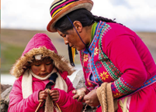
Building on the knowledge and initiatives of pastoralist women: policy brief & summary
The IYRP Working Group on Pastoralism & Gender brought out a policy brief on “Building on the knowledge and initiatives of pastoralist women” in which its encourage governments, policymakers, development organisations, grassroots networks, community leaders and influencers to promote and implement gender-responsive pastoralist programmes and policies and to improve rangeland governance systems in the following ways:
Photo: Petra Dilthey
- Acknowledge and support women’s roles in caregiving and peacebuilding and encourage men to share in carework, reducing women’s triple burden;
- Recognise and reinforce pastoralist women’s rights to use land and other resources;
- Involve pastoralists in land-use and rangeland-management planning;
- Focus on the rights of pastoralist groups as well as women pastoralists, by respecting the collective rights of pastoralist communities while building women’s capacity;
- Eliminate gender-based violence and address its drivers through education programmes for men, women, youth and children that ensure that women understand and exercise their rights;
- Promote and support education, health and other social services adapted to the needs of pastoralist women and girls;
- Open avenues for pastoralist women to advocate for themselves at all governance levels;
- Prioritise support for pastoralist women’s networks and social movements;
- Educate development actors on gender issues in pastoralism;
- Integrate pastoralist women and girls into action research and build their capacities to carry out their own research on pastoralism and rangeland issues;
- Recognise and encourage women scientists and professionals.
The summary of this policy brief can be found here.

FAO COFO Working Group on Sustainable Drylands and Agropastoralism Systems and IYRP Global Alliance partnered again for 2nd Summer School on Drylands

The four-day training course was held on 12–15 September 2024 at the CIFOR-ICRAF Campus in Nairobi, Kenya. The event attracted abour 25 participants from dryland regions worldwide. The purpose was to arm them with knowledge and skills in Monitoring Agrosilvopastoral Systems for Sustainability and Ecosystem Services.

Glossary on people & institutions in pastoralism & rangelands
The International Rangeland Congress (IRC) has collaborated with members of the IYRP Global Alliance to bring out "Rangelands and pastoralists: people and institutions – a glossary of terms" to provide guidance for understanding socio-institutional terms commonly used when talking and writing about rangelands and pastoralists. This Version 1 of the glossary has been published more than a year before the IYRP2026 commences in the hopes that – in the run-up to the Year – it will stimulate reflection and discussion about the use of these terms and thus generate even better understanding. Readers are invited to comment on the definitions in this glossary; contact the Glossary Team (glossary.iyrp2026@gmail.com). Version 2 will be published in January 2026, the first month of the IYRP, focussed on the theme “What are rangelands? Who are pastoralists?”.

Update on the Thematic Working Groups of the IYRP Global Alliance
Jonathan Davies (Working Groups coordinator)
The IYRP Global Alliance, through its Working Groups (WGs), seeks to achieve greater awareness in science and society about how rangelands and pastoralists contribute to food security, economy, environment and cultural heritage. The WGs are working towards informing resolutions taken by the United Nations (UN) and other international entities and bringing about changes in national, regional and global policies in support of rangelands and pastoralists. The WG outputs and activities to date have been:
WG Afforestation in Rangelands
- Brief on Afforestation in Rangelands highlighting that rangeland afforestation is not a viable climate change mitigation strategy (2-page brief in English and Russian)
- State-of-the-science evidence-based paper submitted for publication
- Trees won't save us (YouTube video)
- Scrutinising the Benefits of Rangeland Afforestation as a Natural Climate Solution (YouTube video)
- Rangeland afforestation is not a natural climate solution (published journal article)
- Planting trees in rangelands won’t save the planet (op-ed)

WG Pastoralism & Gender
- Concept note for the working group
- Key messages document, translated into several languages
- Selection of top films on pastoralist women
- Small videos prepared for Women’s Days
- Policy brief and summary (see news item above)
- Plan for Mera+15 Global Gathering of Pastoralist Women to revisit the Mera 2010 Declaration
(see update of RISG in South Asia below)
WG Pastoralism & Water
- Concept note open for comments from WG members with headline messages:
- Rangeland health – balancing ecological processes in the rangelands
- Water governance – decision-making about access to, distribution & use of water
- Water resource development – repair and construction of infrastructure
- WG is engaging with pastoralists to understand rangeland health, history of water resource development, water governance and livelihood outcomes and to identify water interests
WG Rangelands & Land Degradation Neutrality (LDN)
- Science review full document on “Global action for sustainable rangelands and pastoralism to achieve Land Degradation Neutrality”
- Call for Action technical brief emphasising rangelands and pastoralism: a sustainable solution to achieve LDN
- Journal article on science review paper (under review)
- Call-for-action graphics and tweets through social media channels

WG Rangelands & Biodiversity
- Concept note
- Two global reviews for peer-reviewed publication (in pipeline)
- Position paper on “Pastoralism and protected areas” (see news item above)

WG Economics of Pastoralism
- Concept note
- Literature review on different approaches used to analyse pastoralist economy (in French and English)
- List of researchers & institutions working on economics of pastoralism around the world (in pipeline)
- Headline message: Pastoralism is a livelihood system that is key in creating added value, ensuring food security for urban and rural households, and creating jobs.

WG Pastoralist Youth
- Concept note
- Key messages (in pipeline)

WG Pastoral Land Rights
- Concept note
- Position paper on pastoralism and land rights (draft)
- Toolkit for CSOs on how to secure pastoralists’ land rights (in pipeline)
- Archive of case studies (under development)
- Communications & campaigns highlighting that land access, use and tenure security is critical to safeguard pastoralists’ livelihoods an custodianship (underway)

WG Climate Change
- Concept note (being finalised)
- Headline message: WG will bring to light the misleading communications, methodologies and injustices inherent in the narrative that currently exists around greenhouse gas emissions stemming from rangelands and extensive livestock, to better inform policymakers, researchers, producers and advocacy groups.
All of the WG outputs can be found in the Working Groups page of the IYRP website. Anyone interested in joining a WG should contact Jon Davies (jonathantilstonedavies@gmail.com) to obtain the names and email addresses of the WG coordinators.

Selected highlights from the 11 IYRP regions
Multistakeholder Regional IYRP Support Groups (RISGs) were formed in 11 regions around the world to generate partnerships. They seek to expand the network of supporting individuals, organisations and governments in these regions and in countries within them.
Contact details for the RISG coordinators can be found here: www.iyrp.info/resources/front
Short reports on the work of the RISGs can be found in the IYRP updates: www.iyrp.info/resources/news
RISG in West & Central Africa
(Agro)Pastoralism in Africa Conference, Senegal. The second edition of the (Agro)Pastoralism in Africa Conference, held on 11–13 November 2024, brought together 170 participants from 22 nationalities in Dakar, Senegal. Organized by Pôle Pastoralisme et Zones Sèches (PPZS) and the West and Central Africa Regional IYRP Support Group (https://www.iyrp.info/west-central-africa). The event explored current challenges and prospects for (agro)pastoral systems, fostering interdisciplinary dialogue and collaboration.
The symposium, which brought together a total of 170 participants, explored the current issues and perspectives of (agro)pastoralism in Africa and elsewhere. For three days, development practitioners, representatives of pastoralist organisations, researchers, students and a whole range of other international actors exchanged, debated and co-constructed perspectives for the future. The opening ceremony of the symposium was co-chaired by Serena Ferrari, president of the symposium and co-chair of the IYRP Support Group in West and Central Africa. Igshaan Samuels, co-chair of IYRP Global Alliance, put the event within the context of preparations for 2026.
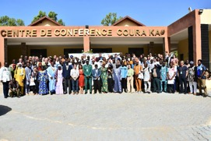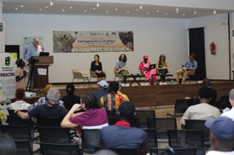
A short report on the event in French can be found here and in English here.
PRAPS-2 Entretiens Techniques (Technical discussions), Senegal. The Projet régional d’Appui au Pastora-lisme au Sahel-Phase II (Regional Project for Support to Pastoralism in the Sahel-Phase II PRAPS-2) held on 2–4 July in Dakar (Senegal) organised the fifth edition of the PRAPS Technical Discussions. Sessions were devoted to understanding the dynamics of Sahelian pastoral rangelands, lessons learnt from rehabilitation experiences evaluated in the six PRAPS-2 countries and perspectives on project implementation. This meeting made it possible to share rich experiences on the rehabilitation of degraded rangelands.
Agriculture, Pastoralism and Protected Areas conference, Chad. CIRAD and the Chad Pastoral Platform held an international conference “Agriculture, Pastoralism and Protected Areas: Tensions and Solutions for the Future of Rural Territories in Central Africa and the Sahel” on 2–3 October 2024 in N’Djamena, Chad. The Conference allowed a review of the state of knowledge on the causes and consequences of tensions between agropastoral activities and protected areas within Sahelian and Sudano-Guinean ecosystems. It also reviewed the governance methods and technical innovations for better management of the interface zones between agropastoral spaces and protected areas, in order to promote the sustainable development of agropastoral territories. Finally, the conference encouraged the establishment of consultation bodies between actors in territorial governance so that they can jointly build future scenarios that integrate the demands of agropastoral households and environmental conservation.
RISG in North America
The Fall 2024 Webinar Series by the North America Strategic Visioning Task Force of the Society for Range Management (SRM) was organised in collaboration with the International Year of the Woman Farmer (IYWF), likewise designated by the UN to be celebrated in 2026. The series brought together diverse perspectives on critical topics in rangeland management, exploring themes such as biodiversity conservation, fire management and adapting to a changing world. The 9 October webinar on "Biodiversity in rangelands: how to simultaneously conserve and manage in working landscapes" highlighted strategies to balance conservation goals with the practical realities of rangeland use. On 23 October the webinar on "Dealing with fire on the range: managing land in a changing world" addressed fire management challenges and explored innovative practices to mitigate fire risks while enhancing ecosystem resilience.
RISG in Australasia
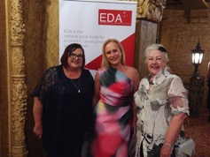
Award finalist: highlighting the value of pastoralism.
The Western Australia IYRP group was part of the Southern Rangelands Project, which was a Finalist in the National Economic Development Awards (EDA) for Excellence. This award helps to highlight the important role of pastoralists in small rural and isolated communities in the rangelands. Pastoralism is the most extensive land use in the Australian rangelands, bringing in over 5 billion dollars to the country’s GDP, only eclipsed by mining.

International Rangelands Congress. The IYRP Australasian Group has focused on developing IYRP sessions for the International Rangelands Congress (IRC) to be held in Adelaide, Australia, in May–June 2025 (IRC2025). The IYRP Global Alliance is hosting two concurrent sessions during the IRC2025 about the regional and thematic work of the Alliance. It is also collaborating in several other events such as on “Women in the Rangelands” and a session with films on pastoralism worldwide and is co-organising a plenary forum together with the IRC Continuing Committee.
Traditional or Indigenous Knowledge Forum. This forum, held immediately before the IRC2025, will be hosted by the North Australian Indigenous Land and Sea Management Alliance Ltd (NAILSMA). It will highlight the role of traditional or Indigenous knowledge in rangeland management, helping pastoralists and other land managers care for native plants and animals, in terms of both maintenance and restoration of land. One key theme is re-imagining conservation from an Indigenous perspective.
This forum is open to all IRC2025 delegates. Registration is not yet open and will be through the IRC website: https://irc2025.rangelandcongress.org/
The two key components of the event are i) Traditional Indigenous Knowledge Forum, Sunday 1 June, open to all Congress delegates; and ii) Pre-forum workshop, Saturday 31 May, open to First Nations peoples only. The Forum is expected to make recommendations to the Congress for endorsement.
Early Bird (discounted) registration for the IRC2025 has been extended to 31 January 2025 and can be done here.

RISG in Central Asia & Mongolia (CAM)
- In the past months, CAM RISG co-chairs Hasrat Arjjumend and Hijaba Ykhanbai had several online conferences/ discussions about CAM activities and plans.
- In the first part of this year, the Environment and Development Association JASIL, a member of the CAM RISG, reported on activities to support the IYRP2026 in CAM to the Regional Coordination Unit (RCU) of the International Land Coalition (ILC). During this meeting, support for the IYRP2026 was agreed to be included in the strategy and work plan of the National Land Coalition (NLC) in Mongolia and among the priority areas for 2024. In accordance with this decision, national-level support for the IYRP was indeed included as one of three sub-objectives of the NLC Mongolia Strategy for 2024–2027 and in the 2024 work plan. Thereafter, an online meeting of CAM RISG members was held.
- In November 2024, through a resolution of the Prime Minister of Mongolia, a Mongolian IYRP Working Group was tasked to prepare an action plan for the IYRP2026, incorporating inputs from supporting countries, international support groups, governmental and nongovernmental organisations, and the private sector. The secretariat is provided by the Ministry of Food, Agriculture and Light Industry.
RISG in East Asia
- 28 April 2024: During the IYRP session in the Annual Meeting of Chinese Grassland Society. Igshaan Samuels, Co-Chair of IYRP Global Alliance, was invited to deliver a talk on the IYRP and its progress globally. RISG co-chair Ruijun Long and five other scholars and three herders also gave talks on regional IYRP activities. Over 50 participants joined the session, chaired by RISG co-chair Han Guodong.
- 24 May 2024: ICIMOD (International Center for Integrated Mountain of Development) held a webinar on “Exploring synergies: pastoral practices, rangeland biodiversity, and ecosystem services”, aimed to
i) increase awareness about the importance of rangelands and pastoralism for conserving biodiversity and providing ecosystem services; and ii) discuss threats to rangelands and pastoral systems, including habitat degradation, land-tenure issues, climate change, invasive species and conflicting land use.
- 24 July 2024: RISG co-chair Ruijun Long was invited to host the Yak Forum during the Yak Cultural Festival in Gannan Tibetan Prefecture of Gansu Province, China. Igshaan Samuels attended the Festival and delivered a talk in the Yak Forum. During the 3-day Festival, more than 10 thousand participants, including herders, scholars, entrepreneurs and officials, attended yak breed competition, milking competition, singing and dancing performance, and other programmed activities.

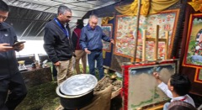
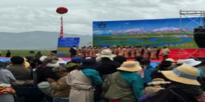

- 1–7 September 2024: Lanzhou University and ICIMOD initiated the Asian Highland Pastoral Network during the workshop on “Networking High-Asian Community of Practice cum Regional Learning on Best Practices for Resilient Pastoralism and Sustainable Rangeland Management”. The network will serve the purposes of exchanging ideas and knowledge, sharing technologies, developing products, setting standards, common branding and aggregating resources and products by Asian highland stakeholders.
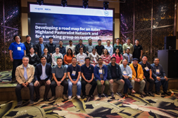

RISG in Eastern and Southern Africa
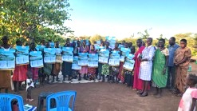
The 51st Commemoration of the Lokiriama Peace Accord was held on 21 September 2024 in Lokiriama, Turkana County, Kenya. Coordinated by members of the IYRP Alliance in Karamoja, Uganda, the event was held in support of the IYRP2026. This annual gathering aligns with the UN International Day of Peace and serves as a platform for regional peace-building and resource-sharing initiatives among the Ateker Cluster communities, which include the Karamojong (Uganda), Turkana and Pokot (Kenya), Toposa (South Sudan) and Nyangatom (Ethiopia). The event underscores the pivotal role of community and government leaders in fostering sustainable peace, economic development and regional cooperation, building on the enduring legacy of the Lokiriama Peace Accord.
RISG members RECONCILE (Resource Conflict Institute) and ESAPN (Eastern & Southern African Pastoralist Network) are collaborating in the preparation phase for a new FAO EU project with funding from the European Union “Pastoralism and Livestock Adaptation to Climate Change in Eastern Africa” (PLACE). In this project, they will strengthen inclusive multistakeholder platforms at local, national and regional/cluster to foster community rangelands governance and will enhance the capacities of pastoralist organisations to advocate for pro-pastoralist policies, especially with national and regional pastoral parliamentary groups.
These RISG members plan to use the platforms to communicate messages on the IYRP2026 and to support pastoralists’ voices in related gatherings at national and international level.

RISG in South Asia
Pastoralist Youth Fair. The South Asian Pastoral Alliance (SAPA) in association with the RISG South Asia organised a Pastoralist Youth Fair on 21–23 June 2024 in the Mehsana District of Gujarat, India, to empower young pastoralists by equipping them with the necessary knowledge, skills and tools to sustain and innovate within pastoral communities. It also raised awareness about the significance of the IYRP2026 and the importance of pastoralism on a global scale. The total of 320 participants, including 80 women pastoralists, came from from different states of India and also from South and Central Asia, namely Nepal, Sri Lanka, Afghanistan, Bangladesh and Pakistan. They came out with a Charter of Demands on Commons, Climate and Culture.
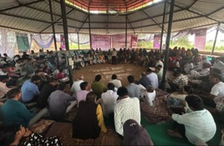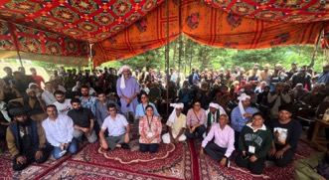
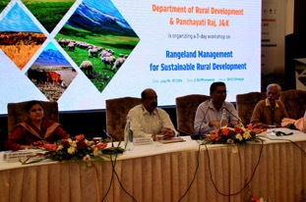
Workshop on “Rangeland Management for Sustainable Rural Development”. The Department of Rural Development, Jammu & Kashmir, in association with the RISG in South Asia and the NABARD Bank Regional Office Jammu, organised a workshop on “Rangeland Management for Sustainable Rural Development” on 29–31 July 2024 in Srinagar, Union Territory of Jammu & Kashmir, India. The 140 participants included representatives of government departments, NGOs and farmer/ pastoralist groups from different parts of Jammu &Kashmir, from other Indian states and from Mongolia. Pedro Herrera, author of the UNCCD Global Land Outlook (GLO) report on rangeland and pastoralists, gave the keynote address. Burmaa Dashbal, IYRP Alliance co-chair, spoke about activities of pasture user groups in Mongolia. The main aim of the workshop was to leverage ongoing government programmes and schemes of different departments in various states of India to develop a model of inclusive and sustainable rangeland management.
Convention on Tamil Nadu Pastoralism. This meeting was held on 18–19 October 2024 at the Agronomy Seminar Hall, Agricultural College, Madurai, organised by the Thozhuvam Farmer Producer Company Ltd, SEVA and the RISG in South Asia, along with other partners. It was focused on “Protection of pasture lands, commons and pastoralism: issues, challenges and way forward”. The over 200 participants included pastoralists, academics, civil society organisations, government officials and volunteers. The event aimed to assess the status of pastoralism and commons in Tamil Nadu, while leveraging government schemes for sustainable rangeland management. The workshop featured an inaugural ceremony, technical sessions and group discussions.
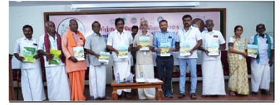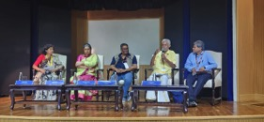
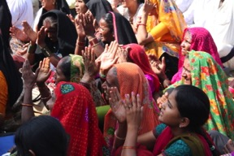
Plans for Global Gathering of Pastoralist Women (Mera+15) in India. The IYRP Working Group on Pastoralism & Gender is planning a Global Gathering of Pastoralist Women to recognise and support women pastoralists and their initiatives, strengthen their solidarity and strengthen their voices in international discourse about rangelands and pastoralists. The first Global Gathering of Women Pastoralists was held in Mera in the State of Gujarat, India, and created an opportunity for pastoralist women from around the world to unite, share experiences and develop a Mera Declaration and Global Action Plan. The second Global Gathering is proposed to take place in November 2025, likewise in Mera, to mobilise pastoralist women in preparation for the IYRP2026 and to celebrate pastoralist women, their contributions to pastoralism, their knowledge, initiatives, innovations,
skills and culture. The event will be hosted by women pastoralists from the local NGO MARAG, which has spent decades raising awareness on and supporting Maldhari pastoralists in northern India.
Mera Global Gathering 2010 (Photo: Sabine Pallas)
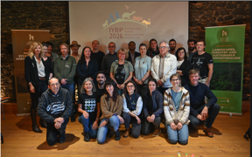
RISG in Europe
On 14–18 October, RISG co-chair Francesca Pasetti attended a meeting in Clermond Ferrand, France, on “Landscape, forestry and sustainable pastoralism”, where inhabited natural areas and the rights of local people to continue their traditional activities in these areas were discussed.
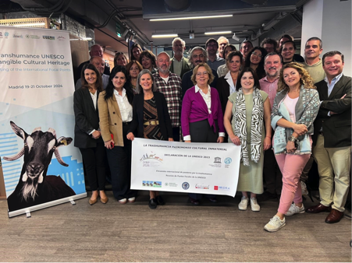
On 19–21 October, representatives from FAO, IYRP and several European countries convened in Madrid to work on the Safeguard Plan of Transhumance as Intangible Cultural Heritage of UNESCO. The meeting also honoured the longstanding tradition of the Transhumance Festival, which began in 1994 and features a flock of sheep passing through the heart of Madrid. This provides an opportunity for representatives from national Ministries and transhumant shepherds from Albania, Andorra, Austria, Croatia, France, Germany, Greece, Italy, Luxembourg, Portugal, Romania, Spain and Turkey to celebrate transhumance in Europe.
Also in October, several herder associations, advocacy groups, environmental organisations and interested individuals, including shepherds, photographers and book authors, formed a German IYRP Group, initiated by the League for Pastoral Peoples, Aktion Agrar and Deutsche Umwelthilfe, which share coordination tasks. This group seeks to raise public awareness about the importance of grazing animals for natural landscapes and the skills of the people who graze their animals in these landscapes. It targets the general public through education, news media and consumer-awareness campaigns and also German and European policymakers and government officials to promote extensive livestock husbandry on natural pastures. It has a specific focus on the European Nature Restoration Law, a key element of the European Biodiversity Strategy.

To find out more about IYRP 2026, go to www.iyrp.info or contact iyrp2026@gmail.com

