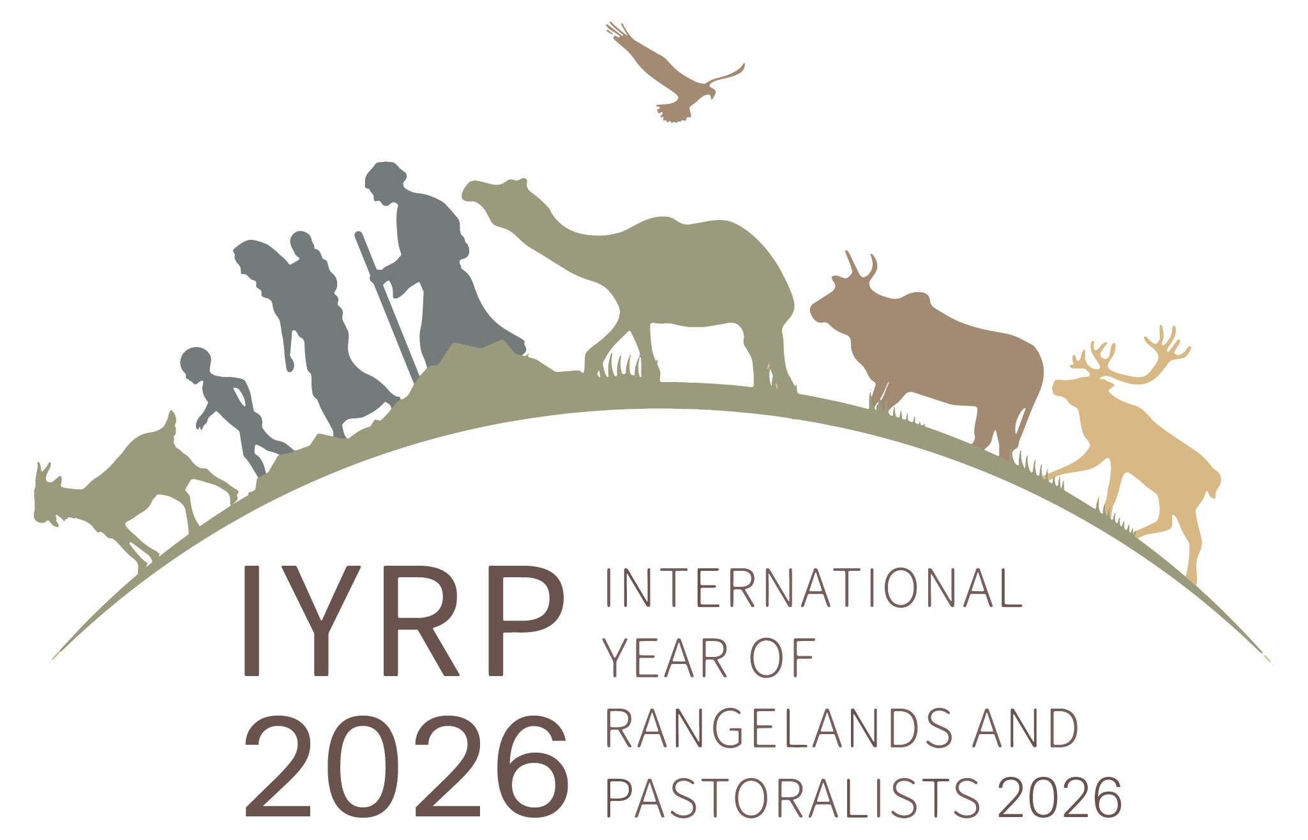
IYRP General Update June 2022

Dear Friends and Supporters of IYRP 2026

We have received so many congratulatory messages from all quarters for the proclamation of IYRP 2026. Thank you all for your kind and very effective support!

State of the IYRP 2026 Partnership

As of now, there are 306 organizations that have sent formal letters/logos in support, and letters and logos are still coming in (see https://www.iyrp.info/friends-of-iyrp). These are 48 pastoralist organizations, 232 civil society organizations and 6 inter-governmental organizations. This is in addition to the 102 governments who have either sent letters, or spoken in favor during UN meetings, or co-sponsored the UN General Assembly resolution. Now that the IYRP 2026 has been proclaimed, we are encouraging more organizations to send letters – this time with the intent of showing how they aim to engage with initiatives and activities for the year 2026.

All of us now have 4 years to start planning, setting the stage, and securing the resources for a very impactful International Year. The International Support Group, and its Global Coordinating Group (GCG), will continue to actively work on this, paving the way for the formal establishment of the International Steering Committee for IYRP 2026 by FAO, expected in 2025.

We have had a leadership turnover: Chair Jim O’Rourke has stepped down so as to focus on the North American regional support group – we are all immensely grateful to Jim for his steadfast leadership and insights over these long years. The co-chairs of the GCG are now Igshaan Samuels (Agricultural Research Council, South Africa and formerly co-chair of the Eastern and Southern Africa Regional IYRP Support Group) and myself. The Regional IYRP Support Groups (RISGs) will be ramping up their activities and working to expand the network. A sub-group is focusing on how to reach and inform millions of pastoralists about the IYRP and find ways for them to participate and benefit. Another sub-group is looking at how to achieve impact on policy change by 2026 through awareness raising in selected global events, such as UNFCCC (UN Framework Convention on Climate Change), CBD (Convention on Biological Diversity), UNCCD (UN Convention to Combat Desertification) and human rights processes. We will also be working closely with the UN Decade for Ecosystem Restoration, the UN Decade of Family Farming, and two other recently proclaimed International Years – IYM 2022 (Mountains) and IYC 2024 (Camelids). If you wish to get actively involved in these sub-groups, please send an email directly to Maryam and Igshaan.

Partner activities at the GLOBAL LEVEL:

- UNCCD Conference of Parties (COP) 15 Abidjan, 9–20 May 2022 – We congratulate the Government of Mongolia, which has been selected to host the UNCCD COP 17 in 2026. This can be an excellent opportunity to achieve real impact in both the UNCCD and the IYRP processes. COP 15 saw several events organized by WWF, CIRAD and WOCAT about rangelands and pastoralism (R&P), and a strong civil society statement shepherded by Nahid Naghizadeh (Middle East & North Africa RISG) highlighted the challenges of pastoral mobility and supported the IYRP 2026. WWF launched a global coalition and platform for Grasslands, Savannahs and Rangelands.

- Global Landscapes Forum meeting of the Rangelands Initiative and WAMIP, 25 May 2022, Jordan – The IYRP was highlighted during this meeting, including a discussion on how the IYRP can better represent and benefit pastoralists.

- Stockholm+50 Official Side Event, Stockholm, 2 June 2022 on Nature-based restoration and multipurpose use of rangelands: promising solutions to benefit our planet and people – Organized by the Government of Mongolia, WWF International, FAO, IUCN, ILRI and the IYRP ISG. The focus was on rangeland conversion (as expressed by Anders Oskal, Chair of the Arctic RISG, and Harouna Abarchi, Chair of the West and Central Africa RISG) and on avoiding negative externalities from afforestation and renewable energy schemes (by Hussein Wario of the Eastern and Southern Africa RISG). High-level panelists, such as Maria Helena Semedo (ADG FAO), Bruno Oberle (Director General of IUCN) and Joao Campari (WWF Global Food Practice), stressed that R&P have been left behind and marginalized, and saw the potential of the IYRP 2026, among other actions, to help redress this. The IYRP’s consensus document on 3 Urgent Actions introduced at the Side Event has been incorporated by UNEP into the final report of the Conference.

- Rural Water Supply Network (RWSN) Webinar on “Pastoralist water rights and governance” on Tuesday 7 Jun 2022 – Organized by RWSN, CELEP, Agrecol Association, IWMI, SIMAVI and partners, this webinar focused on challenges pastoralists face for accessing water for themselves and their animals, with case studies from West Africa (presented by WCA RISG member Astou Diao Camara of the Institut Sénégalais de Recherches Agricoles – Senegal), East Africa and India. GCG co-chair Niamir-Fuller described the IYRP 2026 campaign pointing out that at least two of its 12 monthly themes are directly relevant for advocating on water issues..

- Webinar on “Pastoralism and large-scale renewable energy and green-hydrogen projects” 9 June 2022 – Organised by the Heinrich Böll Foundation and Bread for the World, Germany, this event highlighted its study report on pastoralism and large-scale green energy projects, by ESA RISG members Ann Waters-Bayer and Hussein Tadicha Wario, which refers to the IYRP and acknowledges the ISG. Hussein also wrote a commentary about the topic: “Making green energy safe for pastoralists”.

- IYRP Co-Chair Niamir-Fuller Open Letter to IUCN Members, 17 June 2022 – On the occasion of the International Day of Desertification and Drought, this open letter calls on IUCN members to protect rangelands and pastoralists from eviction and stop converting their lands to unsustainable uses

Regional news:

- Australasia RISG focused on disseminating information about the proclamation of IYRP 2026 through two radio interviews with Queensland Country Life and ABC radio (21 and 22 March, respectively), and through its Twitter account (@IYRP2026AUS). The RISG Co-Chair Dana Kelly submitted two grant proposals on behalf of the Australasia regional group to explore the role of indigenous people in the Australian pastoral industry, with particular emphasis on the voices and stories of Aboriginal Australians and developing communities of practice.

- Eastern & Southern Africa (ESA) RISG:
  - Ethiopia’s Dream II Conference 18 March 2022, sponsored by GIZ and MetaMeta, celebrated the proclamation of the IYRP 2026.
  - Writeshop on Policy Framework for Pastoralism in Africa, 29 May–3 June 2022, Naivasha, Kenya – AU-IBAR convened this meeting with about 35 experts from throughout Africa to assess the policy adoption of the Policy Framework for Pastoralism in Africa and the Africa Regional Strategy for Disaster Risk Reduction. Furthermore, strategies were discussed on how to accelerate the action plans of both policies. The meeting was attended by two ESA RISG coordinating group members.
  - On 22 Apr 2002, the popular agriculture magazine Landbouweekblad published an awareness article on the IYRP 2026 highlighting the need to support pastoralists and protect their rangelands.
  - The Grassland Society of Southern Africa created awareness amongst it members and via its social media platforms when the IYRP proclaimed in March 2022.

- East Asia RISG:
  - The RISG announced the proclamation of the IYRP 2026 through the Chinese Official Account of Highland Plant-Animal-People in Chinese, which so far has been read by more than 12,000 people. The China Grassland Society also posted the news in Chinese, and the Tibetan Official Account of Bonuoer posted it in Tibetan.
  - Symposium on ecological protection and high-quality development of yak industry of Gannan Tibetan Autonomous Prefecture of Gansu Province, 12–13 April – RISG Co-chair Ruijin Long delivered a lecture with introduction of the IYRP to over 50 participants including Prefecture Governor, Vice-Governors and County Governors, department directors, scholars and pastoralists. Following this symposium, and at the invitation of the Gannan Prefecture Government, Prof. Long visited Tibetan families, cooperatives, state farms and relevant departments of 4 pastoralism counties of Gannan Tibetan Autonomous Prefecture, to discuss with pastoralists, technical and extension personnel, and meetings with officials in the 4 pastoralism counties on high-quality development of yak industry of Gannan as well as introducing the IYRP to them. Each county’s TV and local paper media also reported the above events.
  - RISG Co-Chair Han Guodong explained the IYRP 2026 to members of the Chinese Grassland Society in a meeting on 27 May 2022.
  - Article publication: Ruijun Long & Hijaba Ykhanbai (2022). An introduction of the International Year of Rangelands and Pastoralists of United Nations, Grassland and Turf 42 (2): 136–143. This Chinese journal is ranked 10th among 70 different Chinese journals in terms of grassland, animal husbandry and veterinary sciences in China.

- Central Asia and Mongolia (CAM) RISG has been active in bringing new members from the region into the support group. CAM members from Tajikistan, Kyrgyzstan and Mongolia took part and exchanged experiences to support IYRP during the International Water Forum’s Second International High-Level Conference on the International Decade for Action “Water for Sustainable Development” 2018–2028, which was held in-person in Dushanbe, Tajikstan on 6–9 June 2022.

- North America RISG:
  - Multi-national Summit on North America’s Grasslands Road Map, 24–25 May 2022, Fort Collins, CO, USA – More than 200 organizations across eight sectors representing Mexico, Canada, the USA and Indigenous Nations came together to commit to conserve North America’s Central Grasslands. Representatives included a cross-section of leaders and experts that live and work in the Central Grasslands — including producers on working land, Indigenous/First Nations, federal, state and provincial agencies, foundations, industry, and non-governmental organizations including land trusts, tribal representatives and academia. David Borré (Pronatura Noreste, Mexico) highlighted IYRP 2026 and distributed specially made IYRP stickers.
  - Symposium “The ignored richness of Mexican grasslands”, 8th Mexican Conference on Ecology, 24 May 2022, in Oaxaca, Mexico – Organized by the Mexican Scientific Ecological Society, the main goal was to highlight both the biological and productive value of grasslands and the urgent need for research and conservation. Carlos Martorell (National Autonomous University of Mexico) presented “2026: Hope for Grasslands and Pastoralists on a Global Scale (IYRP-UN)”. There were about 100 attendants, with a noticeable proportion of young students and professionals. Participants expressed their surprise about the extreme diversity of Mexican grasslands, the neglect they are in, the rate of their destruction and the need to take action. There was also great interest in the role of appropriate livestock management as a tool for grassland conservation.
  - The North America RISG has adapted the global IYRP 2026 logo into a new logo for its region to better explain its relevance to the diversity of pastoralists in Mexico, USA and Canada.

Coming up:
- ILRI intends to launch a post-UNFSS coalition on “Pastoralism as a Sustainable Food System”; with the intention of working closely with the WWF Grasslands, Savannahs and Rangelands Coalition. Contact: f.flintan@cgiar.org
- The selection of films for the 2nd edition of the Perspectives on Pastoralism Film Festival will be made in July and the film festival will be launched in September in Prague, Czech Republic. Members of the selection team are Clement Cupido, Anthony Denayer, Margareta Lelea, Loupa Pius, Hussein Wario and Ann Waters-Bayer. For those interested in the films in the 1st edition of the film festival, see https://www.pastoralistfilmfestival.com/
- The International Year of Sustainable Mountain Development 2022 will be holding its 6th Mountain Partnership Global Meeting in Aspen Colorado on 29 September 2022. IYRP ISG members are invited to contribute to one of its Policy Briefs entitled “Grasslands and Pastoralists”. There will also be an International Mountains Conference on 11- 16 September 2022 in Innsbruck, Austria. IYRP GCG contact: isamuels@uwc.ac.za
- Dana+20: Mobile Indigenous Peoples, Conservation, Sustainable Development, and Climate Change Two Decades after the Dana Declaration, Jordan, 7–10 September 2022. The Standing Committee of the Dana Declaration, in association with WAMIP, the League for Pastoral Peoples, and the Tenure Facility, is holding a workshop for pastoralist representatives. It aspires to work with mobile indigenous peoples as rights holders to reaffirm, redirect and revise ways to improve engagement on the interrelated priorities of conservation, climate adaptation/resilience, habitat loss, and sustainable development, 20 years after the adoption of the Dana Declaration. Nominations have been sought for pastoral representatives through the IYRP and other networks. Financial support is being provided by the ISG partner University of Nevada (among others) for sponsoring pastoralists to attend this meeting in person. Contact: Dawn Chatty (dawn.chatty@gmail.com) and Ann Waters-Bayer (waters-bayer@web.de).
- The ESA RISG will be hosting a special issue in the African Journal of Range and Forage Sciences on African Pastoralism and how it can contribute positively to global objectives whilst also debunking perceptions on the impacts of pastoralism on the environment. Ten manuscripts were submitted by 31 May 2022 and several IYRP members contributed. Contact: isamuels@uwc.ac.za
- From 25–29 July 2022, the Grassland Society of Southern Africa will be hosting their annual congress and Anthony Egeru (Makerere University) from the ESA RISG of the IYRP will deliver a keynote (in-person) entitled "Wished out: revisiting why pastoralists are invisible", in which he will also critique the dominant narratives (misconceptions) on pastoralism. Contact: isamuels@uwc.ac.za
- The CAM RISG will be organizing a National Symposium on Rangelands in September 2022, in order to discuss and launch the IYRP national plan in Mongolia. Contact: y.hijaba@gmail.com

Afforestation: Planting of new forests on lands that historically have not contained forests (IPCC, 2014c: 1251).

