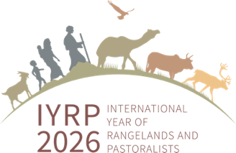

IYRP 2026 Global Action Plan – Executive Summary
The Global Alliance for the International Year of Rangelands and Pastoralists (IYRP) 2026 Action Plan outlines our comprehensive strategy to promote the sustainable management of rangelands and pastoralism at global, regional, national and local levels. Each of the 5 strategies is broken down into specific results, objectives, and activities, with levels of implementation and indicators of success to measure progress (https://iyrp.info/global-action-plan).

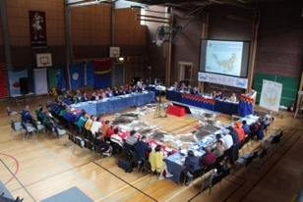
Strategy 1: Multistakeholder Coalition Building. A strong, effective, and durable global partnership can support rangelands and pastoralism. Establishing a multi-stakeholder coalition of countries under the leadership of the Mongolian Government is important to secure budgetary resources to engage with the FAO International Steering Committee, IYRP Global Alliance and the UNCCD. The IYRP Global Alliance will also be strengthened with resources to ensure flexibility and effectiveness in promoting IYRP 2026 at the global and regional scales and to respond to requests from the FAO International Steering Committee. Furthermore, pastoralists and civil society organizations will build partnerships and alliances to enhance knowledge transfer, visibility, and participation in decision-making processes. Pastoralists’ leadership ensures that their voices are reflected in its messaging, including the establishment of a pastoral caucus for the UNCCD, several global and regional gatherings of pastoralists, and capacity strengthening of existing coalitions such as WAMIP, the Global Pastoralist Youth Forum, the Central Asia Pastoralist Alliance, South Asia Pastoral Alliance, Rangelands Initiative Africa, among others.
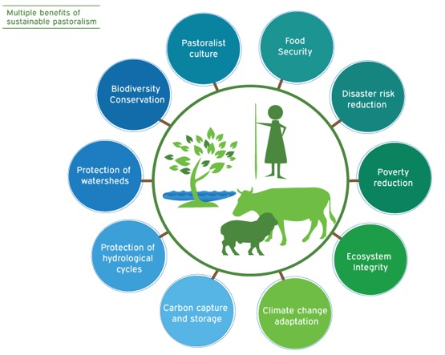
Strategy 2: Knowledge Generation. Knowledge about the state, extent, benefits, threats, and opportunities related to rangelands and pastoralism will be enhanced through evidence-based Working Groups, the launch of a global rangelands data platform, a conference on customary land rights, a pastoralist learning lab in the Horn of Africa, and a rangeland restoration champions initiative. Local knowledge, innovations, and best practices will be documented and shared, including translation of documents into local languages. In addition, mainstream policy frameworks will be encouraged to recognize the centrality of land tenure security for pastoralists as core to securing their future economic and environmental benefits. This will be accomplished through a partnership with the UNCCD to develop a specific module on securing land tenure for land degradation neutrality in rangelands. Key messages on rangelands and pastoralism for policy and advocacy will be disseminated ahead of IYRP 2026 through the Global Land Forum in Colombia and the International Rangeland Congress in Adelaide, Australian - both in June 2025, and the Pastoralist Week in August-September 2025. National and regional webinars and special papers will be disseminated, including MOOCs on pastoralism and rangelands and a white paper on pastoralism as a sustainable food system as well as another on the threat of rangeland conversion.
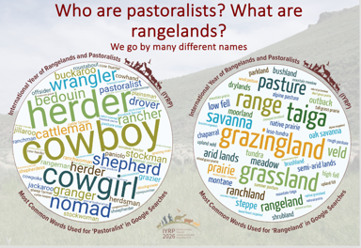
Strategy 3: Celebration & Awareness Raising. Common messages about the importance of rangelands and pastoralism in conserving biocultural diversity, tackling land degradation, fostering sustainable food systems, advancing climate action, and supporting socio-ecological resilience will be effectively communicated to key audiences using appropriate tools such as social media, websites, awards, declarations and other activities. Film festivals will be held, including the SRM North American Rangelands Film Festival. The IYRP Global Alliance will effectively communicate the 12 global monthly themes in 2026 at the global and regional levels, including through the voices of rangeland champions. Specific critical issues will be highlighted, such as a campaign for pastoral mobility. Evidence based pro-pastoralism image campaigns will be created with simple messages for social media, including children’s comics. Respected global, regional and national media outlets will carry positive coverage of IYRP 2026.
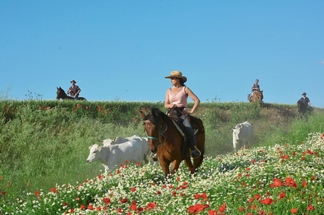
Strategy 4: Policy Advocacy over the next decade. The Global Alliance will collaborate with the Convention on Migratory Species and the Mountain Partnership Secretariat and its constituents including the Carpathian and Alpine Conventions. Policy advocacy will feature in events organized at major global conferences including the CBD COP 17, the UNCCD COP 17, the UNFCCC COP, the UNESCO (World Heritage and Intangible Heritage events), and the IUCN World Conservation Congress in 2025. Particular focus will be placed on the UNCCD COP 17 in Mongolia, including a trade fair for pastoralists, a field trip to Mongolian rangelands, advocacy for a resolution to establish a dedicated fund for rangeland restoration and pastoralism, and advocacy for the establishment of an International Day of Rangelands & Pastoralists. In all these events, the aim is to pass resolutions and declarations supported by both governments and pastoralists, to promote the sustainability of rangelands and pastoral livelihoods, native vegetation conservation, and the protection of rangelands from conversion and degradation. An increase in the number of new government policies is needed that focus on healthy rangelands and pastoralist rights, including restricting afforestation of rangelands and protecting pastoralist migration routes, provision of social (health, education), economic (insurance, finance, markets, balanced subsidies), and production infrastructure and services (internet, renewable energy, livestock movement corridors and bridges, veterinary support).
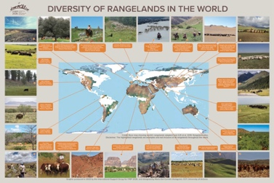
Strategy 5: Appropriate Investment for rangelands and pastoralists. In the past, there have been inappropriate investments such as forced sedentarisation, introduction of invasive species for soil and water conservation, privatisation of resources, and badly planned water point development. The year will be an important time of reflection on past and current investments, correcting our mistakes, better planning for investment in the future, and mobilising public and private sector funds for such investments that respond to needs while doing no harm. The development of a global rangelands standard and supporting monitoring system, overseen by a Rangelands Stewardship Council, is one primary focus. Other actions include donor-government-pastoralist roundtables, private sector targeted round tables on rangelands and pastoralist value chain investments, visibility raising of rangelands and pastoralists at the GLF 2025 and 2026 Business Investment Symposium, launch of UNFSS Coalition on Pastoralism as a Sustainable Food System at Addis Ababa in July 2025, and exchange of experiences among pastoralist entrepreneurs on good investments in rangelands and pastoral production.
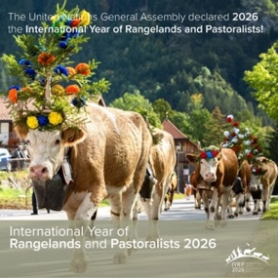

Support the implementation of the IYRP 2026
Global Alliance Action Plan

