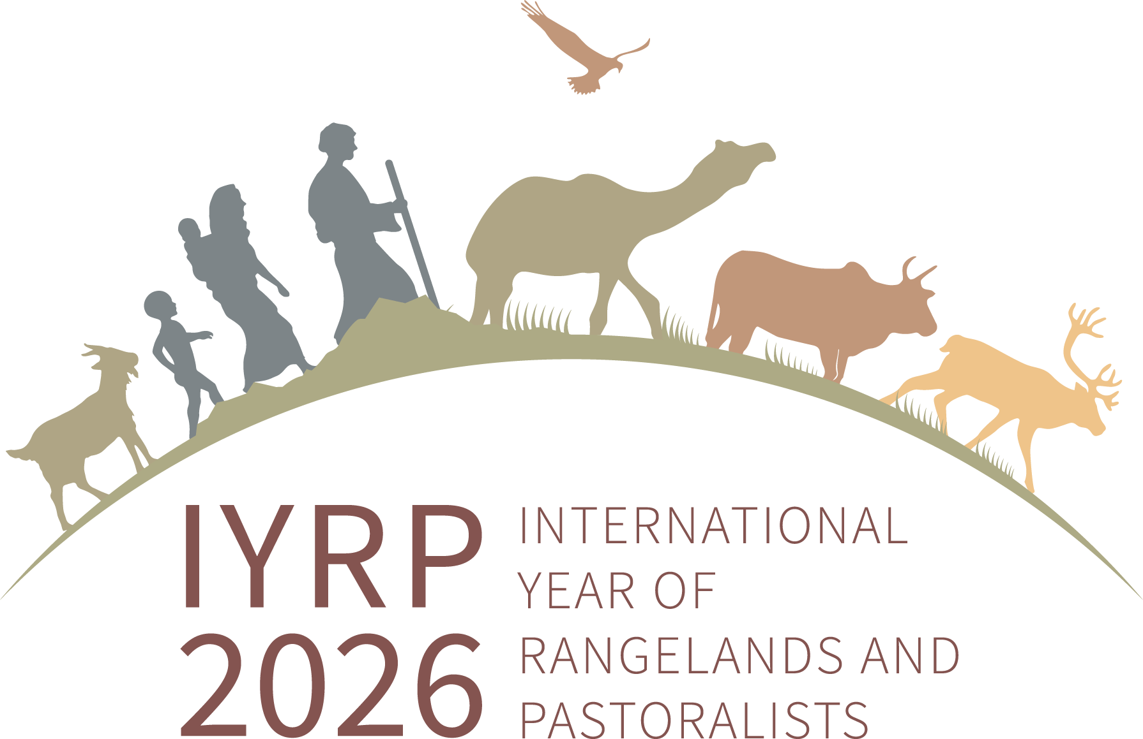
Members and email addresses of the Global Secretariat of the IYRP coalition
(as of 1 February 2024)
(preferred name underlined)

Co-chairs of the IYRP coalition:
(Ms) Burmaa Dashbel, Mongolia (d.burmaa.1@gmail.com)
Carlos Enrique Michaud, Peru (enrique.michaud@gmail.com)
Igshaan Samuels, South Africa (isamuels@uwc.ac.za)

Working Group coordinator:
Jonathan Davies, UK (jonathantilstonedavies@gmail.com)

Website and listserv coordinators:
(Ms) Barbara Hutchinson, USA (barbarah@cals.arizona.edu)
(Ms) Ann Waters-Bayer, Germany (waters-bayer@web.de)

Communications advisors:
Abdul Wahid Khan, UK/Pakistan (abdul.khan@ouce.ox.ac.uk)
Engin Yilmaz, Turkey (engin@yolda.org.tr)

Senior advisor (former co-chair):
(Ms) Maryam Niamir-Fuller, USA (mniafull2@gmail.com)

