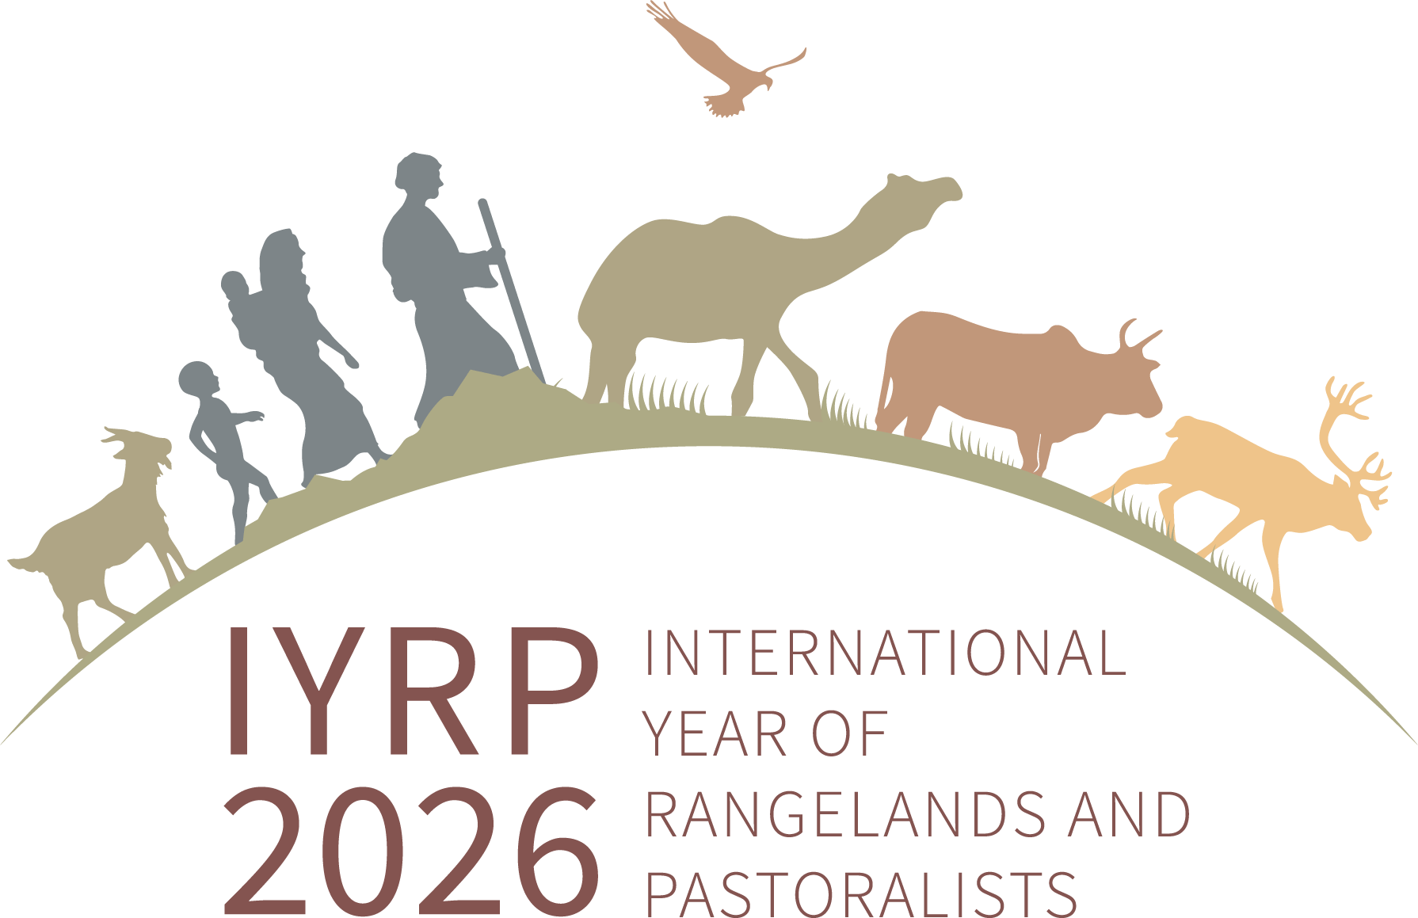

Regional IYRP Support Group (RISG) chairs/facilitators and email addresses
(as of 7 July 2023)

Arctic: Anders Oskal (oskal@reindeercentre.org)
Australasia: (Ms) Dana Kelly (danammkelly@gmail.com)
Central Asia & Mongolia: Hijaba Ykhanbai (y.hijaba@gmail.com) & Hasrat Arjjumend (harjjumend@gmail.com)
East Asia: Ruijun Long (longrj@lzu.edu.cn), Han Guodong (nmghanguodong@163.com) & (Ms) Rong Yuping (rongyuping@cau.edu.cn)
Eastern & Southern Africa: (Ms) Andiswa Finca (fincaa@arc.agric.za), Ken Otieno (kenotieno@reconcile-ea.org), Loupa Pius (daahman89@gmail.com) & (Ms) Prisca Mugabe (phmugabe@gmail.com)
Europe: (Ms) Francesca Pasetti (fpasettib@gmail.com), (Ms) Zuriñe Alba Iglesias González (vincapervincalila@gmail.com) & Joseph Boussion (joseph.boussion@gmail.com)
Middle East & North Africa: Hossein Badripour (badripour@yahoo.com)
North America: Barry Irving (birving@ualberta.ca), David Borre (davborre@gmail.com) & Layne Coppock (layne.coppock@usu.edu)
South America & Caribbean: Pablo Frere (pablofrere@gmail.com), Pablo Manzano Baena (pablo.manzano.baena@gmail.com) & (Ms) Cecilia Turin (ceciturin@gmail.com)
South Asia: Arun Dixit (arunmdixit@gmail.com), Perumal Vivekanandan (vivekseva@gmail.com) & (Ms) Tatsama Motilal (tatsama.m27@gmail.com)
West & Central Africa: Harouna Abarchi (ab.harou@gmail.com) & (Ms) Serena Ferrari (serena.ferrari@cirad.fr)

Co-Chairs of IYRP Global Coordinating Group:
(Ms) Maryam Niamir-Fuller (mniafull2@gmail.com)
Igshaan Samuels (isamuels@uwc.ac.za)

