
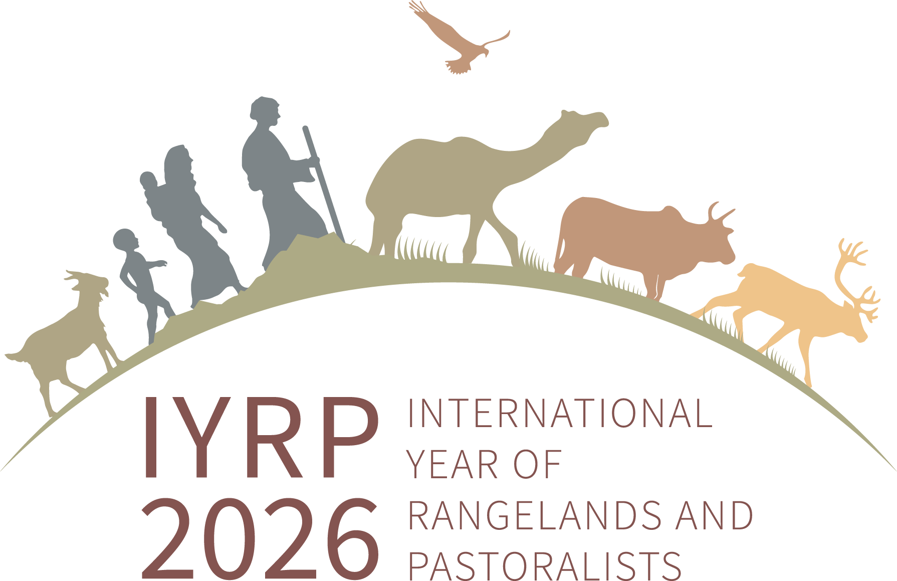
Awards for Pastoralists for Development of CPR / Pasture land & Conserving Local Breeds 2023
Criteria for Selection:
- Awards for Pastoralists, communities, local institutions Conserving Local Breeds and Development of Common Property Resources (CPR)/ Pasture land 2023 is being organized by SEVA in association with volunteers of Honey Bee Network, LIFE Network , Regional IYRP Support Group (RISG), for South Asia, Centre for Pastoralism- Sahjeevan, and National Bureau of Animal Genetic Resources. For selected pastoralists / communities who directly or indirectly responsible for their traditional wisdom, keeping local breeds and regeneration of range lands. Award prize of Rs. 15,000/- (182 USD) and certificate will be given. The award function place and date will be announced in course of time.
  - The merit of each pastoralist – his / their community role in breed conservation / breed development, contribution for restoring common property resources / pastureland management / best practices or innovation will be the criteria for evaluating entries.
  - For information on the previous 9 rounds of the award process, profiles of awardees kindly refer to the SEVA website http://www.sevango.in.

Last date for Submission :
The entries should be submitted only in the ‘Model proforma’ format enclosed. There are 2 types of proforma. For pastoralists conserving local breeds the proforma is separate from those apply for CPR / Pasture land development. One type of proforma shall be used depending upon the category they apply.
The last date for receipt of the completed applications is 31, August 2023.

Selection Committee :

  - Selection committee will include official nominee from NBAGR, Karnal and IGFRI, Jhansi. The decision of the selection committee will be final and binding.
  - Verification of claims will be undertaken for selected cases if it is needed with the help of few independent experts / scientists from universities etc.

- Proforma for submitting details on in-situ Breed Conservation
- Name of Pastoralist : ( Please attach a passport size photo )

- Full Address :

- Contact Phone, Mobile, Identity card No. & Email address :

- Family background including education, total area of land owned, number of animals (breeding males, females, young stock etc), name of community, life style /mobility etc :
(Detailed one-page information should be provided in a separate sheet)

- Details of Conservation of Livestock Breeds including the number of generations for which the breed is being maintained; a brief history of the breed being conserved; breed description , selection criteria for males and females, present status of the breed population; role of fore-fathers earlier generations in conservation and use of this breed

(Detailed 1-2 page information should be provided in a separate sheet. Few good quality photographs of the livestock breed along with the livestock keeper should be also provided).
- Achievements
[Practices or innovations followed by livestock keeper, any value addition of products and income earned in marketing, details of income derived through breed and rearer’s role in breed conservation or improvement and efforts in propagating the breed to other livestock keepers etc]
(Detailed 1-2 page information should be provided in a separate sheet)

Name & Signature of Person who prepares the application Signature of applicant

2. Proforma for Documentation of Pastoralists for contribution of Common Property Resources (CPR) and Pasture land development

- Name of Pastoralist/ community and Identity number
- Address & contact phone number
- No. of animals owned species wise & breed name
- Land area owned and crops grown.
- How many generations involved in livestock keeping
- How he contributed in CPR/ pasture land development
- Area of CPR / pasture land
- Name of CPR / Pasture land - specific name as called by local
communities & classification of land
- How many animals graze this area? How many families dependent on this area?
- Legal authority for the land / ownership
- What are all fodder species available ?
- Who manages the pasture land and how ?
- Any traditional / social institution/rules / regulations in the management of lands
- How he has contributed in the regeneration of CPR / pasture land
- –brief description needed (one page along with pictures)
- Status of pasture land after his intervention and number of animals being grazed and families benefitted.
- Any knowledge on herbal remedies for animals, nutritional value of fodder species, and management of CPR / Pasture land etc.
- Two references for his role in CPR / pasture land development

Name & Signature of Person who prepares the application Signature of applicant

Address for submission of Applications and Further queries:

- Mr. P. Vivekanandan,
Co -Chair-RISG- South Asia
SEVA,
45, T.P.M. Nagar,
Virattipathu, Madurai - 625 010.
Tamil Nadu. India
Mobile: 7708852334
E-mail: vivekseva@gmail.com

- Dr. Arun Mani Dixit
Chair-RISG- South Asia
Centre for Environment and Social Concerns (CESC)
A-307/308, Supath-II Complex,
Near Juna Vadaj Bus Stand,
Ashram Road, Ahmedabad- 380013
Gujarat, India
Ph. +91 79 29706323
Mob: 93743 37471
E-mail: arunmdixit@gmail.com

