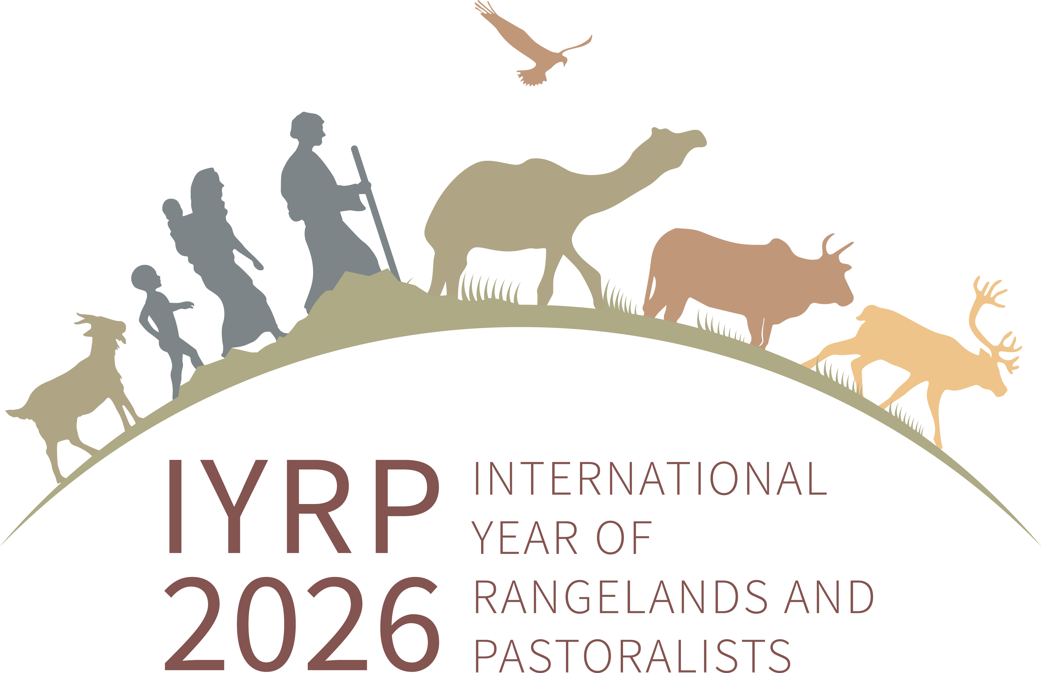

IYRP proposal outline for SNAPP 2022 application
(for upstream review by SNAPP)

Title: Busting old scientific myths to achieve global sustainability objectives and social innovation in rangelands
Goal: To dispel myths and misperceptions about rangelands and pastoralists so as to enable informed policies and investments for sustainability on over half of the Earth’s land surface
Objective: To increase availability and accessibility of evidence-based scientific information that can influence global, regional, national and local policy processes to promote sustainability of rangelands and pastoralism
Outcomes: Answers developed by three Working Groups, working in tandem and cross-referencing each other, to three sets of key questions:
- Are extensive pastoral livestock systems net carbon positive or negative, and how can they sustain rangeland carbon sinks and climate resilience?
- To what extent can sustainable pastoralism meet world demand for animal-based products?
- What are the key contributing factors that make sustainable pastoralism on rangelands a nature-based solution to deal with global socio-environmental challenges?
Expected impacts: Producing evidence-based counterarguments to the misperceptions about rangelands and pastoralists that have fueled inappropriate policies and investments will empower pastoralists and supporting organizations to advocate for meaningful support to and investment in rangelands and mobile pastoralism. The past and still current misconceptions have damaged rangeland ecosystems; increased pastoralist marginalization, displacement, conflict and poverty; and foreclosed opportunities for achieving sustainable development. The value of rangelands as a global carbon sink, sustainable source of food for a large part of humanity and promoter of biodiversity is underappreciated. The complex ecological functions of rangelands, and how pastoralists have adapted to them, are not understood. Therefore, policymakers make false assumptions around how to best utilize the rangelands, or they undercut the potential of pastoralism for both achieving food security and meeting the world demand for animal-based products.
These misperceptions persist despite scientific evidence to the contrary. The International Year of Rangelands and Pastoralists (IYRP) Working Groups are expected to consolidate and verify the evidence around a key topic and present them in a policy-friendly manner for adoption at global, regional, national and local levels. For example, in 2022, the IYRP Working Group on Afforestation in Rangelands created a Policy Note addressing the risks and shortcomings of the Voluntary Carbon Market (VCM), as a contribution to the work of the Integrity Council for the VCM. Each of the Working Groups under this SNAPP proposal is expected, in a similar fashion, to influence and impact global and national processes.
The combined impact of these three Working Groups will help increase understanding of and appreciation for rangelands and pastoralism. This in turn will help increase supportive actions through appropriately modified policies and investments, resulting in protection from conversion, increased carbon sequestration and sinks, increased safeguarding of biodiversity, and more sustainable food systems. In order to bust old scientific myths, it is important that not only policymakers but also pastoralists and other members of civil society learn about how pastoral livestock systems are net carbon positive.
In addition, the combined process of these three and other IYRP Working Groups will help break down the Tower of Babel encompassing terms and concepts currently used to describe rangelands and pastoralism around the world. Rangelands occur on all continents (except Antarctica) and span multiple countries, languages and cultures. This vast social and ecological heterogeneity creates challenges for effective communication in support of global rangeland stewardship in the 21st Century. An internationally accepted set of critical rangeland concepts would represent a major advance toward resolving this challenge. It would create a framework of definitions, with supporting justification, examples and explanations for regional/cultural variation, focusing on a global assessment of current, widely used concepts (e.g. resilience, non-equilibrium, hybrid governance, ecosystem services, local knowledge, regenerative agriculture, carbon sequestration potential). In some cases, conventional terms and concepts will be updated (e.g. rangelands, carrying capacity).
Working Group partners: Each Working Group will gather expertise in its specific area (potential team members listed below are likely but still to be confirmed). In addition, there will be a small Coordinating Team consisting of partners spanning all three topics, who will ensure consistency and relevance across the three groups. The Coordinating Team’s main tasks are to strategize and develop the pathways for disseminating the results of each Working Group, and to resolve any contradictions in definitions and terms. The confirmed members of the Coordinating Team are: Co-chairs of the IYRP International Support Group (ISG); Agrecol/Coalition of European Lobbies for East African Pastoralism; WCS-Mongolia; and UNDP. The lead institution of each of the three Working Groups will sit on the Coordinating Team as well. Other organizations that are in the IYRP network (300+ organizations) will be invited to participate in any of the groups based on their interest and expertise.
Urgency: The spread of myths and misperceptions about rangelands and pastoralism seems to be building up. As more attention is paid to the climate and biodiversity crises, these misperceptions make it more difficult to find sustainable solutions. The IYRP ISG works to bust these myths by providing science-based evidence, with the aim of achieving a major breakthrough by 2026. This SNAPP funding would spur the IYRP Working Groups to complete their work by 2024, so as to give the time necessary for the IYRP ISG to prepare and disseminate the information globally and locally by 2026.
Overall budget: This proposal for SNAPP funding is meant to complement other resources that the IYRP ISG can leverage. The SNAPP funding will enable the timely functioning of the Working Groups and delivery of the necessary outputs. IYRP ISG members will cover costs that are not covered by SNAPP, and will also leverage other funds for the costs of dissemination of the outputs. The overall budget being asked from SNAPP is estimated at $135,000.
A brief description of each IYRP Working Group follows.

WORKING GROUP 1: Pastoral livestock systems, carbon sinks and climate resilience
Key question: Are extensive pastoral livestock systems net carbon positive or negative, and how can they sustain rangeland carbon sinks and climate resilience?
Brief description: The currently misaligned paradigm is that pastoralism is net negative and therefore rangelands needs to be protected from fire, feed needs to be managed so that livestock produce less methane, rangelands need to be ploughed up and planted with improved grasses for optimal production of animals, and humanity has to move to a vegan diet or eat plant-based “meats”. But there is evidence to the contrary. PASTRES (Pastoralism, Uncertainty, Resilience: a research program run by the Institute of Development Studies, Sussex, UK) in particular has highlighted the key issues and called for more data collection, scientific analysis and using a system-based approach to the issue. Through many case studies, arguments have been presented that livestock mobility promotes rangeland restoration and climate resilience. This Working Group will collect and collate scientific evidence. In so doing, it will address a second key question: To what extent and in which circumstances and how can mobility of livestock be a tool for rangeland restoration and greater climate resilience? If pastoral rangelands are indeed net positive, the third question to be addressed is: Are carbon credits good for pastoralists? This question will be answered by focusing on the experiences of pastoralists with carbon markets in different regions in the world. The work of this Group is directly relevant to SNAPP’s focus area on Climate Resilience.
Expected outputs: A full peer-reviewed paper; several ancillary policy notes and fact sheets; a user-friendly guideline/training material describing how pastoral livestock systems are net carbon positive and key roles of pastoralists to maintain carbon sinks, how pastoralist can estimate carbon stocks on their lands, and protocols on how pastoralists can be involved in carbon markets/credits; a film interviewing pastoralists about their experiences with carbon credits.
Expected usage and dissemination of outputs: The results of this Working Group would be used to inform the various UNFCCC processes, including a webinar timed for COP 28 to be hosted by the Government of Mongolia, and a webinar for the scientists/ authors engaged with IPCC’s work on carbon and methane methodology. Results will also be incorporated into the development of standards for certification of rangeland-carbon and rangeland-friendly products currently being tackled by several actors such as the Integrity Council of the VCM and the Sustainable Fibre Alliance’s launch of the Rangeland Stewardship Council.
Potential team members: PASTRES, Institute of Development Studies, UK; Basque Center for Climate Change; ILRI; ICARDA; Oxford University; Colorado State University; RECONCILE, Kenya; Rhodes University, South Africa; University of Nevada; and others.
Budget overview: To cover one research assistant; a journalist to interview pastoralists about carbon credits and prepare film and media materials; cost of development of training materials by experts in pastoralism education and translation; costs of two in-person meetings of Working Group members. Estimated cost is $60,000.

WORKING GROUP 2 : Pastoral systems and world food demand
Key question: To what extent can sustainable pastoralism meet world demand for animal-based products?
Brief description: With relevance to SNAPP’s Food and Freshwater window, this IYRP Working Group would use the IYRP’s concept note for the UN Food Systems Summit (UNFSS) "game changer idea" of 2021 as a basis for sustainable interventions. The focus would be on the question of whether and how extensive pastoral systems could contribute to meeting world demand for meat, milk and other animal products sustainably without degrading rangelands, including grasslands, while reducing reliance on commercial intensive production. The current paradigm maintains that nature-based pastoral systems will not be able to meet world demand and, therefore, more investment needs to be put towards making industrial-scale livestock systems more sustainable. The paradigm extends to those who see livestock as the main cause of land degradation. However, this does not take into account the magnitude of the informal sector and local markets for pastoral products, nor the impacts of drivers such as rangeland encroachment and subsidies for cheap imports in building barriers for sustainable pastoral production. Other parameters to consider would be: food waste, changes in diets, and market demand for niche products such as camel milk for diabetes. Due to the magnitude of this task, the Working Group would include modelers to develop different demand-and-supply models under different scenarios. The work would focus on meat and milk (and therefore food security), but could also incorporate fibres, leather and other products to assess the full economic value of sustainable pastoral systems in different regions and contexts.
Expected outputs: A full paper; several ancillary policy notes and fact sheets; an interactive online map, or a scenario-playing game useful for disseminating results.
Expected usage and dissemination of outputs: Results of the model would be a critical addition to the UNFSS follow-up processes in promoting sustainable pastoralism, such as the Grasslands, Savannahs and Rangelands Coalition that was established at the UNCCD in March 2022, and which will engage with governments and other stakeholders during both CBD and UNCCD events in 2023–2024. It would also be a contribution, through dedicated sessions and panels, to initiatives focusing on moving intensive livestock production towards sustainability, such as by the Global Alliance for Sustainable Livestock (GASL).
Potential team members: Signatories of the IYRP Game Changing Solutions submitted to UNFSS in 2021, including: Association Française de Pastoralisme (France); Global Diversity Foundation, UK; League for Pastoral Peoples; International Institute for Environment and Development; as well as other experts from IFPRI, CIRAD, SNV etc.
Budget overview: To cover one research assistant, and one communications expert to build map or online game; costs of two in-person meetings of Working Group members. Estimated budget of $35,000.

WORKING GROUP 3: Pastoralism as a nature-based solution
Key question: What makes pastoralism on rangelands a nature-based solution to deal with global socio-environmental challenges?
Brief description: The biodiversity community has only recently focused on OECMs (Other Effective area-based Conservation Measures) as part of the 30x30 targets. Within that dialogue and discourse, pastoralism and rangelands continue to be either left behind or lumped in with crop farming. Being left behind reflects a lack of appreciation of the significance and importance of rangelands for biodiversity conservation. As a result, many governments perceive the conversion of rangelands into strictly protected areas and ripe for afforestation and plantations, as a way to reach their 2030 targets. This leads to massive disruption to pastoralists’ livelihoods and cultures (e.g. the eviction of Maasai from the Ngorongoro Crater) and does not improve rangeland health.
Being lumped in with crop farming, and labeled solely as a “production” landscape, is a massive loss of opportunity for achieving OECM through nature-based solutions. Unlike most cropping systems, rangelands and pastoral systems are in fact “net positive landscapes”, because a) grasslands and other rangelands are grazing dependent to maintain their health and biodiversity, b) pastoral systems are not extractive but rather, through depositing manure, return nutrients to the soil, and c) the mobility of livestock in most pastoral systems mimics that of wildlife and allows natural regeneration of these ecosystems.
This Working Group will answer four main questions: What are the key contributing elements of pastoral systems that render them as an OECM? How can our improved knowledge of rangelands and pastoralism, including customary and local governance systems, better leverage nature-based solutions? What are the value chains related to pastoralists’ products and services that can result from promoting their nature-based solutions? If pastoralism and rangelands are both ‘natural ecosystems’ and ‘production systems’, then do they need a new OECM category? This Working Group will build on the IYRP Cancun Declaration, pull together the scientific underpinning of these counter-arguments and develop a policy paper that will be disseminated to all concerned. The outputs will be relevant to SNAPP’s focus on Food and Freshwater, as well as on Social Innovations.
Expected outputs: A full paper; several ancillary policy notes and fact sheets; training manual/guideline for pastoralists; a film of examples of nature-based solutions in rangelands.
Expected usage and dissemination of outputs: The policy notes and fact sheets will be disseminated in events related to the development of the CBD Post-2020 Targets, as well as contribute to the further refinement of the concept of OECMs. They will also be disseminated to relevant meetings of the Intergovernmental Panel on Biodiversity and Ecosystem Services (IPBES) and the Convention on Migratory Species (CMS) processes in 2023–2025. In addition to helping policymakers better understand rangelands and pastoral systems, the outputs will also be tailored to helping pastoralists themselves counteract the old myths and better understand their own contributions to a global society and a healthy planet.
Potential team members: Yolda Initiative, Turkey; IUCN; Universidad Nacional Autónoma de México; PastorAmericas; UNEP; WWF and other partners in the Grasslands, Savannahs & Rangelands Coalition.
Budget overview: To cover one research assistant, costs of two in-person meetings of Working Group members, and production of multi-media materials for dissemination. Estimated cost of $40,000.

