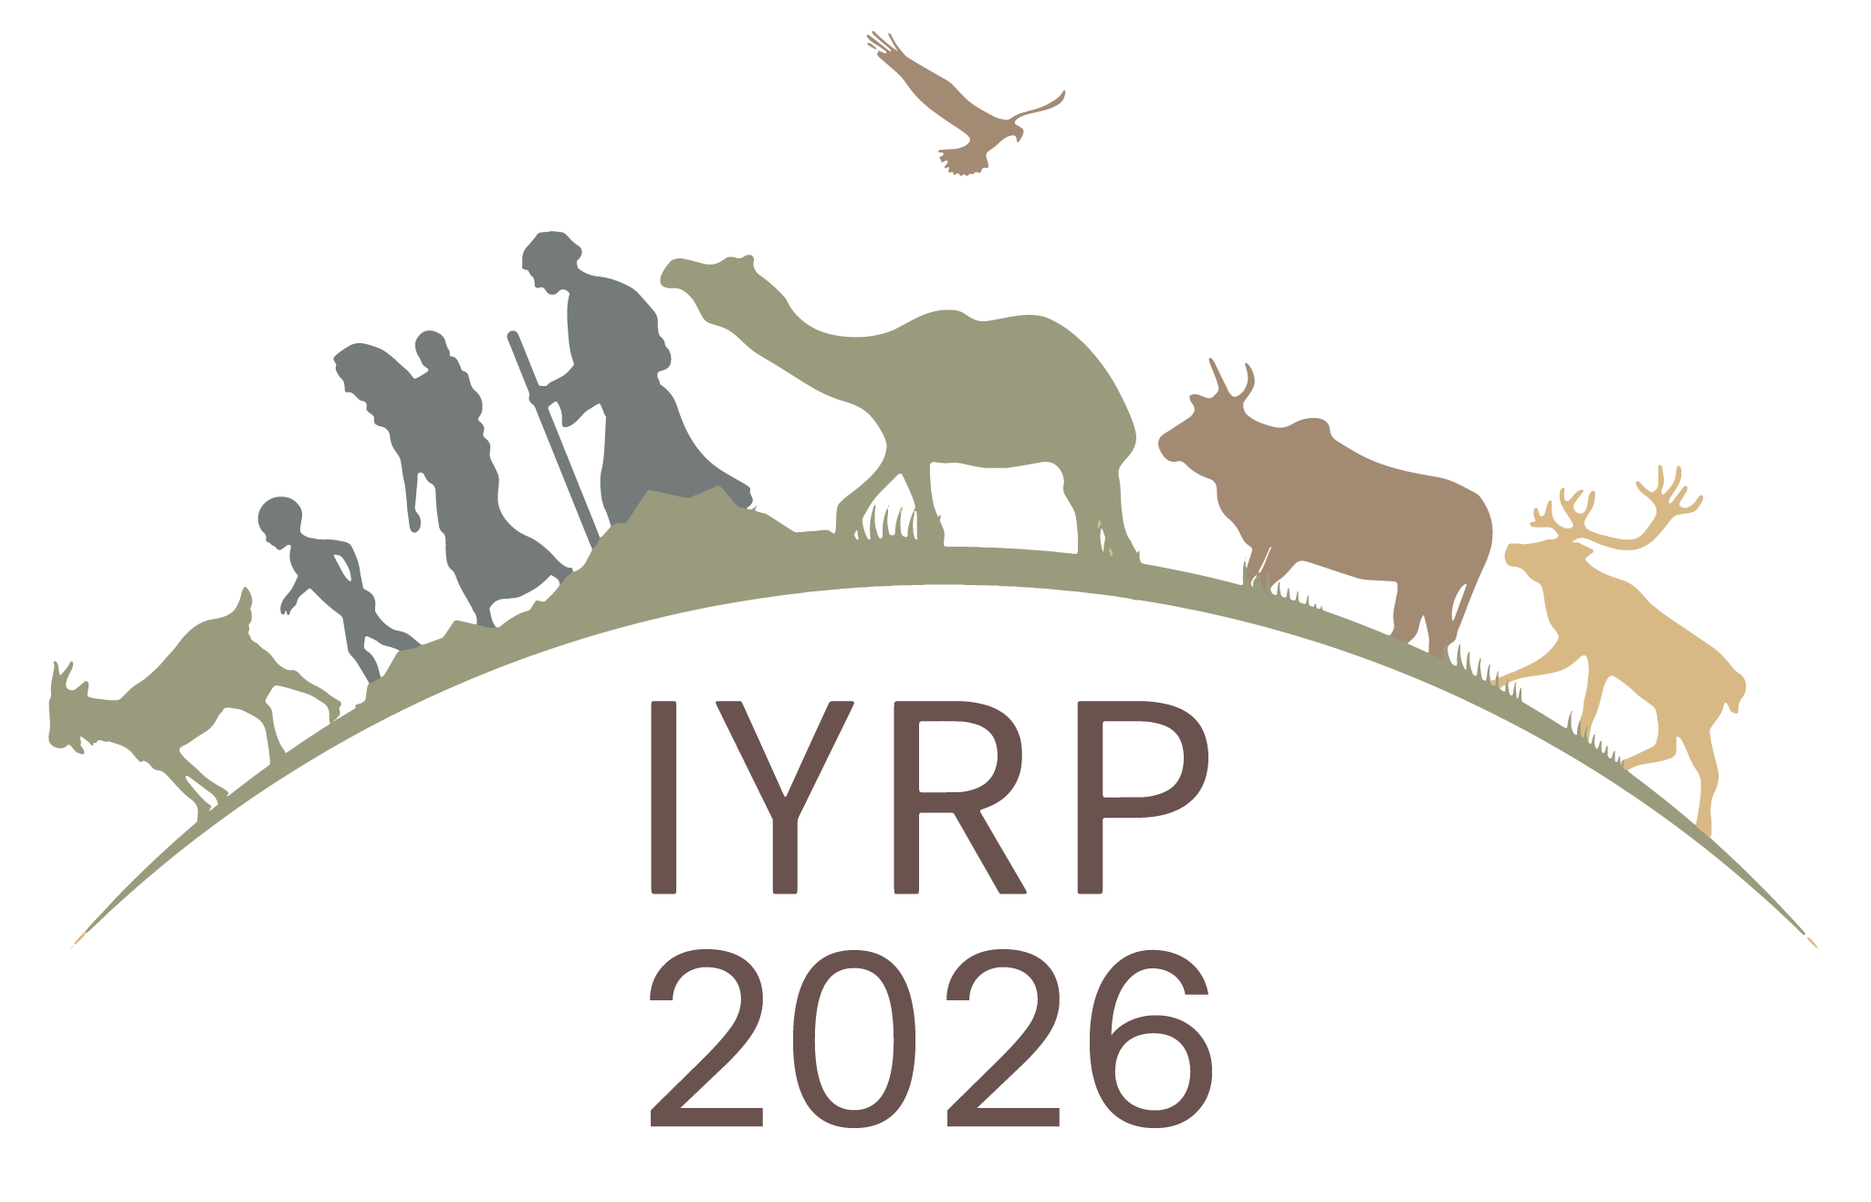

Regional IYRP Support Group (RISG) chairs/facilitators and email addresses
(as of 21 July 2022)

Arctic: Anders Oskal (oskal@reindeercentre.org)
Australasia: (Ms) Sarah McDonald (sarah.mcdonald@dpi.nsw.gov.au)
Central Asia & Mongolia: Hijaba Ykhanbai (y.hijaba@gmail.com) & (Ms) Kuluipa Akhmatova (kuluipa.kg@gmail.com)
East Asia: Ruijin Long (longrj@lzu.edu.cn), Han Guodong (nmghanguodong@163.com) & (Ms) Rong Yuping (rongyuping@cau.edu.cn)
Eastern & Southern Africa: (Ms) Andiswa Finca (fincaa@arc.agric.za), Ken Otieno (kenotieno@reconcile-ea.org), Loupa Pius (daahman89@gmail.com) & (Ms) Prisca Mugabe (phmugabe@gmail.com)
Europe: Engin Yilmaz (engin@bican.net) & Olivier Maurin (o.maurin64@gmail.com)
Middle East & North Africa: Hossein Badripour (badripour@yahoo.com)
North America: Barry Irving (birving@ualberta.ca), Jürgen Hoth (jurgenhoth1521@gmail.com) & Layne Coppock (layne.coppock@usu.edu)
South America & Caribbean: Pablo Frere (pablofrere@gmail.com) & Pablo Manzano Baena (pablo.manzano.baena@gmail.com)
South Asia: Devinder K Sadana (sadana.dk@gmail.com)
West & Central Africa: Harouna Abarchi (ab.harou@gmail.com)

Co-Chairs of IYRP Global Coordinating Group:
Maryam Niamir-Fuller (mniafull2@gmail.com)
Igshaan Samuels (isamuels@uwc.ac.za)

