Outreach to pastoralist groups in remote areas
Prepared by Jürgen Hoth, 2022 05 07

Goal
- Develop a strategy to raise funds to help to reach out to pastoralist groups in remote areas (Anders Oskal)

- Work group: Anders, Hijaba, Jürgen and Maryam

Key proposed Items
1. Name and overall size of the pastoralist group
2. Geographic distribution
3. Main activity that needs to be supported and how would be implemented
4. Amount required
5. Periodicity (permanent, seasonal, or event-based e.g. annual meeting, etc.)

Response 8/11 RISG regions

- Arctic
- Australasia
- Central Asia & Mongolia
- East Asia
  - Inner Mongolia
- Eastern and Southern Africa
- Middle East & N Africa
- Central Asia & Mongolia
- South Asia
- Western & Central Africa

- WAMIP

Integrated Matrix (under review)

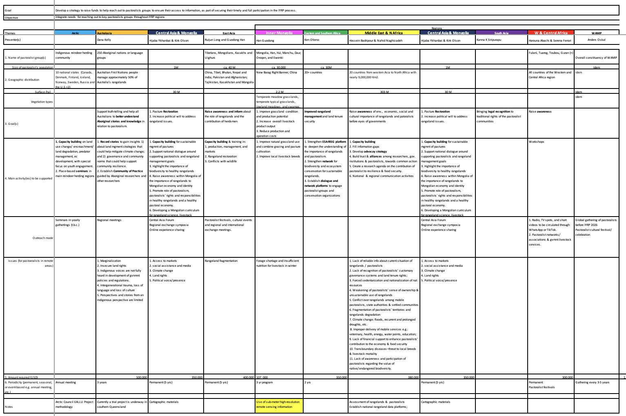

Name and overall size of the pastoralist groups
- Hundreds of groups per region

Main identified goals
- Improve rangeland management
- Bring legal recognition to the traditional rights of pastoralist communities
- Raise awareness about the role of rangelands and the contribution of herders
- Importance of traditional culture through their stories and knowledge

Main Issues
1. Lack of reliable info about current situation of rangelands / pastoralists
2. Lack of recognition of pastoralists’ customary governance systems and land tenure rights;
3. Forced sedentarization and nationalization of natural resources
4. Weakening of pastoralists’ sense of ownership & unsustainable use of rangelands
5. Conflict over rangelands among mobile pastoralists, state authorities & settled communities
6. Fragmentation of pastoralists’ territories and rangelands degradation
7. Climate change: floods, recurrent and prolonged droughts, etc.
8. Improper delivery of mobile services e.g.: veterinary, health, energy, water points, education;
9. Lack of financial support to enhance pastoralists’ contribution to the economy & food security
10. Transboundary diseases–threat to local breeds & livestock mortality
11. Lack of awareness and participation of pastoralists regarding the value of native/endangered biodiversity.

Outreach mode
Who: Pastoralist networks/ associations & gvmnt livestock services.
How: Pastoralist festivals, cultural events and regional and international exchange meetings Radio, TV spots, and short videos to be circulated through WhatsApp or TikTok.

Amount and periodicity
Avg funding requested: &350,000 USD for 3-5 yrs. Overall: $4-5 M USD

Notes
- Assessment of rangelands & pastoralists and establish national rangeland data platforms
- Arctic Council EALLU Project methodology

Summary
- Good input that can be used according to the interests of donors
- This seems more the foundation for a Communication strategy 2022-2026
- Form a Fund-raising Committee
- We would like to hear from all regions, but we can start with what we have.

Next steps related to outreach and fundraising
- Send outreach matrix to all RISG Coordinators (Updated RISG directory?)
- Complete Input from all 11/11 regions: deadline
- RISG map (FAO?)
- Integrate the Fundraising team (contact jurgenhoth1521@gmail.com)

…about the rangeland map

Olson, et al., 2001. Terrestrial ecoregions of the world: a new map of life on Earth. Bioscience 51(11):933-938. www.worldwildlife.org/publications/terrestrial-ecoregions-of-the-world

