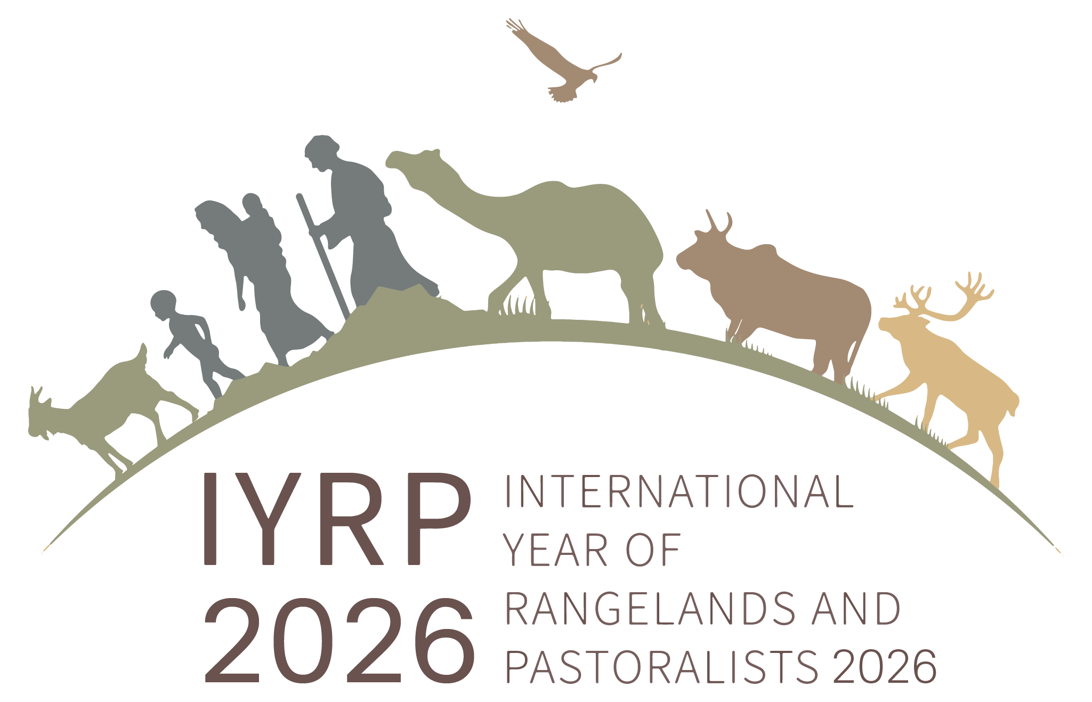
Common statements on Stockholm+50 Background documents from the International Support Group of the
International Year of Rangelands and Pastoralists (2026)

LD1 Background Document: Reflecting on the urgent need for actions to achieve a healthy planet and prosperity of all
- A key fundament for action must be a human rights-based approach, leaving no one behind.
- Pastoral systems are biodiverse and provide a multitude of ecosystem services such as being the sink for one third of the world’s total soil carbon. Pastoral rangelands require protection from indiscriminate conversion and encroachment and, in some places, would benefit from ecosystem restoration to ensure sustainable food security for millions of people whilst providing 46% of the world’s supply of meat, milk and fiber.
- Pastoralism can co-exist with renewable energy production as mutually beneficial land uses only if participatory planning and fair benefit sharing are negotiated from the outset, pastoralists’ traditional knowledge is properly included and indigenous peoples´ rights are respected.
- Existing inequalities and neglect of pastoralists must be eliminated to achieve prosperity, rights and dignity for all and to attain the intrinsic ecological value of the rangelands they manage.
- Pastoralists produce high-quality proteins that are chemical-free and nature-based, often from areas that are not suitable for other forms of food production; access to these products needs to be increased, and intensive and ecologically harmful industrial livestock systems need to be transformed towards full sustainability.

LD2 Background Document: Achieving a sustainable and inclusive recovery from the COVID-19 pandemic
- Achieving a sustainable and inclusive recovery from the pandemic means negating the false narrative that pastoralists and their livestock were to blame for the pandemic. Funding for research to detect and monitor zoonotic events should be increased and findings should be available in real time to prepare for future pandemics.
- Policies that promote transparency and disclosure, certification of animal products from nature-based pastoral systems, balancing of unfair subsidies for the industrial livestock sector and other competing land-use sectors, and enforcing environmental standards and regulations will help pastoralists increase their economic and social resilience and recover from the pandemic.

LD3 Background Document: Accelerating the implementation of the environmental dimension of Sustainable Development in the context of the Decade of Action
- Protecting and restoring grazing-dependent natural rangeland ecosystems will increase soil carbon storage up to 70 t/ha and allow for a sustainable increase in animal production whilst concomitantly fostering social justice in the face of climate change.
- Mobile pastoral systems are proxies for historic migratory wildlife and thus continue to provide valuable ecosystem services such as seed dispersal and landscape structuring. Many crops depend on livestock for providing manure in the recycling of organic matter and the restoration of soil fertility. Mobile pastoralism is an agro-ecological way of producing food and an ideal entry point for scaling up nature-positive production and regenerating ecosystems.
- Mobile pastoralism plays an important role in nature conservation; creating meaningful dialogue between conservation interests and pastoralists, including pastoralist traditional knowledge, would accelerate the protection and expansion of bio-cultural landscapes with broader significance.
- Pastoralists lack access to fair and equitable markets for their products and have to compete with subsidized livestock products, imported or domestic. Converting some of these unfair subsidies into financing for sustainable pastoral infrastructure, value addition and mobile social services will promote fair and competitive markets.
- Pastoralists have historically lived with climate variability and developed traditional management solutions adapted to such variability. In this century, their rangelands are some of the most exposed to climate change. Re-thinking climate financing to include traditional and small-scale livestock keepers is key to achieving resilience against climate hazards.
- Traditional and indigenous pastoral institutions contribute positively to the governance of rangeland resources; thus, reforms of institutions and policies must also include protection of indigenous rights to self-governance of their natural resources.

