Presented by Ruijun Long and Guodong Han, East Asia RISG

East Asia RISG – IYRP

Name and overall size of the pastoralist group
Transhumant mobile pastoralists of the Qinghai-Tibet Plateau and Mongolian- Xinjiang Plateau, such as Tibetans, Mongolians, Kazakhs and Uighurs etc. in the North and West China. Around 40 million people.

Geographic distribution
Among the ethnic groups mentioned above are mainly distributed in the North and West China. Tibetans are mainly distributed in the Qinghai Tibet Plateau, which is adjacent to Bhutan, Nepal and India in the south. Kazak and Uygur are mainly distributed in Xinjiang Autonomous Region, the west of Xinjiang is connected with South Asian countries such as Pakistan and Afghanistan, as well as Central Asian countries, such as Tajikistan and Kazakhstan. Mongols are mainly distributed in Inner Mongolia Autonomous Region, which is connected with Mongolia in the north.
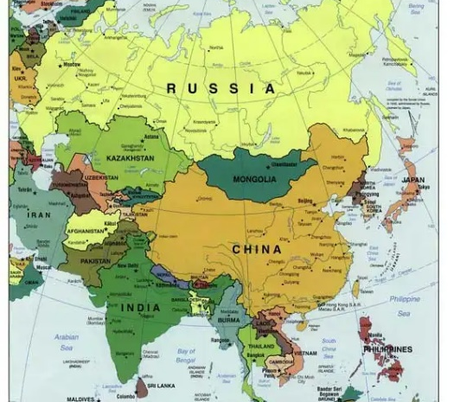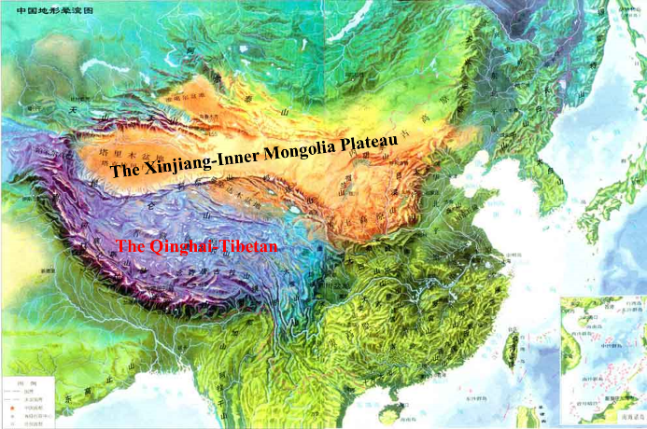

Main activity that needs to be supported and how would be implemented
Since the 1980s, rangeland pastoral areas have implemented the Household Contract Responsibility System, and herdsmen have been assigned their own rangelands and livestock, but only the right to use the grassland without ownership. Grazing is mainly carried out in rotation in four seasons (transhumance among the winter, Spring, Summer and Autumn pastures), and the winter pastures are basically fenced. After more than 40 years of grazing production and management, it is found that single household grazing management cannot give full play to the production efficiency of rangeland ecosystem, and has encountered many difficulties in pastoralism management. Therefore, an innovative system is curried out in many pastoral regions, that is several herdsmen or community herdsmen began to form cooperatives to deal with their grazing production and management based on a large landscape of resources, demolishing unreasonable fences, and managing different herds according to physiological and production needs, achieving to save costs and labors, and the surplus labor force could go out to work, increasing income.
1) Awareness-raising and information missions of the role of rangeland and the contribution of herdsmen in different regions will be carried out. Workshops and pastoralist festivals will be organized with the support of pastoralist networks. All materials will be translated into local languages.
2) Provide technical guidance and training for the cooperatives and youth in pastoralism production, management, products and markets.
3) Guide herdsmen to repair degraded rangelands, increase supplementary feeding in cold season, improve livestock nutrition, emphasize the individual production capacity of livestock, reduce the number of livestock and avoid the pressure of overgrazing.
4) Help herdsmen deal with and solve the contradiction between livestock and wild animals competing for grassland resources.

Amount required
Total amount of required funding is 400,000 USD.

Periodicity (permanent, seasonal, or event-based e.g. annual meeting, etc.)
These activities will be permanent for the period up to 5 years, with seasonal/annual event based on the pastoralist festivals, other cultural events and regional and international exchange meetings.

