Eastern and Southern Africa-RISG IYRP proposal.

Background
After the UN General Assembly at its Plenary Meeting on 28 February 2022, adopted the resolution that was initiated and spearheaded by Mongolia, and supported by 60 Member States representing all regions of the world, 2026 was declared the International Year of Rangelands and Pastoralists. This declaration is significant and is a true reflection of the important that healthy rangelands play in creating a sustainable environment, economic growth and resilient livelihoods for pastoralists and other indigenous communities across the world who depend on rangelands resources. The ESA-RISG presents a platform that would support creating momentum through different pastoralist groups and networks to amplify the local voices and promote advocacy at regional and global levels through such platforms. This initiative is important in a context where rangeland degradation has implications to ecosystem services, especially provisioning and regulating services, affects livelihood vulnerability, increased conflict and loss in biodiversity.

Name and overall size of the pastoralist group
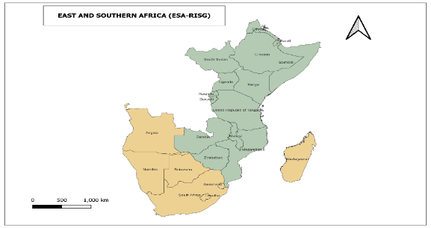
Eastern and Southern Pastoralists of are part of the Sub-Saharan pastoralists estimated to be 268 million people (FAO 2018) ESA-RISG will focus of approximately 30 million spread across countries (to be defined later)

Geographic distribution

Strategic Objective: Improved rangeland management and tenure security for ESA-RISG.

Main activity that needs to be supported and how would be implemented
Activity 1: Strengthening ESA-RISG platform to create awareness on the IYRP and deepen the understanding of the importance of rangelands and pastoralism.
Activity 2: Strengthen network for biodiversity and ecosystem conservation for sustainable rangelands.
Activity 3: Establishment of dialogue and network platforms to engage pastoralist groups and conservation organizations

Period
2 years

Amount Required
350, 000 USD

