Presented by Harouna Abachi and Serena Ferrari, RISG West & Central Africa

Western and Central Africa RISG – IYRP

Name and overall size of the pastoralist group
Transhumant mobile pastoralists of West and Central Africa, such as Fulani, Tuareg, Toubou, Guran, etc. Around 40 million people.

Geographic distribution
All countries of the Western and Central Africa region

Main activity that needs to be supported and how would be implemented
Many pastoralist communities of the region are and feel marginalized, since they live in remote areas often with no network and internet coverage. It is fundamental to reach out to these communities and make them involved in the set-up of the IYRP. Awareness-raising and information missions in the different countries should be carried out, with as an entry point pastoralist associations and government livestock services. Workshops could be organized with the support of pastoralist networks. Further, this could be done by disseminating information on the Year via radio, TV spots, and short videos to be circulated through WhatsApp or TicToc. The information channeled through radio and TV would be more accessible for everybody, including elder people: in particular, radio emissions would reach out to those very remote areas which have no access to electricity. WhatsApp and TicToc videos would target in particular the youth. Every kind of material should be translated into local languages

Amount required
300,000 $

Periodicity (permanent, seasonal, or event-based e.g. annual meeting, etc.)
This activity should be permanent, but must above all be concentrated on certain times of the year, namely the periods and areas of concentration of pastoralists, such as pastoralist festivals.

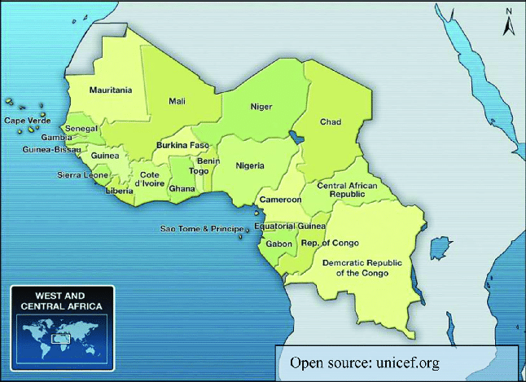
(Note from JH: Please add priority regions.)

