 | 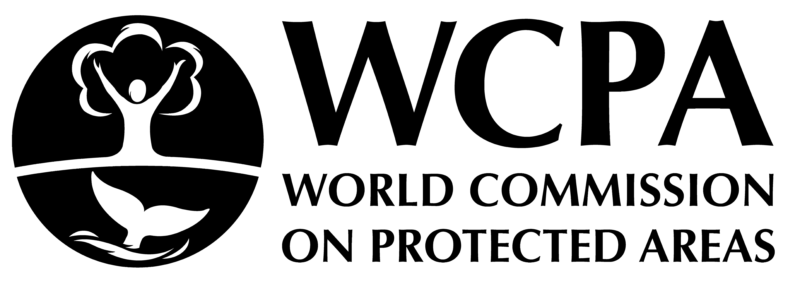 | 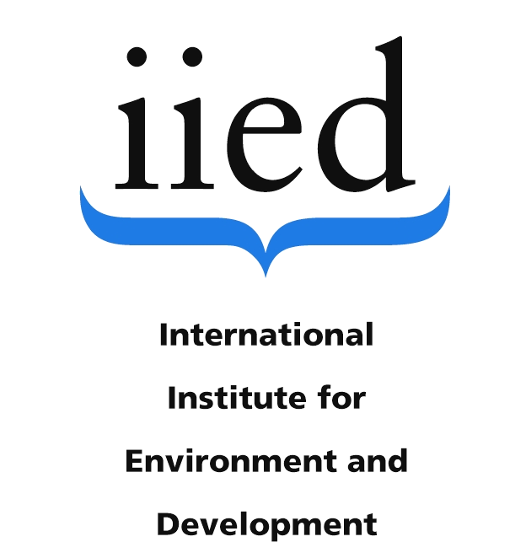 | 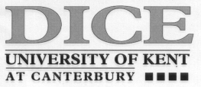 |  | 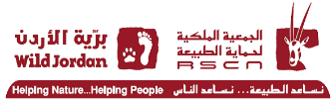
Dana+20: Mobile Indigenous Peoples, Conservation, Sustainable Development, and Climate Change Two Decades after the Dana Declaration

Funding Proposal Summary

Mobile indigenous peoples (e.g., pastoralists, swidden farmers, and hunter-gatherers) have sustainably managed the lands they lived on for centuries. However, throughout the modern era and especially in recent decades, many have been displaced, dispossessed and expelled from their traditional territories, forced to settle and prevented from practicing the forms of mobility upon which their livelihoods and social systems are based. These restrictions have left many destitute and disrupted the cultural foundations of mobile indigenous identities. While the aims of settling mobile peoples have largely been discarded in the rhetoric of conservation, development and human rights advocacy, practical steps toward land restitution and mobility governance have not been forthcoming. Policy has not kept pace with advances in thinking about the relationship between mobile peoples, the state, and territory. Nor do states and international actors often live up to public declarations of concern for human rights of mobile peoples. Sedentarisation policies have become less domineering and overt, but a bias towards the settled remains pervasive, if unconscious, in much development thinking. Mobile peoples, even as rights-holders, continue to be marginalized in policy and practice.
Since 2002, the Dana Declaration Standing Committee has worked with other bodies to address the concerns regarding the welfare of mobile indigenous peoples in sustainable development in general and in biodiversity conservation in particular. A key product was the Dana Declaration on Conservation and Mobile Peoples (www.danadeclaration.org), which provided guidelines for a synergistic strategy for both environmental protection and meeting human rights and needs of mobile peoples (see annex).
In 2012 a Dana+10 Workshop was held in Wadi Dana, Jordan which followed up on the previous 10 years' work to embed the Dana Declaration into soft international law. The Dana+10 workshop was attended by representatives of mobile peoples as well as academics and practitioners. Capacity building among mobile indigenous peoples, as rights holders, was at the core of the workshop’s aims. One outcome of the workshop was a statement delivered by the mobile peoples’ elected representative to the Earth Summit (Rio+20) meetings in June 2012. This statement called for the human rights of mobile indigenous peoples in the face of continuing expulsions from nature reserves and extractive industry land grabbing, and other forms of territorial and resource dispossession to be addressed. The workshop was designed to further raise and maintain awareness of the special vulnerabilities of mobile indigenous peoples through partnership with the World Alliance of Mobile Indigenous Peoples (WAMIP).
As we approach the 20-year anniversary of the Dana Declaration, there is need to take stock of ecological, technical, and political developments over the past two decades and to bring the implications for mobile peoples to the attention of global forums. Furthermore, it is critical that a younger generation of indigenous peoples’ advocates become informed about the key issues which continue to plague mobile peoples. As such, we propose a Dana+20 workshop to reaffirm, redirect, and re-examine some of the stubborn biases that continue to influence mainstream sustainability, climate change, and development paradigms. Working with mobile peoples as rights holder, the workshop’s final agenda will be drafted flexibly to address their priorities and concerns. The Dana+20 workshop aspires to outline ways forward in consultation with mobile peoples’ representatives to improve engagement on the interrelated priorities of conservation, climate adaptation/resilience, habitat loss, and sustainable development.

Context

The first decade of the 21st century has seen a major biodiversity conservation goal achieved: the setting aside of large areas of the earth’s surface to protect its biodiversity. The Convention on Biological Diversity has succeeded in its target of expanding protected areas to 17% of the earth’s surface (UNEP-WCMC, 2009). Many of these areas, are also inhabited by indigenous and traditional peoples.
In the drive to establish reserves and parklands for the protection of habitat and to prevent species loss, traditional and indigenous peoples throughout the world have suffered limitations on resource use, land expropriation, even expulsion at the hands of national and international agencies, as well as human rights violations. While conservation agencies have publicly denounced such practices - see for example the Durban Accord and Action Plan adopted at the World Parks Congress in 2003 - progress in land restitution and protection of indigenous rights has been either sluggish or non-existent, particularly where the peoples concerned are mobile, dispersed, and not physically present at all times of the year.
In light of an improved understanding of the causes of environmental damage, the conservation movement has re-examined their approaches to biodiversity protection, especially the assumptions underlying the exclusion of indigenous peoples from protected areas (Chatty and Colchester, 2002; West, et al, 2006; Brockington et al, 2008; Gilbert 2018). The beginning of the 21st century has been marked by a new understanding of indigenous peoples’ positive contributions to their local ecosystems and conservation (Rio Declaration, Article 22; Convention on Biological Diversity, Articles 8j and 10c; Resolutions on Indigenous peoples, IUCN General Assembly 1996; Beltran, IUCN and WWF, 2000; and the Durban Accord and Durban Action Plan: IUCN, 2004). This nuanced recognition of the special knowledge, roles and rights of such peoples has resulted in increasing efforts to integrate indigenous, traditional, and local communities into the planning and management of conservation areas or, at the very least, ameliorating the negative impact that such schemes have on the sustainability of their livelihoods (Borrini-Feyerabend et al., 2007; Renard et al., 2007; Colchester, 2020). When indigenous peoples are sedentary and relatively organized due, in part, to the density of their habitation patterns, developing and building capacity to take part in conservation-based negotiations are normally straight-forward. However, when indigenous peoples are mobile, then standard sedentist efforts to reach them often fail.
Mobile peoples are a subset of traditional and indigenous peoples whose livelihoods depend upon mobility and extensive common property use of natural resources; mobility is both a management strategy for sustainable livelihoods and land and a distinctive source of cultural identity. In some parts of the world, such as Latin America, mobile indigenous peoples do have an organized presence within the Indigenous Peoples Movement. In many other parts of the world, however, such as Africa, the Middle East, Central and South Asia, Australia, and the Pacific, they remain largely excluded and peripheral to the main dialogues on Indigenous Peoples – Biodiversity Conservation – Sustainable Development.
Mobile peoples – be they pastoralists, hunters and gatherers, far-ranging swidden agriculturalists or other similarly land-based groups – are marginalized due to the mobility that they exercise as a fundamental aspect of their livelihoods. The requirement to be widely dispersed and spread out over extensive territory makes them largely invisible in their natural habitats but also marginalizes them, in particular when they are forced to settle on the edges of their former territories, be it desert, savannah or forest. The removal of mobile indigenous peoples from their traditional lands often goes unrecognized because there is no organized protest, outcry or interest group advocating their right to remain mobile both within the borders of their traditional lands and beyond. This is the case even when their land management practices are such that the lands that they occupy are considered to be of high biodiversity value and meriting conservation. Furthermore, the special knowledge that mobile indigenous peoples have about their environment and the special role that their mobility plays in the conservation and sustainable use of biological resources often go unstudied and unrecorded.

Dana Declaration enters soft international law

Over the past twenty years the Dana Declaration Standing Committee has organized initiatives specifically designed to build capacity among mobile indigenous peoples to represent themselves and advocate their rightful place in the context of biodiversity conservation, extractive industry activity, and sustainable development. One aim has been to promote wider recognition of mobile indigenous peoples’ specialist knowledge, customary systems of resource management based on mobility and their fundamental human rights. Another aim has been to slow down – and perhaps eventually stop – the displacement, dislocation, and forced sedentarisation of mobile indigenous peoples; and to move toward restoration of the communal land rights and territoriality upon which mobility depends. Taking a global perspective, these initiatives combined a number of simultaneous strategies to develop and build capacity among mobile indigenous peoples as well as to raise awareness of their special needs within the general indigenous peoples’ movement. The Dana Declaration Dana and Dana+10 endeavoured to: promote research and dissemination of Mobile Peoples’ traditional knowledge and practices; build the capacity of mobile peoples’ customary institutions by facilitating their representation at international fora; advocate for their inclusion in planning for biodiversity conservation and sustainable development; facilitate the inclusion of addendums to international guidelines relating to indigenous peoples (especially the World Congress of Protected Areas [WCPA], International Union for the Conservation of Nature [IUCN], International Labour Organisation [ILO], United Nations Development Programme[ UNDP], and World Wildlife Fund [WWF]); and develop networking capacity across mobile indigenous peoples groups.
The Standing Committee for the Dana Declaration has succeeded in implementing all of the above. It has disseminated the Dana Declaration to key conservation actors through a dedicated website (www.danadeclaration.org) and arranged an effective presence at the World Parks Congress (WPC) in 2003 in Durban, South Africa, where the Declaration was endorsed in the WPC Workshop Recommendation 5.27. It supported the attendance of representatives of mobile indigenous peoples at the Congress and encouraged their participation in the Indigenous Peoples’ Caucus at the Peoples’ Park – a parallel event in Durban. It encouraged the formation of the World Alliance of Mobile Indigenous Peoples (WAMIP), which came together at the WPC in Durban in 2003, at the IUCN 3rd and 4th Congresses in Bangkok in 2003 and Barcelona in 2008 and at the Dana+10 workshop in 2012. At the 4th World Conservation Congress organized by the IUCN in Barcelona in 2008, the Dana Declaration was finally endorsed as part of the working principles for social development in the International Union for the Conservation of Nature (IUCN) (see www.danadeclaration.org). And it has supported the production of several issues of Policy Matters identifying good practice among mobile indigenous peoples and bringing these to the attention of biodiversity conservation organizations (Vols 13, 2004; 15, 2007) .
The Standing Committee for the Dana Declaration also supported representatives of mobile indigenous peoples from Kenya, Ethiopia, Namibia, Tanzania, Mali, Morocco, Jordan, Syria, the United Arab Emirates, Socotra/Yemen, India, Mongolia, Peru and the United States to attend the Pre-World Conservation Congress Indigenous Peoples’ workshops in 2004 and 2008. It facilitated their attendance at the United Nations Permanent Forum on Indigenous Issues (UNPFII) in 2006 and 2008; it also conducted capacity-building workshops and side events at the UNPFII, where information regarding the Dana Declaration was disseminated through round table discussions on the particular impact of climate change and extreme weather on mobile indigenous peoples’ livelihoods.

Funding proposal
The Dana Declaration Standing Committee proposes that the next logical next step would be the holding of a Dana Declaration + 20 workshop, in which representatives of mobile indigenous peoples meet and work alongside interested natural and social scientists from academia, the IUCN and other NGOs to set out a detailed programme of work to mainstream mobile peoples’ concerns with regard to sustainability, climate change discourse, and development paradigms, and to evaluate the impact of implicit biases in much contemporary practice and policy. Mobile peoples’ delegates to the workshop would be selected in consulation with WAMIP, the League for Pastoral Peoples, The Tenure Facility, and other similar indigenous peoples’ associations. The final agenda of the workshop would be determined in consultation with the mobile peoples’ delegates who have accepted the invitation to take part in the workshop. The workshop aspires to work with mobile indigenous peoples as rights holders to reaffirm, redirect and revise ways to improve engagement on the interrelated priorities of conservation, climate adaptation/resilience, habitat loss, and sustainable development.
The Dana Declaration Standing Committee is exploring the possibility of grants and non-monetary pledges in partnership with international foundations, such as the Ford Foundation, the Christensen Fund, IFAD, FAO Forest and Farm Facility, and the World Wildlife Fund in order to organize and promote the Dana+20 workshop in Wadi Dana, Jordan in the early September of 2022. This workshop would build a strategic framework for reducing the invisibility and marginality of mobile indigenous peoples and address the biases and problematic issues mobile peoples face in the context of contemporary biodiversity conservation, sustainable development, and climate change. To that end, the workshop would aim to also generate an advocacy, research and work plan for furthering the rights of mobile indigenous peoples in international and national policy making.
It is envisaged that the Dana Declaration Standing Committee would organize the workshop and initially oversee the implementation of any strategy emerging from such a meeting, while also overseeing the development of a statement to be delivered to numerous international fora such as the UNPFII, COP28 (November 2022), and events leading up to and during the International Year of Rangelands and Pastoralists (IYRP) proposed for 2026. This workshop would include a component of how mobile peoples’ advocates could raise awareness about the IYRP among their communities and give feedback to refine the 12 global IYRP themes; and also, how they could bring the findings of the Dana+20 workshop to the attention of IYRP stakeholders. This would make the Dana+20 workshop a vital step in the IYRP process by helping mobile pastoralists organize themselves to take full part in the activities leading up to and during the IYRP in 2026.

Total Funding Required: £ 55,000

Funding received thus far: £20,000 _____________________________________________
Funding Outstanding: £ 35,000

Local travel, accommodation, and air fares: 16 representatives of mobile indigenous peoples (including translators) £2,000 per person X 16 £ 32,000
Accommodation and air fares: 9 senior scientist and policymakers
(Including organizer and admin assistant) £1,500 per person X 10 £ 15,000
Administrative assistant £18 per hour X 10 hours X 8 weeks £ 1,440
Design and printing costs for outputs £ 1560
Office costs and administration (10%) £ 5,000

TOTAL = £ 55,000

Dawn Chatty and Ariell Ahearn
Co-Chairs, Dana Standing Committee

References:

Beltran, J. (ed) 2000 Indigenous and Traditional Peoples and Protected Areas: Principles, Guidelines and Case Studies. IUCN, Cambridge UK and Gland Switzerland.
Borrini-Feyerabend, G., M Pimbert, et al (2007) Sharing Power; A Global Guide to Collaborative Management of Natural Resources. London: Earthscan
Brockington, D, J. Igoe, and K. Schmidt-Soltau (2006), “Conservation, Human Rights and Poverty Reduction” in Conservation Biology, 20 (1):250–252.
Brockington, D., R. Duffy, and J. Igoe (2008) Nature Unbound: Conservation, Capitalism and the Future of Protected Areas. London: Earthscan.
Chatty, D. and Colchester, M. (eds) 2002 Mobile Peoples and Conservation: Displacement, Forced Settlement and Sustainable Development. Oxford and New York: Berghahn Press.
Colchester, M. (2020) Legal Obstacles to Territorial Rights, Compensation, Sustainable Production and Conservation on Forest Peoples’ Lands. Liverpool: Liverpool University Press.
Gilbert, J. (2018) Natural Resources and Human Rights: An Appraisal. Oxford: Oxford University Press.
Renard, Y et al. (2007) Sharing Power – Learning by Doing in Co-Management of Natural Resources throughout the World. London: Earthscan.
United Nations, List of Protected Areas – 2009. World Conservation Monitoring Centre www.unep-wcmc.org/protected areas/UN_list.
West, P, J. Igoe, and D. Brockington (2006) “Parks and Peoples: The Social Impact of Protected Areas” in Annual Review of Anthropology, 35:251–277.

Annex: Dana Declaration on Mobile Peoples and Conservation

A group of concerned professionals including social and natural scientists from all regions of the world met in Wadi Dana Nature Reserve, Jordan, 3-7 April 2002, to consider a comprehensive approach to mobile peoples and conservation. At the end of this meeting, they agreed the following declaration:

The world faces unprecedented threats to the conservation and sustainable use of its biodiversity. At the same time, its cultural and linguistic diversity, which includes an immeasurable and irreplaceable range of knowledge and skills, is being lost at an alarming rate.

The linked pressures of human population dynamics, unsustainable consumption patterns, climate change and global and national economic forces threaten both the conservation of biological resources and the livelihoods of many indigenous and traditional peoples. In particular, mobile peoples now find themselves constrained by forces beyond their control, which put them at a special disadvantage.

Mobile peoples are discriminated against. Their rights, including rights of access to natural resources, are often denied and conventional conservation practices insufficiently address their concerns. These factors, together with the pace of global change, undermine their lifestyles, reduce their ability to live in balance with nature and threaten their very existence as distinct peoples.

Nonetheless, through their traditional resource use practices and culture-based respect for nature, many mobile peoples are still making a significant contribution to the maintenance of the earth’s ecosystems, species and genetic diversity – even though this often goes unrecognised. Thus, the interests of mobile peoples and conservation converge, especially as they face a number of common challenges. There is therefore an urgent need to create a mutually reinforcing partnership between mobile peoples and those involved with conservation.

In the light of this understanding, we commit ourselves to promoting conservation practices based on the following principles:

PRINCIPLE 1. RIGHTS AND EMPOWERMENT

Conservation approaches with potential impact on mobile peoples and their natural resources must recognise mobile peoples’ rights, management responsibilities and capacities, and should lead to effective empowerment. These rights include:

  - Human rights: civil, political, social, economic and cultural.
  - Land and resource rights, including those under customary law.
  - Cultural and intellectual property rights.
  - The right to full participation in decision-making and relevant negotiation processes at different levels.
  - The right to derive equitable benefits from any consumptive or non-consumptive use of local natural resources.

To this end, appropriate legislative reforms should be promoted as needed, at national and international levels. In addition, because mobile peoples often move through different territories, transboundary co-operation between national authorities may be required.

Recognition of mobile peoples’ rights should lead to effective empowerment and include consideration of gender and age.

PRINCIPLE 2. TRUST AND RESPECT

Beneficial partnerships between conservation interests and mobile peoples should be based upon mutual trust and respect and address the issue of discrimination against mobile peoples. To this end partnerships should:

2.1 Be equitable.
2.2 Fully respect and acknowledge mobile peoples’ institutions.
2.3 Balance the exercise of rights by all parties with the fulfilment of responsibilities.
2.4 Recognise and incorporate relevant customary law.
  - Promote the accountability of all parties in relation to the fulfilment of conservation objectives and the needs of mobile peoples.

PRINCIPLE 3. DIFFERENT KNOWLEDGE SYSTEMS

In planning and implementing conservation of biodiversity with mobile peoples, there is a need to respect and incorporate their traditional knowledge and management practices. Given that no knowledge system is infallible, the complementary use of traditional and mainstream sciences is a valuable means of meeting the changing needs of mobile peoples and answering conservation dilemmas. In particular:

  - Traditional and mainstream sciences and management practices should enter into dialogue on a basis of equal footing and involve two-way learning.
  - Traditional and mainstream sciences should be appropriately valued, and their dynamic nature acknowledged.

PRINCIPLE 4. ADAPTIVE MANAGEMENT

Conservation of biodiversity and natural resources within areas inhabited or used by mobile peoples requires the application of adaptive management approaches. Such approaches should build on traditional / existing cultural models and incorporate mobile peoples’ worldviews, aspirations and customary law. They should work towards the physical and cultural survival of mobile peoples and the long-term conservation of biodiversity.

More particularly, such adaptive management approaches should:

  - Build on areas of common interest between the chosen lifestyles of mobile peoples and the conservation objective of sustainable resource management.
  - Allow for diversification of livelihoods and ensure provision of a variety of benefits at all levels, including mobile services.
  - Recognise the diversity of systems of tenure and access to resources, including the customary sharing of resources.
  - Recognize and support the contributions made by mobile peoples to conserving and enhancing the genetic diversity of domesticated animals and plants.
  - Learn from the flexible management practices of mobile peoples to enrich conservation.
  - Develop conservation planning at a larger landscape scale, using the notion of mobility as a central concept, and incorporating both ecological and cultural perspectives.

PRINCIPLE 5: COLLABORATIVE MANAGEMENT

Adequate institutional structures for adaptive management should be based on the concept of equitable sharing of decision-making and management responsibilities between mobile peoples and conservation agencies. This is only possible if the existing decision-making mechanisms for biodiversity conservation become more democratic and transparent, so as to allow for the full and open participation of civil society and mobile peoples in particular, and for the establishment of co-management and self-management systems. This requires that the relevant parties:

  - Develop processes and means that foster cross-cultural dialogue directed towards consensual decision-making.
  - Incorporate culturally appropriate conflict-management mechanisms and institutions.
  - Recognize the time-scale appropriate to cultural processes and the time required to build intercultural partnerships for adaptive management.
  - Foster locally agreed solutions to conservation problems.
  - Encourage diverse and pluralistic approaches to conservation planning and implementation.
  - Develop their capacities to enter into mutually beneficial partnerships.

This declaration is our contribution to narrowing the disciplinary divide. The ideas in it need to be tested, refined and further developed in dialogue with mobile peoples themselves and others. But these issues need to be considered urgently at national and international levels – and in particular at the forthcoming World Summit on Sustainable Development and the World Parks Congress.

PARTIES TO THE DECLARATION:

Alejandro Argumedo | Asociacion Quechua-Aymara ANDES, Indigenous Peoples' Biodiversity Network (IPBN), Peru
Richard Baker | School of Resources, Environment and Society, Australian National University, Australia
Ahmed Belal | UNESCO ECOTECHNE Chair, South Valley University, Egypt
Grazia Borrini-Feyerabend | Commission on Environmental, Economic and Social Policy, IUCN – The World Conservation Union
Geraldine Chatelard | European University Institute, Italy
Dawn Chatty | Refugee Studies Centre, University of Oxford, UK
Marcus Colchester | Forest Peoples Programme
Christo Fabricius | Environmental Science Programme, Rhodes University, South Africa
Taghi Farvar | Commission on Environmental, Economic and Social Policy, IUCN – The World Conservation Union
Patricia Feeney | Rights and Accountability in Development- RAID, UK
Graham Griffin | Centre for Arid Zone Research, Commonwealth Scientific and Industrial Research Organisation, Australia
Garth Owen-Smith | Integrated Rural Development and Nature Conservation, Namibia
Margaret Jacobsohn | Integrated Rural Development and Nature Conservation, Namibia
Chris Johnson | Royal Society for the Conservation of Nature, Jordan
Ilse Köhler-Rollefson | League for Pastoral Peoples, India
Terrence McCabe | Department of Anthropology, University of Colorado, USA
Jeff McNeely | IUCN - The World Conservation Union
Helen Newing | Durrell Institute of Conservation and Ecology, University of Kent at Canterbury, UK
Gonzalo Oviedo | International Consultant on People and Conservation
Adrian Phillips | Former Chair of the World Commission on Protected Areas of IUCN
Mohammad Qawabah | Royal Society for the Conservation of Nature, Jordan
Flavien Rebara | Worldwide Fund for Nature – WWF, Madagascar
Alan Rowe | Department of Geography, University of Glasgow, UK
Sabine Schmidt | GTZ, Project Nature Conservation and Bufferzone Development, Mongolia
Irina Springuel | UNESCO ECOTECHNE Chair, South Valley University, Egypt
Nick Turvey | Documentary Film-maker, UK
Reed Wadley | Department of Anthropology, University of Missouri at Columbia, USA

Common property systems have well established community rules for use/ownership. They are not the same as open access and include such land use types as seasonal grazing, community conserved areas, etc.
By mobile peoples, we mean a subset of indigenous and traditional peoples whose livelihoods depend on extensive common property use of natural resources over an area, who use mobility as a management strategy for dealing with sustainable use and conservation, and who possess a distinctive cultural identity and natural resource management system.

