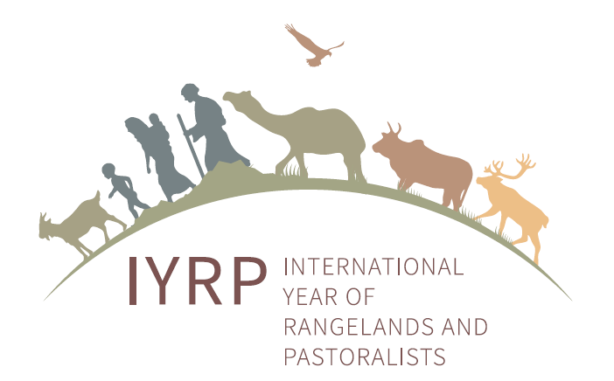
Guidance on preparation of Regional IYRP Action Plans: content and process

Background
The overall goal of the IYRP is to achieve the best possible worldwide awareness, recognition and understanding of the value and contributions of rangelands and pastoralists to global society, biodiversity preservation, ecosystem services, and food production, so as to influence and launch beneficial country policies, legislation, programmes, and development and research initiatives that would lead to sustainability of rangelands and pastoral systems.
The immediate objectives of the IYRP are twofold:
- to increase awareness and recognition of the importance of rangelands and pastoralists to environmental, social and economic goals; and
- to increase understanding and knowledge for healthy rangelands and sustainable pastoralism.
The IYRP is supported by almost 300 entities across the world, and the list is growing. The IYRP is a multi-stakeholder coalition (see box). All of these entities have committed to lead and/or participate in activities before, during and even after 2026.
Some entities have been able to identify, at this early stage, specific priorities for action, and a few have offered resources. This information has been gathered together in the “Draft Global Action Plan for IYRP”.
National IYRP Committees would coordinate activities in the country, corresponding to the “IYRP global 12 monthly themes”. IYRP supporters in each interested country will lead and/or participate in the national priority activities. Several National IYRP Committees may also decide to carry out regional activities together and participate in global activities.
IYRP supporters in some regions have developed papers for the Joint International Grassland Congress and International Rangeland Congress in 2021 (Joint IGC/IRC 2021) that briefly describe the priority issues in filling knowledge gaps and raising awareness. These papers are meant to be the ‘baseline’ for the regional action plans to be built upon.
Some key activities will also be identified at the global level by the Global Coordination Group (GCG); they will be fully costed, and funds raised where necessary.
Three phases can be identified:
- Preparatory phase (2021–2025): some activities to be done in 2026 require prior planning and preparation, research, etc.; moreover, many awareness-raising, learning and policy-influencing activities related to rangelands and pastoralists would need to take place already before 2026
- The International Year (IY) (2026)
- Post IY follow-up (2026 and beyond): some activities (particularly research and evaluation) may be done after 2026.
Purpose of regional action plans
- To spearhead regional/multi-country activities
- To help coordinate national activities across the region
- To contribute to global activities.

Suggested content of regional action plans (Suggested total length of document = 10 pages)

Chapter | Brief description | Notes
Executive summary | Highlight of main points and conclusions | Suggested length less than 1page  Consider adding a summary in English
Background and preamble | The context of the regional action plans, such as number and type of supporting organizations, list of products/activities already finalized by the Regional IYRP Support Group (RISG) or individual partners in support of the IYRP, etc.
Goals and objectives | a) To increase awareness and recognition of the importance of rangelands and pastoralists to environmental, social, cultural and economic goals; and  b) To increase understanding and knowledge of healthy rangelands and sustainable pastoralism  c) To promote cooperation and synergies within and among regions | Should be the same for all regional plans and correspond to the Global Action Plan
Current status and trends of rangelands and pastoralists (R&P) | Brief description of:  - the rangelands and pastoralist systems occurring in the region  - state of knowledge and knowledge gaps  - how are R&P perceived in the region? (both by the public and by pastoralists themselves)  - what are the main trends of the integrity of the natural and cultural heritage of rangelands and pastoralists? | This chapter should use as a baseline the papers prepared for the Joint IGC/IRC 2021 and could include key maps, word clouds and other graphics.
Thematic priorities for the region | How each of the 12 monthly themes will be adapted to the region; what are the specific sub-themes or areas of regional focus, e.g. if the main theme is gender, then what specific issue will become the focus of a) filling knowledge gaps and b) raising awareness?
Regional-level activities | Specific activities to be spearheaded at regional level:  - Activities in the preparatory phase (2021–2025)  - Activities to be done during 2026  List of specific activities and their expected costs and/or resources to be identified. | If possible at this early stage, each activity should also have one or more lead entity identified.
Support to national-level activities | How the RISG expects to support and collaborate with National Committees
Support to global-level activities | How the RISG expects to contribute to the global level activities, and what resources and funds can partners in the region contribute. | Start building partnerships around activities already listed in the Draft Global Action Plan
Activities that go beyond 2026 | Some activities, such as research and advocacy projects, may continue beyond 2026 and need to be noted.  The RISG will contribute to the final evaluation of the project.
Organizational issues | Brief description of the role and Terms of Reference (ToRs) of the RISG and its Communications Team, member list, possibly Policy Working Group, etc.  Brief description of how the RISG will monitor and record all IYRP-related activities before, during and after the IY in 2026 (list of activities, partners involved, resources/funds used, outcomes achieved). | All activities need to be properly recorded for the purpose of the final evaluation.

Suggested process of Regional Action Planning

RISG (co-)chairs should take the leadership in this process and involve as many other RISG members as possible, including additionally recruited members. It is particularly important to include people from pastoralist organizations and government agencies from different levels
The RISG should identify all opportunities for preparation and refinement of the Regional Action Plans during the preparatory phase as follows:

- Regional Planning Start-up at the Joint IGC/IRC (October 2021):
  - Presentation of the Congress paper relevant to the region (‘baseline paper’)
  - Discussion in break-out groups to identify strategic regional priorities, drawing from the ‘baseline paper’, the 12 global monthly themes, and the Draft Global Action Plan
  - Present findings and conclusions at the Congress
  - Contribute key messages from the conclusions to the Congress Resolutions

- Regional Action Plan drafting, verification and finalization post-Congress (by October 2022)
  - Draft Regional Action Plans (for Preparatory Phase and for 2026 and beyond)
  - Present draft Regional Action Plans at relevant national and regional meetings and conferences, such as Rangeland Societies, Pastoralist Gatherings, meetings of National IYRP Committees, exchange between different RISGs, etc. for verification and refinement
  - Finalize the Regional Action Plans and present it to the GCG by October 2022 for final coordinated agreement
  - Present Regional Action Plans to UN Global Steering Committee (or similar structure to be set up by FAO and UN Agencies)
  - Leverage funds and other resources needed to carry out the Action Plan
  - Review and update the Regional Action Plan on a yearly basis until 2025

Available in English, French, Russian and Spanish at https://iyrp.info/resources/front

