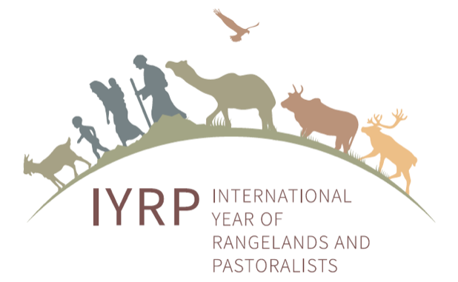
Non-governmental Contributions to IYRP, a preliminary estimate
(August 2021)

Introduction and methodology

This analysis has been conducted by the International Support Group (ISG) for IYRP at the request of the Government of Mongolia, as a way of expressing the level of commitment identified by supporting organizations. Of the almost 300 organizations who have officially supported the IYRP proposal to date, a total of 43 organizations have been able to identify and describe specific activities, resources and funding to be carried out before and during the IYRP 2026.

This analysis is based on two definitions:
- “Re-directed” = In-kind resources include staff time, supplies, and other resources already budgeted for and existing, that the organizations will re-direct or re-assign to support IYRP activities.
- “Leveraged” = activities that are undertaken with newly raised or mobilized funds, and new additions to existing budgets.

Costs vary tremendously by continent, as well as by scale (local, national, international). An attempt is made to standardize cost ranges by type of activity into US dollars, making very conservative assumptions. The standards cover the entire life-cycle of an activity, from design to production to dissemination, unless where specified. Costs are in-person not virtual, unless specified.
Cost standards

- Virtual media materials and campaigns = $2000 national; $5000 international
- Mobile exhibit / film festival = $20,000 national; $50,000 regional/international
- Seminar/workshop = $10,000 national; $30,000 regional; $50,000 international
- Virtual webinar = $5000
- Demonstration/training = $10,000 national; $50,000 regional/international
- Publication = $20,000
- Conference = $30,000 national; $50,000 regional; $100,000 international
- Side event at a conference = $10,000 national; $30,000 international
- Pastoralist gathering = $5000 national; $10,000 regional; $50,000 international
- Research/development project, per year = $5000 national; $20,000 international

Findings

The summary table below shows a total of $2.1 million of both in-kind and leveraged financing has been offered by 43 supporting organizations fairly equally representing all 7 regions and those working at the global level. Of this, 11% of the resources can be considered as newly leveraged and mobilized funding. About half of the resources are for international activities, 40% for national and the 10% for regional level activities.

Summary table – Monetizing commitments to IYRP by type and region (US dollars)

Type of activity | Africa | Asia | Middle East | AUS + NZ | Europe | USA + CAN | LAC | Global | TOTAL
Media Campaign - national | 2000 | 5000 |  | 5000  +15,000 | 5000 | 15,000 | 20,000 |  | 67,000
Media Campaign – int’l | 5000 |  |  |  |  |  |  | 55,000 | 60,000
Mobile exhibit/film festival – nat’l |  |  |  |  | 20,000 |  | 5000 |  | 25,000
Mobile exhibit/film festival –int’l | 50,000 |  |  |  |  |  |  |  | 50,000
Seminar/workshop - national | 10,000 | 50,000 + 10,000 |  | 50,000  +20,000 | 10,000 |  | 10,000 |  | 160,000
Seminar/workshop - regional | 50,000 |  |  |  |  |  |  |  | 50,000
Seminar/workshop - international |  |  |  |  |  |  |  | 30,000 | 30,000
Online webinar | 2000 |  |  |  |  | 24,000 |  |  | 26,000
Demo/training program – nat’l |  | 20,000 |  | 60,000 | 10,000 |  | 60,000 |  | 150,000
Demo/training program – int’l |  |  |  |  |  |  | 100,000 |  | 100,000
Publication | 40,000 | 20,000 | 40,000 | 40,000 | 40,000 | 20,000 |  | 20,000 | 220,000
Conference - national |  | 30,000 |  | 30,000+  120,000 | 30,000 | 80,000 |  |  | 290,000
Conference - regional |  |  |  |  |  | 100,000 |  |  | 100,000
Conference - international |  | 100,000 |  |  |  |  |  |  | 100,000
Side event only |  |  |  | 10,000 |  | 10,000 | 6000 |  | 26,000
Pastoralist gathering – nat’l | 5000 |  | 10,000 |  |  |  |  |  | 15,000
Pastoralist gathering – reg’l | 10,000 | 10,000 |  |  |  |  |  |  | 20,000
Pastoralist gathering – int’l |  |  |  |  |  |  |  |  | -
Research/dev project – nat’l |  | 25,000 |  | 50,000 |  |  |  |  | 75,000
Research/dev project – int’l |  |  |  |  |  |  | 50,000 | 460,000 | 510,000
Financial support (unspecified) |  |  |  | 10,000 |  |  | 30,000 |  | 40,000
TOTAL re-directed/in-kind | 174,000 | 160,000 | 50,000 | 315,000 | 115,000 | 239,000 | 251,000 | 565,000 | 1.869 m
TOTAL leveraged funds |  | 110,000 |  | 95,000 |  |  | 30,000 |  | 235,000
GRAND TOTAL | 174,000 | 270,000 | 50,000 | 410,000 | 115,000 | 239,000 | 281,000 | 565,000 | 2.104m

Full tabular calculations per organization available on request.

