**Environment & Resilience VIPs**  **uavip.arizona.edu**

**Seed Funding Opportunity**

**July 2022** [**APPLY HERE**](https://uarizona.co1.qualtrics.com/jfe/form/SV_0DFUsxLvpXbL4ai) **(Priority review begins July 18th)**

**Multi-disciplinary Undergraduate**

**Vertically Integrated Projects (VIPs) in Environment & Resilience**

A topical cluster of VIPs coordinated by Arizona Institutes for Resilient Environments and Societies (AIRES)

1. Already have undergraduates working in your research group?
2. Looking for a network of complementary collaborators and teams?
3. Want to enhance your research capacity?
4. Seeking interest and engagement from a more diverse set of students?
5. Believe in the experiential learning power of undergraduate engagement in authentic inquiry and scholarship at a Research-1 and Hispanic-Serving university?

***JULY 2022 SEED FUNDING OPPORTUNITIES***

**For this July 2022 VIP seeding initiative, individual faculty from any relevant discipline can apply for up to $5,000, and teams (2 or more faculty) can apply for up to $8,000 per team. Fund uses are flexible (supplies, student support, sample processing, etc.) but need to be spent in FY2023 (01 July 2022 – 30 June 2023). Successful VIP leads can then apply for a second year of similar funding in 2022. *See page 3 for details, process, & speedy timeline.*** [**APPLY HERE**](https://uarizona.co1.qualtrics.com/jfe/form/SV_0DFUsxLvpXbL4ai) **(Priority review begins July 18th)**

***WHY***

VIPs provide compelling and authentic inquiry experiences for students, increasing their research skills and levels of engagement while on campus and their employability upon graduation. Students engage in long-term research with tangible outcomes and develop valuable, in-demand skills in the process, such as collaboration and accountability. Additionally, students holding a key role in a close-knit research team helps to improve undergraduate retention rates. VIPs also align faculty efforts in research, teaching, and service at a prestigious R1 university and provide a visible focus on UArizona global strengths in water, environment, & Earth sciences. In doing so, VIPs can align key promotion and tenure considerations with teaching assignments and help to connect students and tuition revenue to grants and publication productivity. VIPs are an opportunity to invest in the future economic prosperity of Arizona by investing in students, faculty, and the generation of new knowledge in response to today’s most pressing challenges.

***HOW***

The Environment and Resilience VIPs will engage students in authentic discovery and knowledge development across world-class UArizona disciplines. VIPs emphasize access and inclusion of under-represented groups, working to break down barriers to participation in science, research, and knowledge creation. Teams of students work on VIP projects and experience the benefits of community and belonging through multi-year research and inquiry experiences within supportive frameworks. Additionally, VIPs reach across departments and outside of campus walls. The Environment & Resilience VIPs will link UArizona programs with complementary emphases as well as connect them to existing K12, community, and first-year initiatives – including ASEMS (<https://asems.arizona.edu/home>).

***WHAT***

The Environment & Resilience VIPs are slated to be a cornerstone methodology within a cohesive program inspired by resilience, the UN Sustainable Development Goals, and other frameworks for approaching global grand challenges. The VIPs will provide research experiences across a diversity of environment options and showcase an explicit coordination and support of programs and pathways for all students. In execution, VIPs will facilitate undergraduate engagement in research, as well as provide structured opportunity to support RAs and faculty. In scope, the parallel development of VIP options and infrastructure will provide longer-lasting impact and benefit the UA community at large. In their existence, VIPs are poised to be a flagship research and student-engagement program at the only university in country that simultaneously holds the R1, AAU, HSI, and Land Grant designations.

Students, enrolling for usually 1-3CR per semester, will come and go over the years, with many students participating for multiple years and producing senior theses or capstone projects. Motivated, excelling students may continue into an Accelerated Master’s Program (<https://catalog.arizona.edu/policy/accelerated-masters-program-amp>) degree – completing undergrad and grad degrees simultaneously, usually after five total years.

***EXEMPLARS***

VIP teams work on pressing problems using cross-disciplinary skills and knowledge bases for multiple years at a time. As new students enter teams, they bring their own perspectives and skill sets while learning from the work that has already been completed. The UA has several successful VIP teams, including Dr. Bhattacharya’s Brain Communication Network team and Dr. Burleson’s Holodeck: Health, Wellbeing, and Design Thinking team. Dr. Bhattacharya’s team studies inter-cellular communication within the brain through genetics, coding, protein informatics, and flow cytometry, sharing their new discoveries with the public. Dr. Burleson’s team utilizes an experiential supercomputing facility and design thinking to explore, visualize, and engage with a host of concepts, from telehealth to climate science. Further details about both can be found at <https://uavip.arizona.edu/>, and exemplars of global VIP teams can be found at <http://vip-consortium.org/>. UArizona is one of 40+ international members of the VIP Consortium.

Additionally, a new VIP led by Drs. Hackett (Ecology & Evolutionary Biology), Thompson (Geosciences), and Miller (Mathematics) using the Biosphere 2 research ocean will draw on molecular and genomic biology, biophysics, mathematics, and chemical analyses to better understand coral reef resiliency in the face of climate change and other human-caused threats. Using the UA’s one-of-a-kind Biosphere 2, the team will be able to simulate ocean changes and coral responses within the experimental facility.

***JULY 2022 SEED FUNDING OPPORTUNITIES***

The Arizona Institutes for Resilient Environments and Societies is looking to seed Vertically Integrated Projects (VIPs) that fall under the broad umbrella of environment and resilience. Individual faculty, or small teams of faculty, are encouraged to apply. VIP projects that will engage students should be aligned with the scholarly work of faculty applicants – students should be working on the same projects that tenured and tenure-track faculty value for promotion and accolades at UA and in their broader fields, namely the generation of new knowledge and appropriate dissemination via publications, academic conferences, and other communication avenues. The VIP model will not by itself sustain a faculty member’s research and inquiry activities, but can add a valuable education and training element by attracting and integrating diverse and motivated students, which in turn can expand the overall productivity of the research group.

**The AIRES Education team plans to make 5 or 6 awards by early August, 2022. Individual faculty from any relevant discipline can apply for up to $5,000, and teams (2 or more faculty) can apply for up to $8,000 per team. Fund uses are flexible (supplies, student support, sample processing, etc.) but need to be spent in FY2023 (01 July 2022 – 30 June 2023). Successful VIPs can then apply for a second year of similar funding in 2023. Diverse mentorship training will also be available for the cohort of faculty leads.**

Applications for shifting your research group to a VIP model should be concise and include a clear, long-term (5 or more years) vision for the research and scholarly activity of the VIP – including engagement of undergraduates from different stages and disciplines, graduate students, and perhaps post-doctoral scholars. We seek to launch multiple VIPs that will each engage 8-10 (or more) undergraduate students per year by year three, with a planned VIP duration of 5 or more years.

For more information on the VIP model please visit [uavip.arizona.edu](http://uavip.arizona.edu) and/or [vip-consortium.org](http://vip-consortium.org).

***APPLICATION & SELECTION PROCESS –***

* The AIRES Environment & Resilience Education Team, led by Dr. Kevin Bonine, has developed a short application process, available via Qualtrics survey. [**APPLY HERE**](https://uarizona.co1.qualtrics.com/jfe/form/SV_0DFUsxLvpXbL4ai) **(Priority review begins July 18th)**
* A small Advisory and Selection Committee will review applications, solicit any supplemental information from applicants, and seek to commit funds to top applicants by early August 2022. Funds are to be spent in FY2023, beginning 01 July 2022. Use of funds is flexible and can include research supplies, student employment, grad-student support, travel, etc.
* Exciting, cross-disciplinary VIPs will likely review better than narrow, discipline-specific proposals.
* Proposals that are most aligned with the environment and resilience objectives of AIRES (<https://www.environment.arizona.edu/air>) will likely review better than proposals with little alignment to scholarly and solutions-oriented goals of AIRES.
* Environment and Resilience VIP proposals that include community and/or private-sector partners and underwriters are welcome.
* If you already engage undergraduate students in your research group, the shift to a VIP model will not be a large hurdle, and you will be making opportunities more visible to diverse students.

Environment and Resilience VIPs provide clear opportunities to link research and outcomes with the UN Sustainable Development Goals (SDGs) which are especially attractive motivators for groups of students underrepresented in STEM careers:

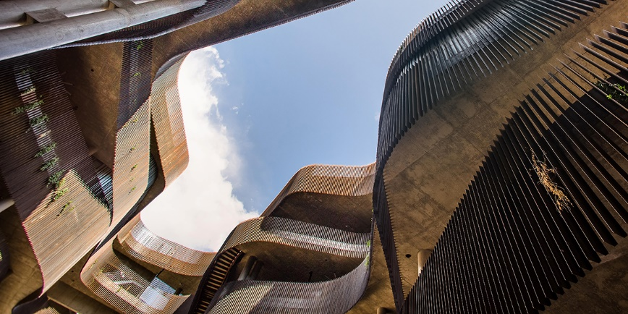

**Environment & Resilience VIPs**

***Equitable scholarly engagement to increase UArizona environmental inquiry capacity and improve recruitment, learning, retention, and employability for all undergraduate students via project-based research experiences.***



The University of Arizona resides on Indigenous Homelands

of the Tohono O’odham and the Pascua Yaqui people.