

March 31 from 2-3:30 pm  
KIVA room SUMC

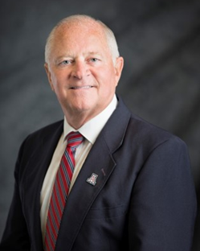**EDUCATIONAL EXCELLENCE:   
A VISION BEYOND TRADITION**

# Presented by Dr. James Knight

The educational excellence movement has had a profound effect upon how we approach teaching and learning in education at all levels. If we are committed to improved performance of students, we must necessarily be committed to creating a learning environment that is purposefully positive, personal, and pleasant. This presentation focuses on strategies that have been identified in the research on student achievement and teaching effectiveness and will provide specific suggestions on how to implement them.

**SEATS ARE LIMITED & REGISTRATION IS REQUIRED.** [**REGISTER FOR THE SESSION HERE**](https://uarizona.co1.qualtrics.com/jfe/form/SV_5hgZ0xE5pVbLHDM)**.**

**Please register by Monday, 3/28.**

About the Speaker:

Dr. Knight earned his Bachelor’s and Master’s degrees from Colorado State University and was a teacher in public schools in Holyoke and Golden, Colorado. He received his doctorate from The Ohio State University in 1977 and served as a full-time professor until 1988. At that time he became an adjunct professor, moved to Tucson, Arizona, and started his own private consulting business. He resumed university work with the University of Arizona in 1996, was appointed full professor in 2000, and became Department Head in Agricultural Education in 2001. In 2005, he was named as a Faculty Associate for the College of Agriculture and Life Sciences at the University to work with Faculty Development and student recruitment. He retired from the UA on July 1, 2014.

As a classroom teacher and professor, Dr. Knight has received numerous awards and recognition for his teaching skills. He received the “Alumni Distinguished Teaching Award” at Ohio State in 1987, given annually to only eight persons out of 3500 faculty members. During 2005 he was recognized by the Western Region American Association for Agricultural Educators with the Distinguished Teaching Award. The College of Agriculture and Life Sciences at the UA inducted Dr. Knight as a “Fellow” in the Bart Cardon Academy for Teaching Excellence in 2010. In 2013, he was recognized as the Faculty Member of the Year by both the Ag-100 Council and the Arizona Student University Association.

For question, please contact Kelly Jackson, [kjackson@email.arizona.edu](mailto:kjackson@email.arizona.edu).