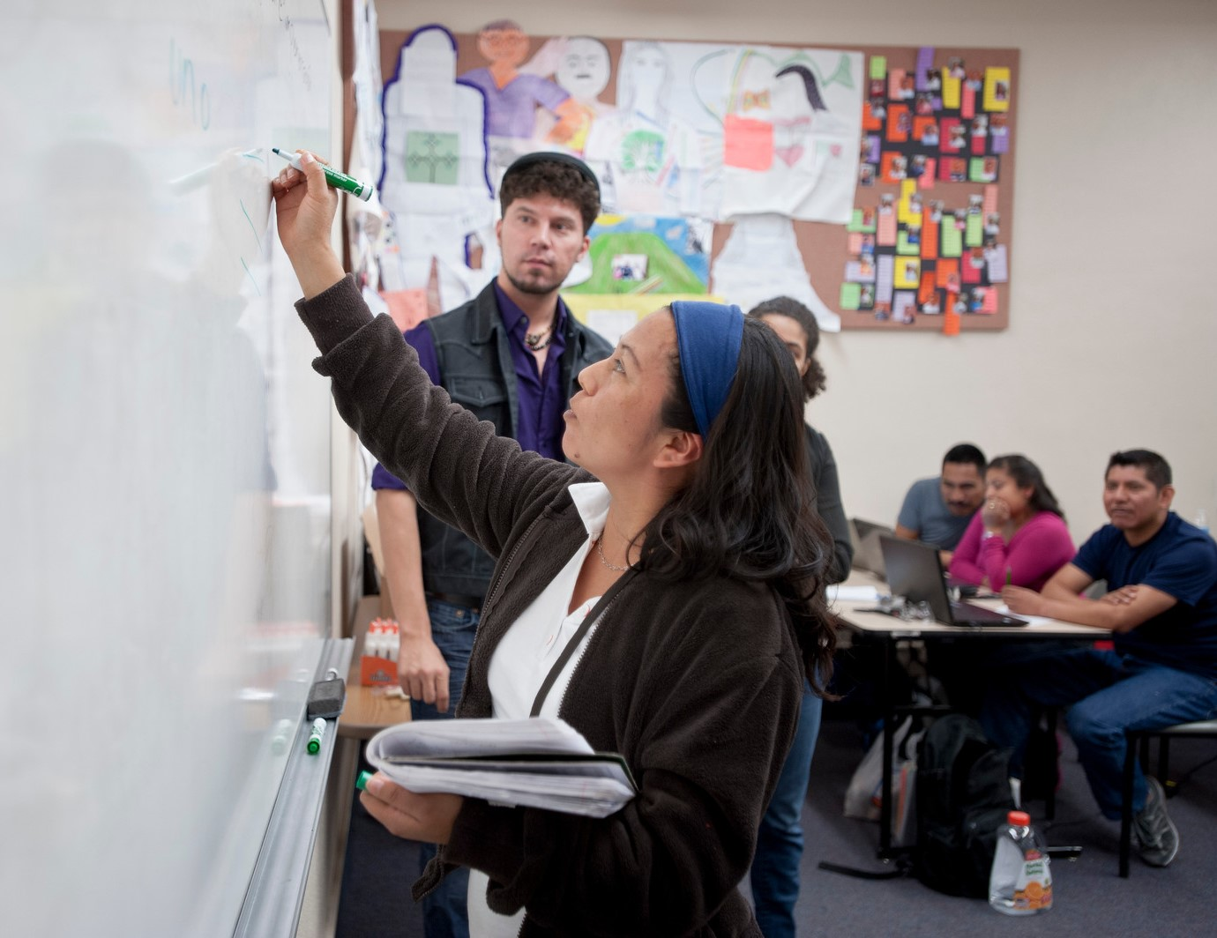  March 11, 2019  inclusified: Promoting Equity Through Inclusive Teaching Practices  Professors Kelly Hogan and Viji Sathy…  will provide a framework for inclusive teaching designs and lead participants through active learning exercises. Hogan and Sathy will model approaches that can be readily implemented with any discipline or class size.    Kelly Hogan, PhD, is a STEM Teaching Professor in the Department of Biology, Assistant Dean of the Office of Instructional Innovation and Director of the University's Quality Enhancement Plan associated with SACSCOC accreditation.    Viji Sathy, PhD, is a Teaching Associate Professor in the Department of Psychology and Neuroscience, Special Projects Assistant to the Senior Associate Dean of Undergraduate Education and Program Evaluator of the Chancellor’s Science Scholars. | Enhance Your Teaching with Inclusive Practices  ────  Special Afternoon Session for CALS  ────  Monday, March 11  2:30-4:00 PM  ────  Student Union Memorial Center  Rincon Room  ────  Refreshments will be Served  Please RSVP  Cecilia Mazon  cmazon@email.arizona.edu  

