Proposal for Cross-college Institute under RDI
Institute for Language & Innovation, University of Arizona
Mission Statement
Sonia Shiri
Draft 7, May 17, 2018

The Institute for Language & Innovation is a cross-college institute whose mission is to catalyze innovation and interdisciplinary initiatives that advance language science research and education at the University of Arizona by helping UA participate in tackling language-centered grand challenges and by coordinating and supporting interdisciplinary partnerships across campus and with other institutions, government organizations, industry and business. The institute will be housed in RDI and will serve the whole campus.

ILI will particularly pursue the following goals:

- Research innovation:
  - Catalyze innovative research centered on language as it intersects with areas such as science and technology, health and medicine, education, society, and law and business
  - Coordinate efforts to better equip UA to participate in setting and tackling grand challenges and contribute to generating disruptive solutions to novel problems
  - Promote synergies across colleges and centers and provide the organizational support for new and innovative scholarship by faculty, GAs and undergraduate students
  - Facilitate the formation of sustainable and strategic research networks/clusters that enable interdisciplinary and team-based endeavors including large-scale projects, conferences, symposia and successful grant writing that help make UA a premier institution in this field
- Interdisciplinary partnerships:
  - Stimulate interdisciplinary collaborations in language science scholarship, teaching and community engagement by connecting units and individuals working with language with each other, with STEM and the professions, as we well as with the greater community
  - Encourage and facilitate collaboration with industry, business, other institutions, and government organizations as well as the pursuit of cutting edge projects that bridge research and practical applications
- Infrastructure and community building across administrative borders:
  - Provide physical space for exchange among UA language science scholars and for learning that transcends program, department and college affiliations
  - Establish a forum for collective thinking and collective strategizing to serve the field as well as the mission of the university, including its role as a land grant institution
  - Foster a sense of community around language work on campus, regardless of disciplinary and administrative affiliation
  - Coordinate and facilitate fundraising efforts to support innovative, cross-college and cross-disciplinary projects
- Capacity building in teaching, training and leadership:
  - Promote innovative and interdisciplinary teaching practices that bridge the disciplinary lines between the language field and STEM/the professions to train a citizenry and workforce that are better equipped for a team-driven and global economy. Disseminate these practices on campus and beyond.
  - Provide inclusive leadership training and mentoring for language-focused faculty, GAs and undergraduate students in the various roles they occupy in the academic structure, including project leadership, coordination or administration
- Raising the profile of language on campus and engaging communities at the local, national and global levels:
  - Promote language science research and practical applications at UA and in other educational settings and in communities within the state of Arizona, including in matters pertaining to social policy
  - Streamline connections between language-related work on campus with UA offices (e.g., RDI/RDS, Academic Affairs, the Libraries, UA Foundation, Global Initiatives, International Education, Student Engagement, Digital Learning, Faculty Affairs, Graduate Center) and with initiatives connecting UA at the regional, national and global levels
  - Advocate for language research, teaching and service, and make them visible by highlighting their relevance to UA’s mission and educating the academic and language community on language issues
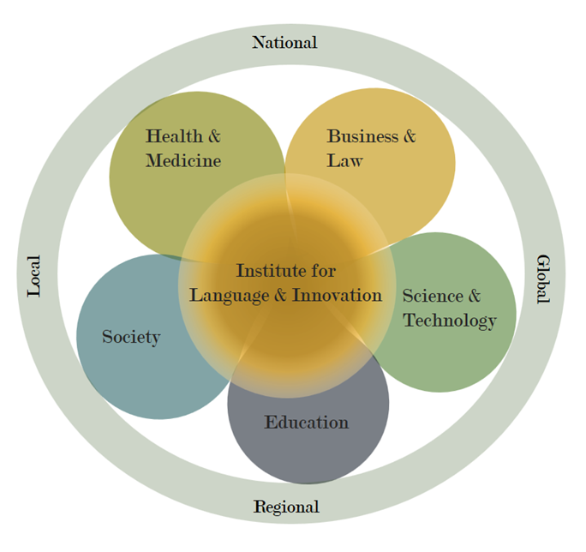
Institute for Language & Innovation: Scope of Interdisciplinary Language Sciences at UA

Defining “Language Sciences”
The term “language sciences” has growingly been used in an inclusive manner to describe collective campus-wide research activity that spans a wide range of disciplines that involve language. This designation is intended to underscore the interdisciplinary effort to connect the fundamental science side of the field (e.g., research in cognitive science, computational linguistics, medicine, or psychology) with applications in education and society, for instance (e.g., research in child development, bilingualism/multilingualism, language revitalization).

This trend is being spearheaded and adopted nationally and internationally by leading institutions in the field, with the goal of advancing knowledge by generating greater cross-disciplinary interactions among historically separate fields. Cambridge University, for example, launched its own Language Sciences Centre in 2017. The definition adopted by Cambridge is quoted in full below, as an example (https://www.languagesciences.cam.ac.uk/about):

Language sciences is the term for a broad area of research on language and communication. It covers both theoretical and applied research into language acquisition, the role of language in society, patterns and processes of signalling, information transfer, and the processing of information.
The four main pillars are:
- the study of the (neuro)biological basis of human communication, the evolution of language, and language in the context of human behaviour
- the study of language in its political, societal and cultural context (the ecology of language)
- the study of the structure, sounds, and meaning of language
- speech and language technologies, including their application to Machine Learning and Artificial Intelligence.
Language research is a part of many disciplines including psychology, anthropology, linguistics, education, computer science, and engineering. Interactions between researchers which cut across these disciplinary boundaries are the most fertile and important element of current research.

