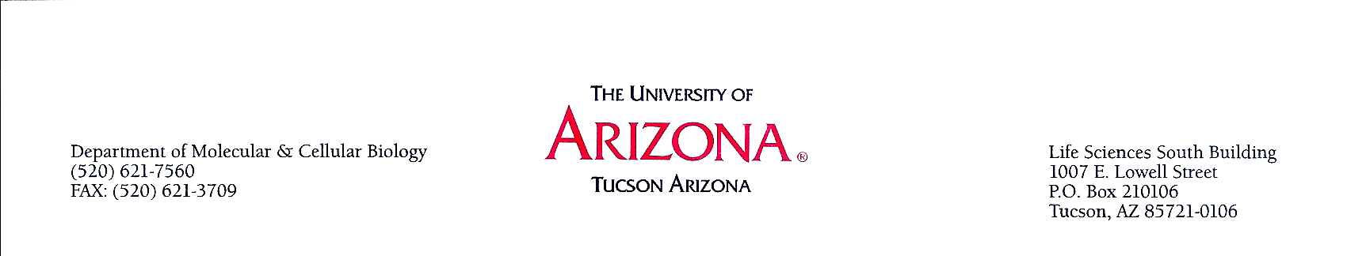
MEMORANDUM

DATE: October 16, 2013

TO: UA Agriculture and Life Sciences, BIO5, Biosphere 2, Medicine, Optical Sciences, and Science Department Heads, Directors, and Faculty

FROM: Lisa Elfring, Departments of Molecular and Cell Biology and Chemistry/Biochemistry

RE: Invitation for Arizona Partners in Science Teacher Internship Reception

We invite all interested faculty to join us for an informational reception on Monday, October 28 from 4:30 to 6:00 pm to learn about the Arizona Partners in Science teacher internship program. In the 1980s and early 1990s, Research Corporation sponsored this science teacher internship program; in response to overwhelming interest, they resurrected the highly successful program in 2008. In this program, qualified high-school teachers in any of the science disciplines form partnerships with University-based researchers for two consecutive summers. Applications are accepted only for teacher/researcher partner teams, and the application must originate from the research mentor.

Research Corporation for Science Advancement will host its sixth Arizona Partners in Science program in Summer 2014, with applications due December 1, 2013. We would like to recruit potential faculty mentors in all the science disciplines so that interested teachers can start working to develop the partnerships, discuss possible projects, and work collaboratively on the applications (which must be submitted by the researcher through Sponsored Projects).

The invitation flyer for the reception is on the second page of this document. This would be a great place to look for a like-minded teacher who is eager to learn more about your work. This program offers a tremendous opportunity to learn more about how secondary teachers are working to bring meaningful science content to their students, and perhaps to begin a partnership that can lead to broader impacts/ CAREER-type projects.

If you are interested but cannot attend, please let me know (elfring@email.arizona.edu) so that I can connect you with interested teachers. I will also be working with the teachers to help them identify faculty mentors. We have created a database of interested faculty so that teacher applicants can browse through research interests to find a match, and I’ll pass your information on if you’d like to participate.

More information on the program can be found at http://www.rescorp.org/grants-and-awards/az-partners-in-science. I would be happy to answer questions about the program, as would Silvia Ronco, the program manager at Research Corporation. She can be reached at sronco@rescorp.org.
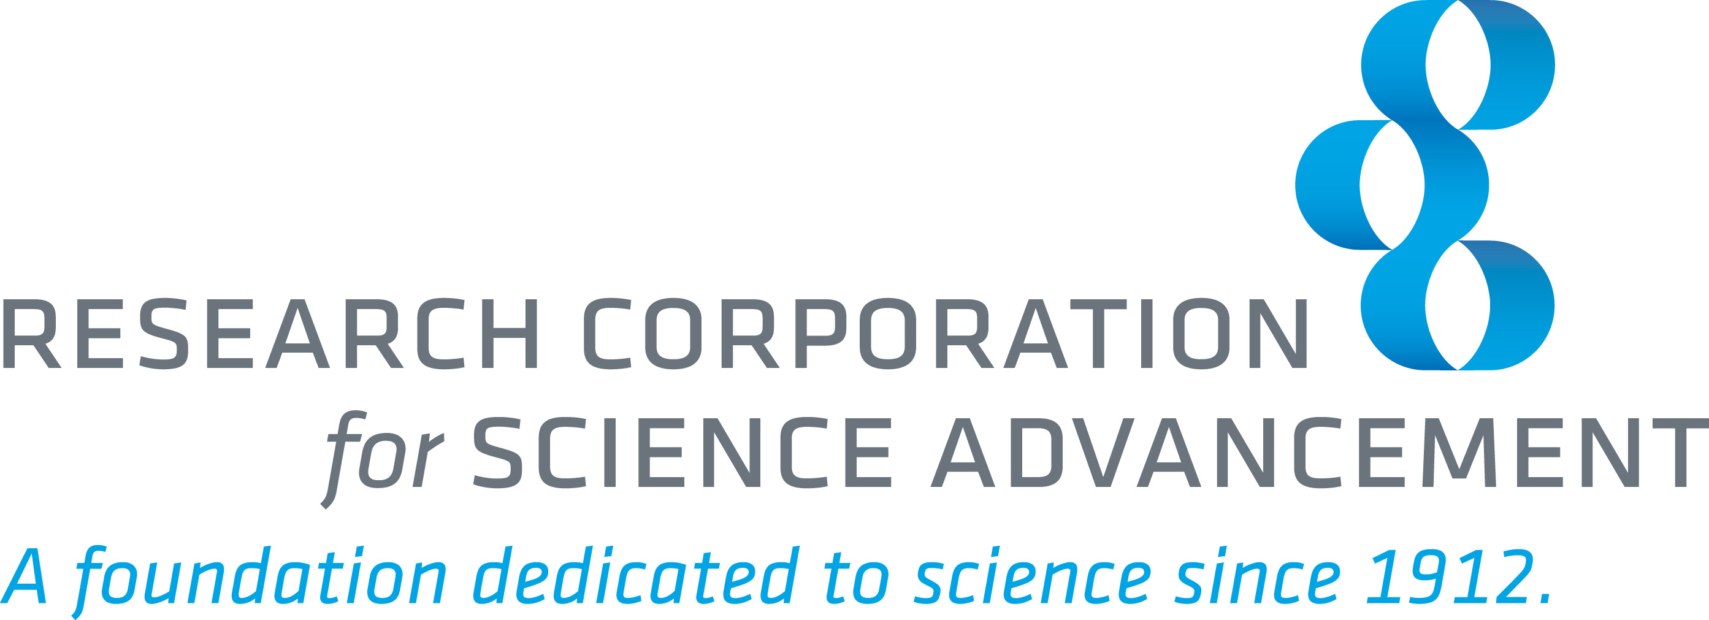

What America’s top high-school science teachers know:
Research is the best hands-on way to learn science and advance student learning.

RCSA invites you to a reception to learn about
ARIZONA PARTNERS IN SCIENCE

$7,000 per summer available for a High-School teacher working in a University of Arizona research laboratory
http://www.rescorp.org/grants-and-awards/az-partners-in-science

*

Monday, October 28, 2013 from 4:30-6:00
On the UA Campus: Tubac Room, Student Union Building 4th floor,
Tucson, AZ 85721
Closest parking is in the Second Street Garage

Please RSVP to Silvia Ronco, Program Officer
sronco@rescorp.org

