County Extension and Ag Center Directors Conference Call
Tuesday, September 24, 2019 – 10:00
StartMeeting Toll Free Calling Directions

Dial: 1-855-212-0212 / Passcode: 357-296-852#

Jeff Silvertooth, Paul Brown, Jeremy Elliott-Engel, Carolyne Greeno, Trent Teegerstrom, Kristie Gallardo
Call in: Don Alamban, Joyce Alves, Russ Engel, Rick Gibson, Steve Gouker, Ed Martin, Cathy Martinez, Dan McDonald, Kim McReynolds, Jeff Schalau, Evelyne Whitmer

Director’s Report – Jeff

UCAP Review (compass.arizona.edu/ucap)

- UCAP started over two years ago and is still not complete.
- Policy is still changing.
- Make sure you and your business employees know the facts.
- Jeff Ratje’s September 23rd memo gives the current guidelines. Please refer to it for help.
- No one is losing their job due to UCAP.
- Employees with “research” in their title have gone through the most change. Check your employees. If there is a problem with the researchers – contact Sangita Pawar sangita@email.arizona.edu
- If current classified staff have an issue with their mapping, do NOT opt in. Fill out the “Reassessment of Mapping” between Oct 29 – Nov 15. HR has the final decision in the mapping process.
- If there is an employee out of line in their mapping – a employee can initiate the Reassessment, or the supervisor can initiate the Reassessment after talking with the employee.
- Please check the University Staff Policies & Guidelines and provide feedback.
- Please attend (Zoom) FSLA trainings. Many employees are going from Exempt (salaried) to Non-Exempt (hourly).
- Business managers should be sharing all incoming information with CEDs.

Branding/Marketing
- Work with Faith and Kelly for branding issues. They will loop in Jennifer Yamnitz’s office if necessary.

Legislative District Data
- This handout came from the Dean’s office and was prepared by George Frisvold’s Economic Impact team. Use this information wisely.

Q & A with Dr. Silvertooth today (Sept 24) at 1:30. Any questions?

Bilingual Content Writer
- Temp funds, 2 years funding. Targeting new original content in both languages.
- Counties are very interested in getting documents translated to Spanish.
- Please send feedback to Dominic by the end of September

Continuing vs. non-continuing agents
- See below for more information on classifications

Winter Extension Administration Retreat
Homewood Suites
Dec 3rd (11:30 – 5:00) & Dec 4th (8-12:00)

Leadership Secrets of Attila the Hun
Chapter 9 – Kim - October
Chapter 10 – Hattie
Chapter 11 – Jeremy
Chapter 12 – Russ
Chapter 13 – Steve
Chapter 14 – Trent
Chapter 15 – Bill
Chapter 16 – Barry
Attilaisms – last section – Evelyn
General overview – Dominic
Overall assessment – Cathy

Conference Calls 2019

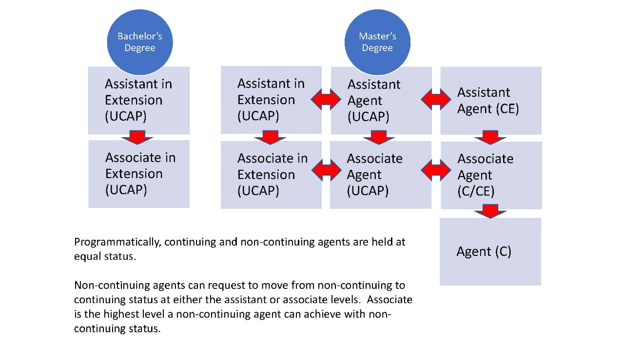
October 29, November 26

