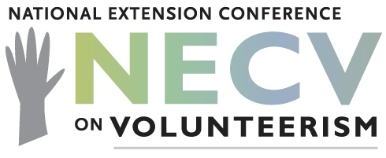
2019 National Extension Conference on Volunteerism
Host State Application
Background: The National Extension Conference on Volunteerism has been held every other year since 1999 with the inaugural event held at Estes Park, Colorado. Since that initial conference, volunteerism in Cooperative Extension has continued to evolve to meet the needs in local communities. New strategies have been developed, research conducted, evaluations implemented, and priorities identified at the local, state, and national level. The 11th National Extension Conference on Volunteerism will be held in April or May, 2019.
We invite states interested in hosting the conference to submit a hosting proposal by December 8, 2017. Include the attached cover-page and no more than three pages of supporting documentation that addresses the criteria below. Submit via email to:
Doug Swanson
4-H National Headquarters; USDA – National Institute of Food and Agriculture
202-690-1227
dswanson@nifa.usda.gov

Recommended Hosting Criteria
- Capacity to host a minimum of 250 attendees;
- At least one large room for plenary and keynote sessions that will hold a minimum of 250 attendees;
- Minimum of seven breakout rooms that hold a minimum of 30 attendees each and are flexible in their arrangement (classroom, rounds, space to move around, etc.);
- Appropriate, on-site lodging for all attendees;
- Appropriate meal availability for all attendees;
- Lodging and meeting rooms under one roof, or in adjoining facilities;
- Economical, yet professional lodging rooms, rates and registration fees;
- Close proximity to airport with multiple connections and reasonable prices (30 minutes or less);
- Shuttle from airport to facility;
- Adequate audio visual equipment (speakers, microphone, wireless microphone, screens, etc.) and internet connections in all meeting rooms;
- Availability of evening opportunities that are self-directed/self-selected

Additionally, the host state will be responsible for:
- Hosting a website and handling all pre- and post-conference materials for a minimum of six months prior to the conference and six months after the conference;
- Handling all registration fees (must offer credit card option);
- All registration logistics (a fee may be charged to handle registration processing);
- Identifying a minimum of one person to serve on the overall planning committee who also serves as the facilities logistics coordinator;
- Identifying in-state professionals/volunteers to serve on hospitality, welcoming, etc. committees for the conference as needed.
Logistics:
- List potential facilities for consideration with location and brief description;
- List an estimated range of lodging costs;
- List any additional costs required for hosting the conference;
- Provide a proposed date in April or May 2019. Please avoid other national Extension related conferences and days designated for religious observations.
- Travel day should be a Monday or Tuesday with the conference on Tuesday – Thursday or Wednesday – Friday.

Contacts:
Doug Swanson
4-H National Headquarters; USDA – National Institute of Food and Agriculture
202-690-1227
dswanson@nifa.usda.gov

Harriett Edwards
North Carolina State University
North Carolina State Extension
Phone: 919.515.9548
harriett_edwards@ncsu.edu

2019 National Extension Conference on Volunteerism
Host State/Institution Cover-Page

Institution Name:
Primary Contact:
Address:
Email:
Telephone:
Supervisor:

Please provide a brief overview of your experience organizing a conference or being involved in the organizing and implementation of a conference (state-wide or national in scope):

Signature & Date
(by signing you confirm that you have your supervisor’s support and the support of your State, including your Extension Director

