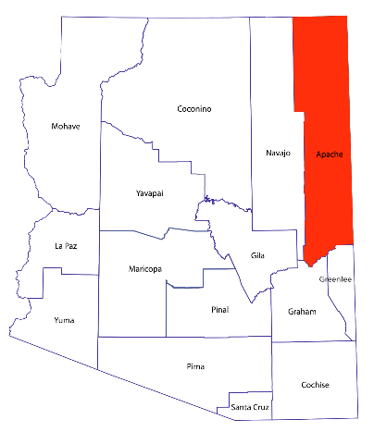
The University
of Arizona Cooperative Extension

Apache County Annual Report 2014



Improving Lives, Communities,
and the Economy.



