 | The University  of Arizona Cooperative Extension  Apache County Annual Report 2013  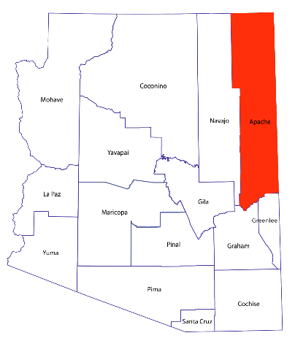
csp1814876
Improving Lives, Communities,
and the Economy.



