USDA Announces Signup for 2023 Assistance for On-Farm Food Safety Expenses for Specialty Crop Growers

Toolkit for Stakeholders
The U.S. Department of Agriculture (USDA) reminds specialty crop producers of available assistance to help cover costs with complying with regulatory and market-driven food safety certification requirements.

Applications for the Food Safety Certification for Specialty Crops (PSCSC) program for 2022 costs are due Jan. 31, 2023. USDA’s Farm Service Agency (FSA) will accept applications for 2023 costs from Feb. 1, 2023, to Jan. 31, 2024.

We need your help. We want to ensure specialty crop producers are aware of this program and the available resources to apply, including how to contact the FSA office at their local USDA Service Center and FSA’s call center. This toolkit is meant for partners and stakeholder groups to share information on FSCSC in their networks. It includes:

- Key messages
- Newsletter article
- Social media posts with graphic

Answers to frequently asked questions can be found at farmers.gov/food-safety/faq.

Please contact us at fpac.bc.press@usda.gov with any additional questions.

Key Messages
- USDA reminds specialty crop producers of available assistance to help cover costs with complying with regulatory and market-driven food safety certification requirements.
- Applications for the Food Safety Certification for Specialty Crops (FSCSC) program for 2022 costs are due January 31, 2023.
- USDA’s Farm Service Agency (FSA) will accept applications for 2023 costs from February 1, 2023, to January 31, 2024.
- Up to $200 million is available through the Food Safety Certification for Specialty Crops Program (FSCSC) for specialty crop operations that incurred eligible on-farm food safety program expenses related to obtaining or renewing a food safety certification in calendar years 2022 and 2023.
- USDA is delivering FSCSC to provide critical assistance for specialty crop operations, with an emphasis on equity in program delivery while building on lessons learned from the COVID-19 pandemic and supply chain disruptions.
- The Food Safety Certification for Specialty Crops Program (FSCSC) is funded by the Commodity Credit Corporation.
- The development, implementation, and maintenance of on-farm food safety programs resulted in unforeseen costs for many specialty crop operations who sought alternate markets for their products, as demand from traditional markets such as restaurants and food service diminished or disappeared.
- As specialty crop operations identified new markets, many also found they needed to undergo food safety audits to achieve food safety certification through a private or government-based certification program in order to meet buyers’ requirements to sell their products.
- Additionally, the Food and Drug Administration established January 27, 2020, as the compliance date for very small businesses to meet the requirements of the Food Safety Modernization Act’s (FSMA’s) Produce Safety Rule. As a result, those specialty crop operations had to expend resources and capital to comply with new regulatory requirements for the first time during the pandemic.
  - Very small business means an applicant that had an average annual monetary value of specialty crops the applicant sold during the 3-year period preceding the program year of no more than $250,000.
- USDA’s Farm Service Agency established FSCSC to assist specialty crop operations that incur eligible on-farm food safety program expenses related to obtaining or renewing a food safety certification in calendar years 2022 and 2023.
- For each year, FSCSC covers a percentage of the specialty crop operation’s cost of obtaining or renewing their certification, as well as a portion of their related expenses.
- To be eligible for FSCSC, the applicant must be a specialty crop operation; a small business or very small business; and have obtained or renewed a:
- 2022 food safety certification that was issued between June 21, 2022, and December 31, 2022; or
- 2023 food safety certification issued during the 2023 calendar year; and
- Have paid eligible expenses
- FSCSC is open to specialty crop operations located in the United States and territories.
- FSCSC provides assistance for eligible expenses paid by the applicant related to the food safety certification for 2022 and 2023 calendar years.
- Expenses that have been incurred by the applicant but have not been paid are not eligible for assistance through FSCSC.
- Specialty crop operations that obtain food safety certification through a group model under a food safety management system are eligible to apply for assistance for their share of eligible expenses paid by the group, in addition to any eligible expenses they incur individually.
- Specialty crop operations may receive assistance for the following costs:
- Developing a food safety plan for first-time food safety certification
- A food safety plan is a requirement for any specialty crop operation or group undergoing formal food safety certification, and the majority of costs associated with food safety plan development occur the first year an operation undergoes food safety certification.
- FSCSC will cover a percentage of the costs of specialty crop operations developing their own plan or hiring a consultant.
- For specialty crop operations that develop their own plans, FSCSC will cover a percentage of the costs of seminars and tools used to create a food safety plan.
- For those that hire a consultant, FSCSC will cover a percentage of the consulting fees and other associated expenses.
- Maintaining or updating an existing food plan
- Certification programs typically require an annual review of the food safety plan to ensure it is current and addresses any new audit or regulatory requirements, as well as incorporates any new hazards.
- FSCSC will cover a percentage of the costs of maintaining and updating existing food safety plans.
- Food Safety Certification
- FSCSC will cover a percentage of the cost of obtaining food safety certification issued by a certifier, including application fees, inspection costs, inspection fees (including travel costs and per diem for certifiers), user fees or certifier sales assessments, and postage.
- Certification Upload Fees
- FSCSC will cover a percentage of the cost to upload audit reports and certification documentation into commercial audit databases, which may be required by buyers of specialty crops.
- Microbiological Testing
- FSCSC will cover a percentage of the microbiological testing for products, soil amendments, and water as specified by a food safety plan or food safety management system.
- The FSMA Produce Safety Rule requires covered farms to test their agricultural water, and commercial food safety standards may require additional testing to determine if water meets the microbial requirements of the Environmental Protection Agency’s drinking water standard.
- Retail, food service, and institutional buyers are also increasingly requiring microbiological testing of finished product.
- Testing of soil amendments, particularly amendments of animal origin (composting) is also required by many food safety audit programs.
- Training
- FSCSC will cover the cost of food safety training for the specialty crop operation.
- The FSMA requires all covered operations to take a training course. Additionally, most certification programs require training as well.
- Ineligible expenses include infrastructure improvements, equipment, supplies, salaries and benefits and fees or penalties for late payment.
- Interested specialty crop producers can apply by completing the FSA-888, Food Safety Certification for Specialty Crops Program (FSCSC) application, along with other required documents and submit to their local Farm Service Agency (FSA) in their USDA Service Center.
- Applications will be accepted in person, by mail, email, fax, or electronic means.
- Applicants may be required to provide additional documentation to FSA if necessary, to verify eligibility or issue payment.
- Specialty crop operations certified as part of a group under a food safety management system must provide documentation of the applicant’s portion of the group’s expenses from the entity responsible for maintaining the group’s certification if requested by FSA.
- FSCSC payments are calculated separately for each category of eligible costs based on the percentages and maximum payment amounts:

Category of Eligible Expenses | Payment Amount of Eligible Costs
Category of Eligible Expenses | Historically Underserved Farmers and Ranchers | All other applicants
Development of a food safety plan for first-time certification | 75 percent (no maximum) | 50 percent (no maximum)
Maintaining or updating a food safety plan | 75 percent, up to a maximum of $375 | 50 percent, up to a maximum of $250
Food safety certification | 75 percent, up to a maximum of $2,000 | 50 percent, up to a maximum of $2,000
Certification upload fees | 75 percent, up to a maximum of $375 | 50 percent, up to a maximum of $250
Microbiological testing – products | 75 percent, up to 5 tests | 50 percent, up to 5 tests
Microbiological testing – soil amendments | 75 percent, up to 5 tests | 50 percent, up to 5 tests
Microbiological testing – water | 75 percent, up to 5 tests | 50 percent, up to 5 tests
Training | 100 percent, up to a maximum of $300 | 100 percent, up to a maximum of $200

- Payments will be equal to the applicant’s eligible expenses multiplied by the percentage for the applicable category in the table above, not to exceed the maximum payment amount for the category, if applicable.
- An applicant must report any previous cost share assistance received for the expenses included on their application.
- The amount of the applicant’s FSCSC payment plus the reported additional cost share assistance cannot exceed the total amount of eligible expenses for each category.
- FSA will issue payments at the time of application approval for 2022 and after the application period ends for 2023. The 2023 application period opens Feb. 1, 2023, and closes Jan. 31, 2024. If calculated payments exceed the amount of available funding, payments will be prorated.

Newsletter Article
USDA Announces Signup for 2023 Assistance for On-Farm Food Safety Expenses for Specialty Crop Growers
Deadline for Calendar Year 2022 Applications is Jan. 31, 2023
The U.S. Department of Agriculture (USDA) reminds specialty crop producers of available assistance to help cover certain costs of complying with regulatory and market-driven food safety certification requirements. Applications for the Food Safety Certification for Specialty Crops (FSCSC) program for eligible 2022 costs are due by Jan. 31, 2023. USDA’s Farm Service Agency (FSA) will accept applications for 2023 costs from Feb. 1, 2023, to Jan. 31, 2024.
FSA is making available up to $200 million through the FSCSC program, which is part of USDA’s broader effort to transform the food system to create a more level playing field for small-scale agricultural operations and a more balanced, equitable economy for everyone working in food and agriculture.

USDA first announced and opened this program for signup in 2022, delivering critical assistance for specialty crop operations, with an emphasis on equity in program delivery while building on lessons learned from the COVID-19 pandemic and supply chain disruptions.

Program Details

FSCSC assists specialty crop operations that incurred eligible on-farm food safety certification and expenses related to obtaining or renewing a food safety certification in calendar years 2022 and 2023 for certifications issued on or after June 21, 2022. For each year, FSCSC covers a percentage of the specialty crop operation’s eligible costs of obtaining or renewing their certification, as well as a portion of their related expenses.

To be eligible for FSCSC, the applicant must:
- Be a specialty crop operation.
- Meet the definition of a small business or very small business.
- Have paid eligible expenses related to certification.

Specialty crop operations may receive assistance for the following costs:
- Developing a food safety plan for first-time food safety certification.
- Maintaining or updating an existing food safety plan.
- Food safety certification.
- Certification upload fees.
- Microbiological testing for products, soil amendments and water.
- Training.
FSA calculates FSCSC payments for each category of eligible costs. FSA set a higher payment rate for underserved farmers and ranchers, which includes socially disadvantaged, limited resource, beginning and veteran producers who have a CCC-860 on file with FSA.

FSA will issue payments at the time of application approval for 2022 and after the application period ends for 2023. The 2023 application period opens Feb. 1, 2023 and closes Jan. 31, 2024. If calculated payments exceed the amount of available funding, payments will be prorated.

Applying for Assistance

Interested specialty crop producers can apply by completing the application, FSA-888. The application, along with other required documents, can be submitted to the FSA office at any USDA Service Center nationwide by mail, fax, hand delivery or via electronic means. Producers can visit farmers.gov/service-locator to find their local FSA office. Specialty crop producers can also call 877-508-8364 to speak directly with a USDA employee ready to assist.

Producers can visit farmers.gov/food-safety for additional program details, eligibility information and forms needed to apply.

Sample Posts for Facebook and Twitter
Below are social media posts for use on Facebook, Twitter, and other platforms. Be sure to tag us on Twitter: @FarmersGov and @usdaFSA.

- .@USDA reminds specialty crop producers of assistance to help cover the costs of food safety certification requirements. Calendar year 2022 enrollment closes Jan. 31, 2023. Calendar year 2023 enrollment opens Feb. 1, 2023. farmers.gov/pandemic-assistance/food-safety

- The deadline to apply for assistance to help cover the costs of food safety certification requirements for calendar year 2022 is Jan. 31, 2023. farmers.gov/pandemic-assistance/food-safety

- Eligible specialty crop producers can apply for assistance for on-farm food safety expenses related to obtaining or renewing a food safety certification in calendar year 2023 starting Feb. 1, 2023. farmers.gov/pandemic-assistance/food-safety

Use this graphic through Jan. 31, 2023:
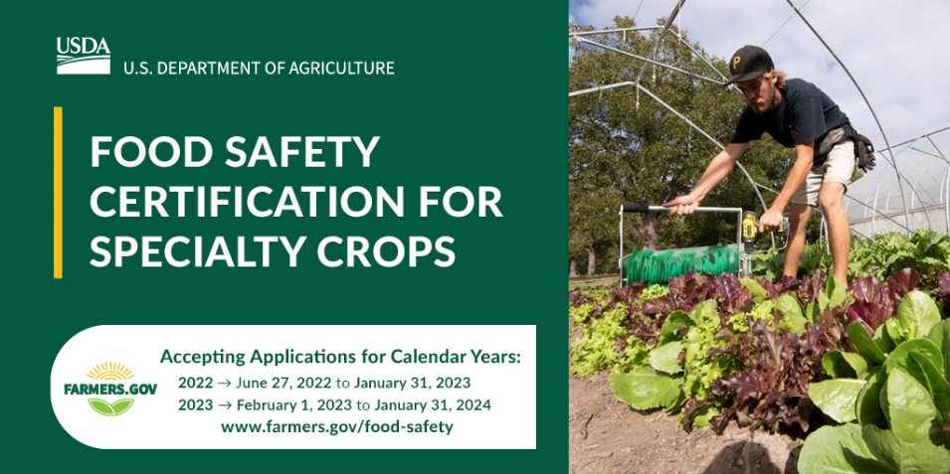

Use this graphic starting Feb. 1, 2023:
