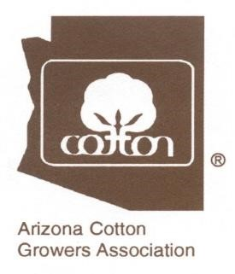
NOTICE
Request for Proposals - 2021
Arizona Cotton Growers Association

Arizona State Support Committee
The Arizona Cotton Growers Association State Support Committee (Ag Research) is requesting research proposals for funding under the Cotton Incorporated State Support Program to benefit the Arizona Cotton Industry. As in the past the ACRPC will be in attendance and will consider supporting research in partnership with us.
The ACGA/State Support Committee is requesting that all research proposals be submitted to the Association by no later than the close of business on Friday, September 4, 2020. The proposals can be submitted via e-mail to Kevin Rogers, kevin@azcottongrowers.com or by mail: 9885 S. Priest Drive, Suite 102, Tempe, Arizona 85284.
We will entertain proposals addressing a broad spectrum of topics. However, due to a reduction in the 2020 research budget, it is highly likely that we will need to focus only on programs that are currently being funded by the ACGA.
Research Priorities: The ACGA/State Support Committee is continuing its current Research Priorities, as follows:
Cotton Production Activities
Insect Control
Water/Water Conservation
Dust Control in Pinal County
Advanced Strains Trials
Herbicide Resistance Management
Format: The Association further requests that all proposals be submitted on no more than two pages with the following information:
- Research Project Title
- Researcher(s)
- Amount Requested (although the Association funds on a one-year basis, please indicate whether this project will involve multiple years)
- Brief description of the project and objectives
- How this research project will benefit the Arizona Cotton Industry
Presentation: The presentation of projects to the Committee has not be scheduled as of yet, and as soon as I have a date I will get it to you.
If you have any questions, please call Kevin Rogers at (602) 437-1344.

