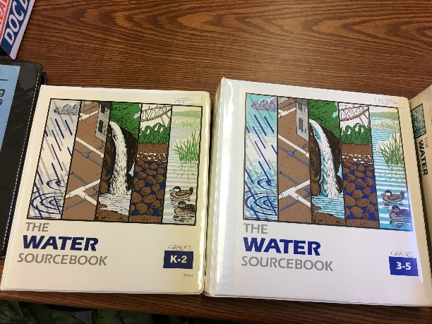
Box 1 Contents:
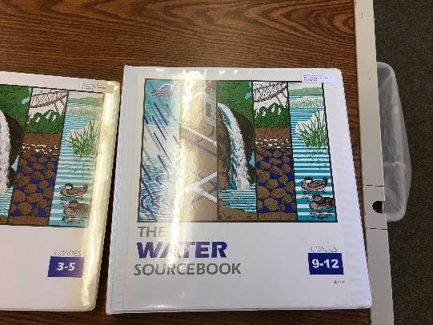
The Water Sourcebook, Grades 9-12 (3-ring binder) (Kelly Zamudin)
The Water Sourcebook, Grades K-2 (3-ring binder) (Bill Brandau)

The Water Sourcebook, Grades 3-5 (3-ring binder) (Bill Brandau)
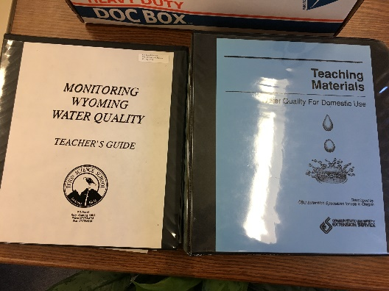
Monitoring Wyoming Water Quality (3-ring binder)

Teaching Materials: Water for Domestic Use (3-ring binder)
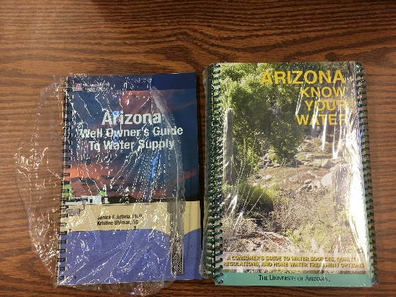
Arizona well owner’s guide to water supply (Kelly Zamudio)

Arizona Know Your Water (6 copies)

Box 2 contents:
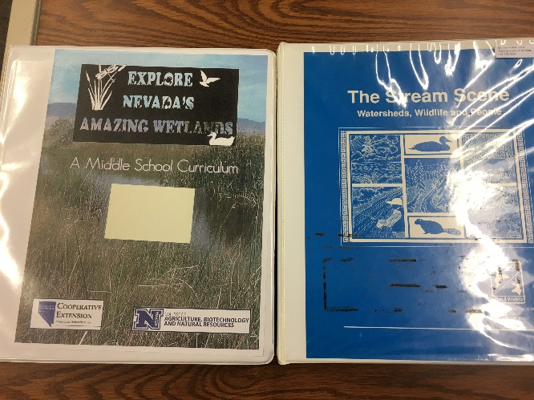
Explore Nevada’s Amazing Wetlands: A middle school curriculum (3-ring binder)

The Stream Scene: Watersheds, Wildlife and People (3-ring binder)

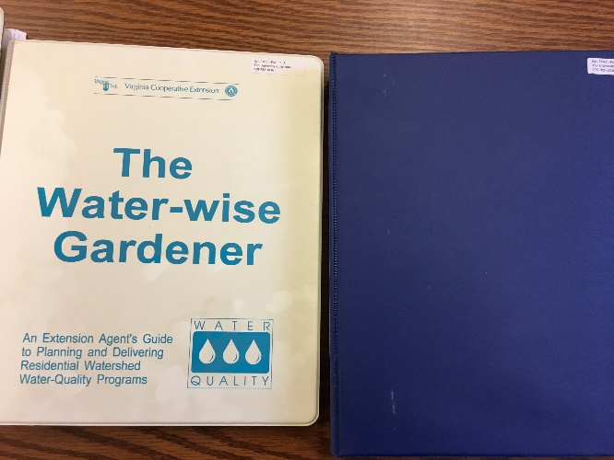
The Water-wise Gardener (3-ring binder)

Watershed Science for Educators (3-ring binder)

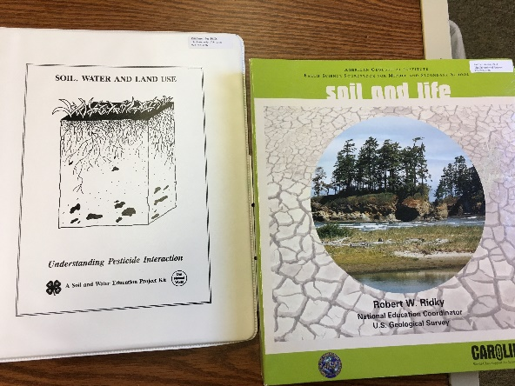
Soil, Water, and Land Use: Understanding Pesticide Interaction (3-ring binder)

Soil and Life (3-ring binder)

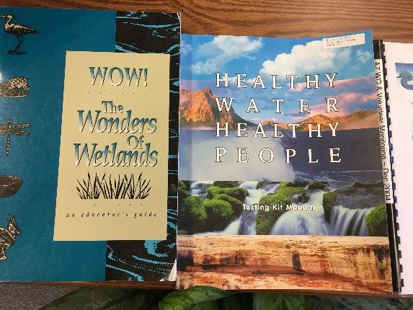
WOW! The wonders of Wetlands

Healthy Water Healthy People (Bill Brandau)

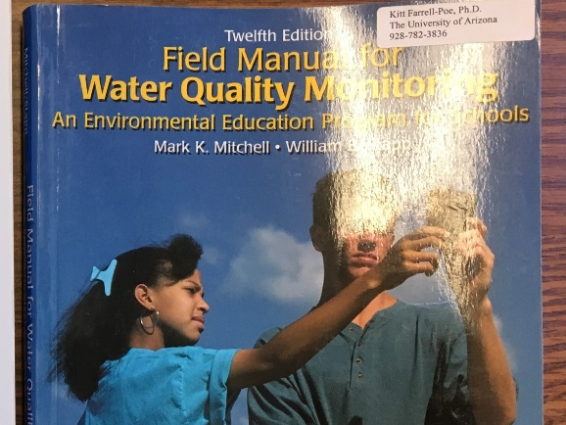
Field Manual for Water Quality Monitoring (Lynn Woolever-Telleen)

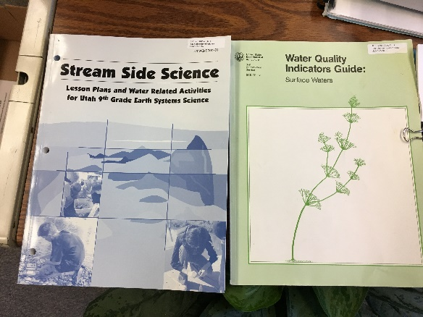
Stream Side Science: Lessons plans and Water related Activities for Utah 9th grade earth systems science (Kelly Zamudio)

Water quality indicators guide: Surface waters

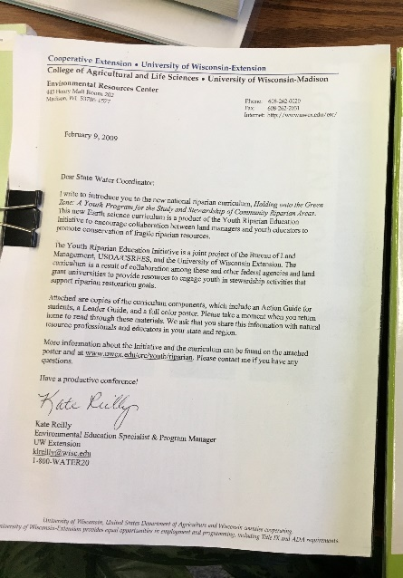
Holding onto the Green Zone: A Youth Program for the Study and Stewardship of Community Riparian Areas, College of Agriculture and Life Sciences, University of Wisconsin-Madison

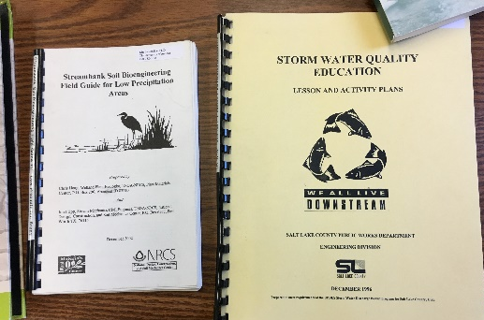
Stream Soil Bioengineering Field Guide for Low Precipitation Areas

Storm Water Quality Education, Lessons & Activity Plans

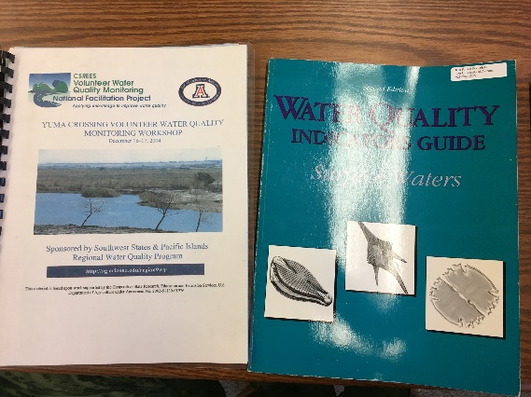
Yuma Crossing volunteer water quality monitoring workshop

Water quality indicators guide

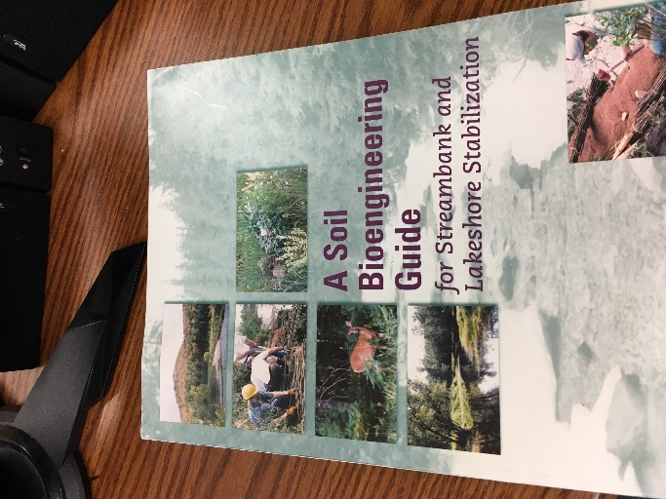
A Soil and Bioengineering Guide for Streambank and Lakeshore Stabilization

Box 3 Contents:

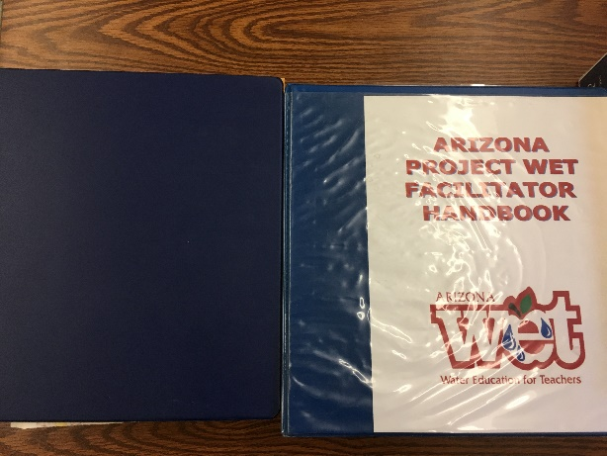
NPS Water Pollution Curriculum (3-ring binder)
Arizona Project WET Facilitator Handbook (3-ring binder) (Lynn Woolever-Telleen)

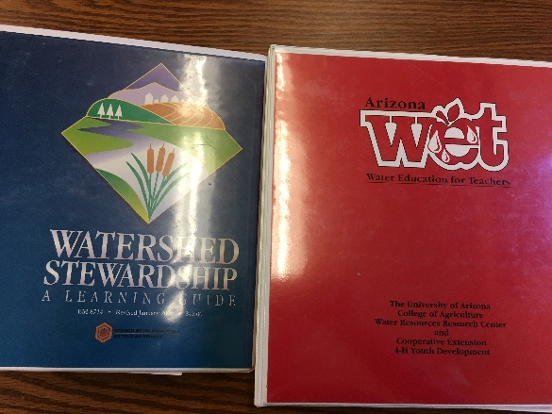
Watershed Stewardship: A Learning Guide (3-ring binder) (Lynn Woolever-Telleen)

Arizona WET: Water Education for Teachers (3-ring binder) (Lynn Woolever-Telleen)

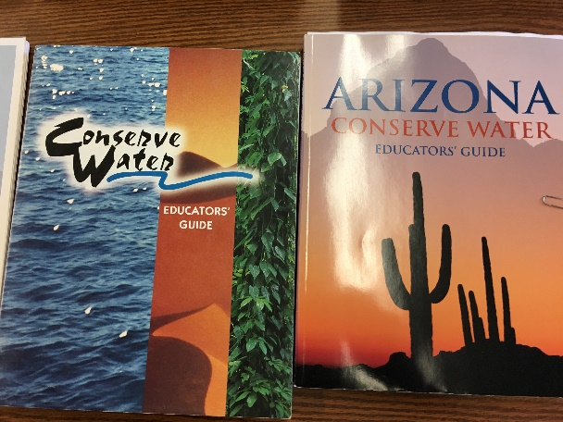
Conserve Water: Educator’s Guide (Bill Brandau)

Arizona Conserve Water: Educator’s Guide (Bill Brandau)

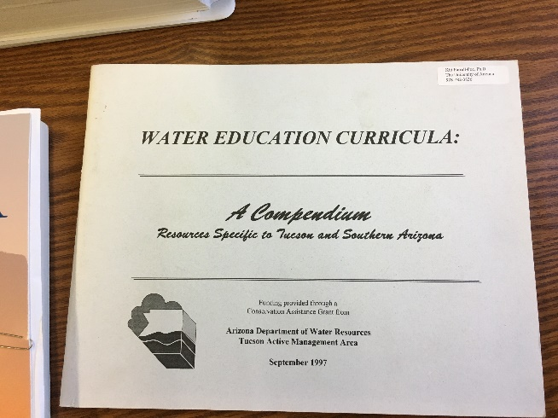
Water Education Curricula: A compendium resources specific to Tucson and southern Arizona (Bill Brandau)
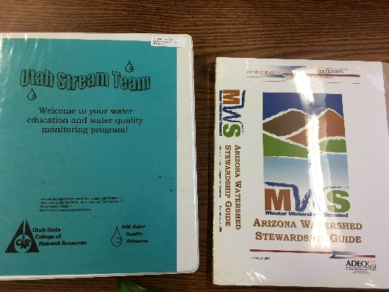
Utah Stream Team: Welcome to your water education and water quality monitoring program (3-ring binder)

Arizona Watershed Stewardship guide

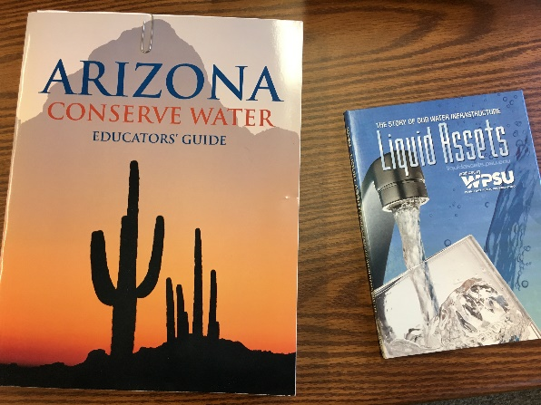
Arizona conserve water: Educator’s guide (2nd copy)

The story of our water infrastructure: Liquid assets

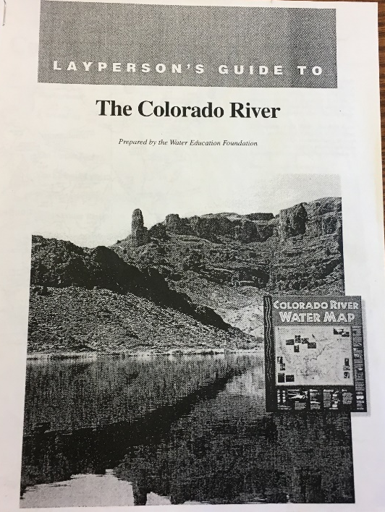
Layperson’s Guide to: The Colorado River

