Arizona Domestic Well Owner’s Workshop

A three-hour workshop will be held at your local County Extension office, date and time: TBA

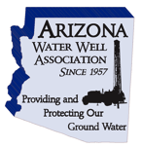
In Arizona, has an estimated 90,000+ wells across the State. Private wells provide water supply to an estimated 160,000 households, or about 5-7% of the state’s population. Your County has many domestic wells that provide water to homes. It is important that well owners are knowledgeable on how to care and maintain their well and have a basic understanding of issues that come with owning a well. This information will help the owner to provide safe drinking water and protect their investment. This workshop is grant funded by the Centers for Disease Control and Prevention’s (CDC) Safe WATCH program. Staff from the Arizona Department of Health Services and University of Arizona will provide important environmental health information on drinking water quality. To learn more please visit www://azdhs.gov/well water


Speakers:

- Janick Artiola, Ph.D.: University of Arizona Cooperative Extension, Water Quality Specialist jartiola@email.arizona.edu


- Gary Hix, RG: Past President of the Arizona Water Well Association

- Niki Lajevardi-Khosh, MPH: Arizona Department of Health Services, Office of Environmental Health, Health Educator Niki.Lajevardi-Khosh@azdhs.gov

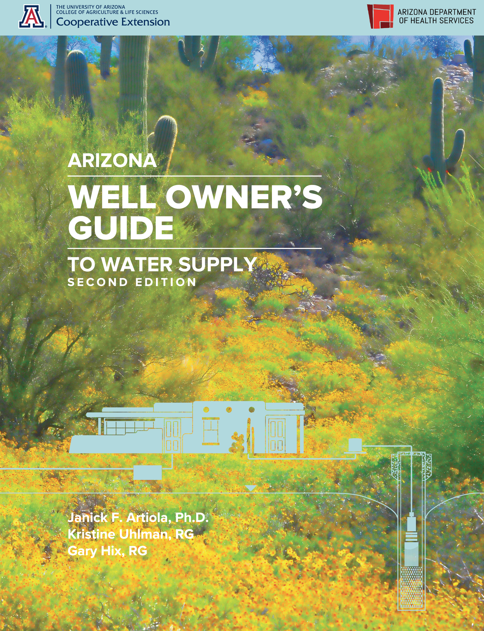
The workshop will cover water sources, regulations, domestic well maintenance and water treatments topics, including:
- Introduction to Arizona Geology and aquifers
- Basic domestic well facts
- Regulations, Well registration, County Issues
- Routine well operation and maintenance
- Naturally occurring contaminants
- Aquifer vulnerability
- Well head and source water protection
- When to sample and what to sample for
- Home water Treatment options for your well water
- Health recommendations for drinking water wells

The information presented at the workshop comes in from a booklet titled:
“Arizona Well Owner’s Guide to Water supply. University of Arizona
Cooperative Extension publication #AZ1485.” Hard copies will be given
to all attendees.

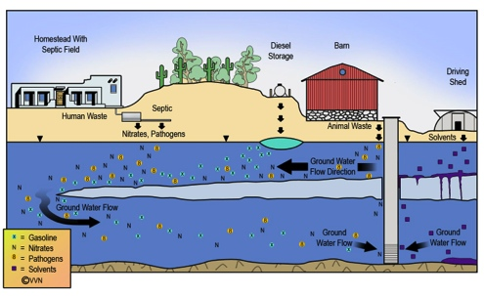
Please Note*: a USB thumb drive will be given to all attendees with electronic versions (pdf file) of the Well Owner’s Guide and the Arizona Know your Water booklets, the Well Owner’s Video Series and many other water-related Extension publications.

Visit Arizona Cooperative Extension publications Office Website for more information. http://extension.arizona.edu/pubs/

