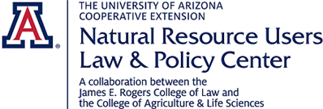

You are Invited!

“Waters of the United States (WOTUS) – Evolution of a Quagmire
and the Supreme Court”

Presented by Jim Burling, Esq.
Vice President of Litigation and Principal Attorney for Property Rights
Pacific Legal Foundation

April 24, 2018
11:00am - Noon: presentation & discussion
(refreshments provided)

Location: UA ENR2 Building, S107
1064 E. Lowell Street
Tucson, Arizona

Link for Remote Participation
https://attendee.gotowebinar.com/register/1872291670474784513

Mr. Burling has been with Pacific Legal Foundation since 1983 and his cases involve regulatory takings, environmental and land use regulations, eminent domain, and Indian law. N 2001 he successfully argues a leading property rights case, Palazzolo v. Rhode Island, before the United States Supreme Court. He is a frequent lecturer at continuing legal education courses on topics such as the regulation of wetlands, eminent domain, and the “taking” of private property. Mr. cases have focused on environmental and land use regulations, eminent domain, and Indian law. In 2013, Mr. Burling was awarded the Crystal Eagle Award by the Owners Counsel of America in recognition of his work on behalf of property rights.

Questions? Contact Barbara Hutchinson (barbarah@cals.arizona.edu)

