
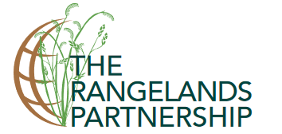
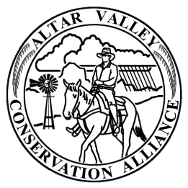

You are Invited!

Brush Management Workshop (first in a series of three)

Funded by Western SARE
(Sustainable Agriculture Research and Education Program)

January 22, 2018
8:00am – Noon: presentations & discussion
Noon – 1:00pm: lunch
1:00pm - 3:00pm: field trip & wrap up

Santa Rita Experiment Range, Florida Station
(includes refreshments, lunch, and workshop materials)

To Register or for more information, contact:
Online Registration: http://whoozin.com/64W-3KG- EGJH
Limited to the first 30 registrants, Please RSVP by January 8, 2018
Kyle Thompson (kyle@altarvalleyconservation.org)

Focus of Workshop 1: “Historical Perspectives and Current Trends: Brush and Woody Species Management and Environmental Conditions on Southwestern Grasslands”

Speakers:
- History and current status of the SRER (Mark Heitlenger, SRER)
- Grasslands and mesquite on the SRER, a historic perspective (Mitch McClaran and Elise Gornish, UA SNRE)
- Vegetation change and mesquite control in Southeastern Arizona (Dan Robinett, retired NRCS)
- Vegetative changes in Chihuahuan desert grasslands in New Mexico (Amy Ganguli, NMSU)
- Southwestern climate trends (Mike Crimmins, UACE)
- Includes presentation of short “local stories” videos (Cody Sheehy, UA/CALS/CCT)

Workshop 2 will be held at the Buenos Aires National Wildlife Refuge in April 2018. The topic will be “Brush and Woody Species Management Methods in a Changing Environment.”
Workshop 3 will be held in October 2018 and will focus on landowner collaboration on brush and woody species management.

