
School of Plant Sciences • Tucson AZ 85721 • 520 621 1977 • Fax: 520 621 7186 • http://turf.arizona.edu

A winter weed - - still here but best forgotten: Mediterraneangrass (Schismuss barbatus).

Vol 2: No 1. March 2016.
David M. Kopec, Extension Specialist / Turfgrass.

In the low desert, winter annual weeds germinate in the early fall, grow vegetatively from November to February, and then flower, set seeds, and die in the spring.
The overall plant size and population density of winter annual weeds in an unirrigated landscape often depends on the amount of rainfall. When there is little rain, winter annuals can go unnoticed. In times of high winter rainfall, they can suddenly become a visual nightmare.
Such is the case with the winter annual weed, Mediterraneangrass (Schismus barbatus). It is also called “six weeks Schismus”.
Mediterraneangrass is a bunchgrass that produces vegetative shoots by tillering. It has no underground rhizomes or above ground stolons. In late October and November, individual plants produce small rosettes, ranging in size from a nickel to quarter. With adequate winter rain, the plants enlarge and rapidly tiller reaching 2 to 3-½ inches in diameter.
This species is not competitive, and often there are only 2 to 3 plants per square foot. Halfway through its short lifespan, short flower heads will appear in the form of panicles. The seed heads often emerge in a radial pattern, just above the green leaves close to the ground. Other plants send up almost vertical seed heads. The seed heads bring attention to the layperson, which now validates it’s presence as a distraction in the landscape. Postemergence herbicide weed control is possible early, but is not practical since the mature weed is rapidly declining after it has reached the flower stage. Mediterraneangrass does not tolerate hot air temperatures. After several days of 85°F or hotter air temperatures, the plants will wither and die. If a small population of weeds is unsightly in a xeriscape setting, simply remove the plant and with a shovel or hula hoe. Mediterraneangrass has a very shallow and weak root system which makes it is easy to mechanically remove.
In larger areas or highly infested landscapes, hand-hoeing may not be possible. The same is true for infestations in xeriscapes that feature large diameter rock mulch or gravel. In these situations, a postemergence herbicide such as RoundUp* (glyphosate), Finale* (glufosinate), Scythe* (pelargonic acid), or Reward* (diquat) can be used for eliminating the grass and other weeds. In areas where Mediterraneangrass is a repeated problem year after year, a grass herbicide should be applied in late September through October to prevent this weed from emerging.
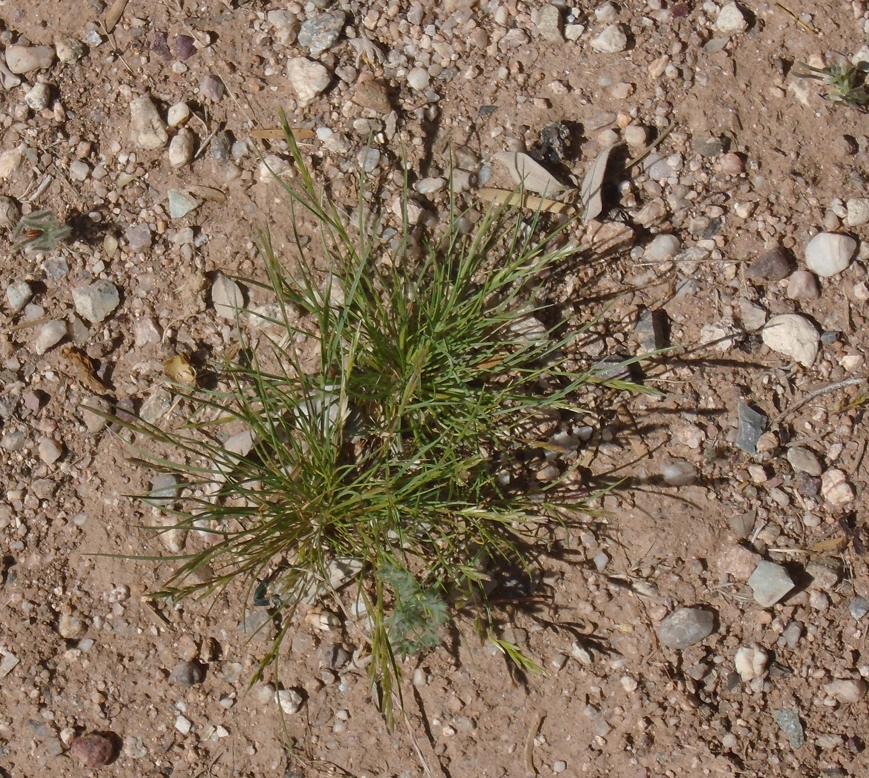
Photos: (property of author).
Figure 1. A small Mediterraneangrass plant, typical size by late December or early January

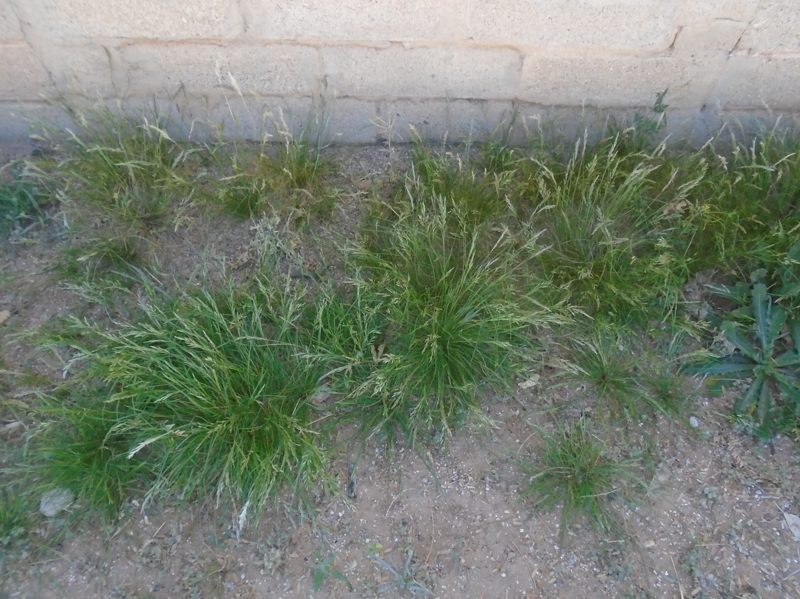

Figure 2. Group of mature Mediterraneangrass plants by garden wall.

Figure 3. Flower head (panicles).
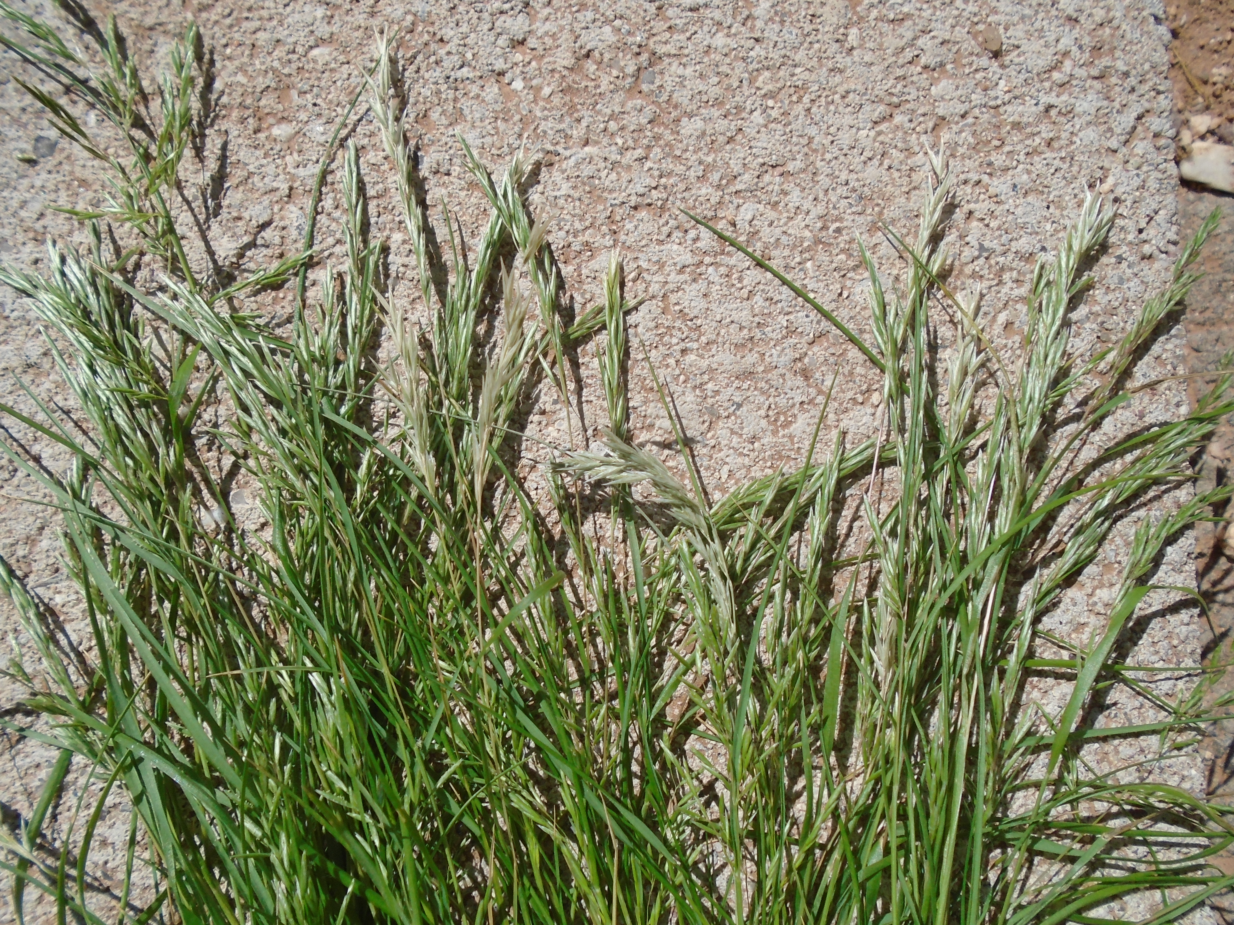
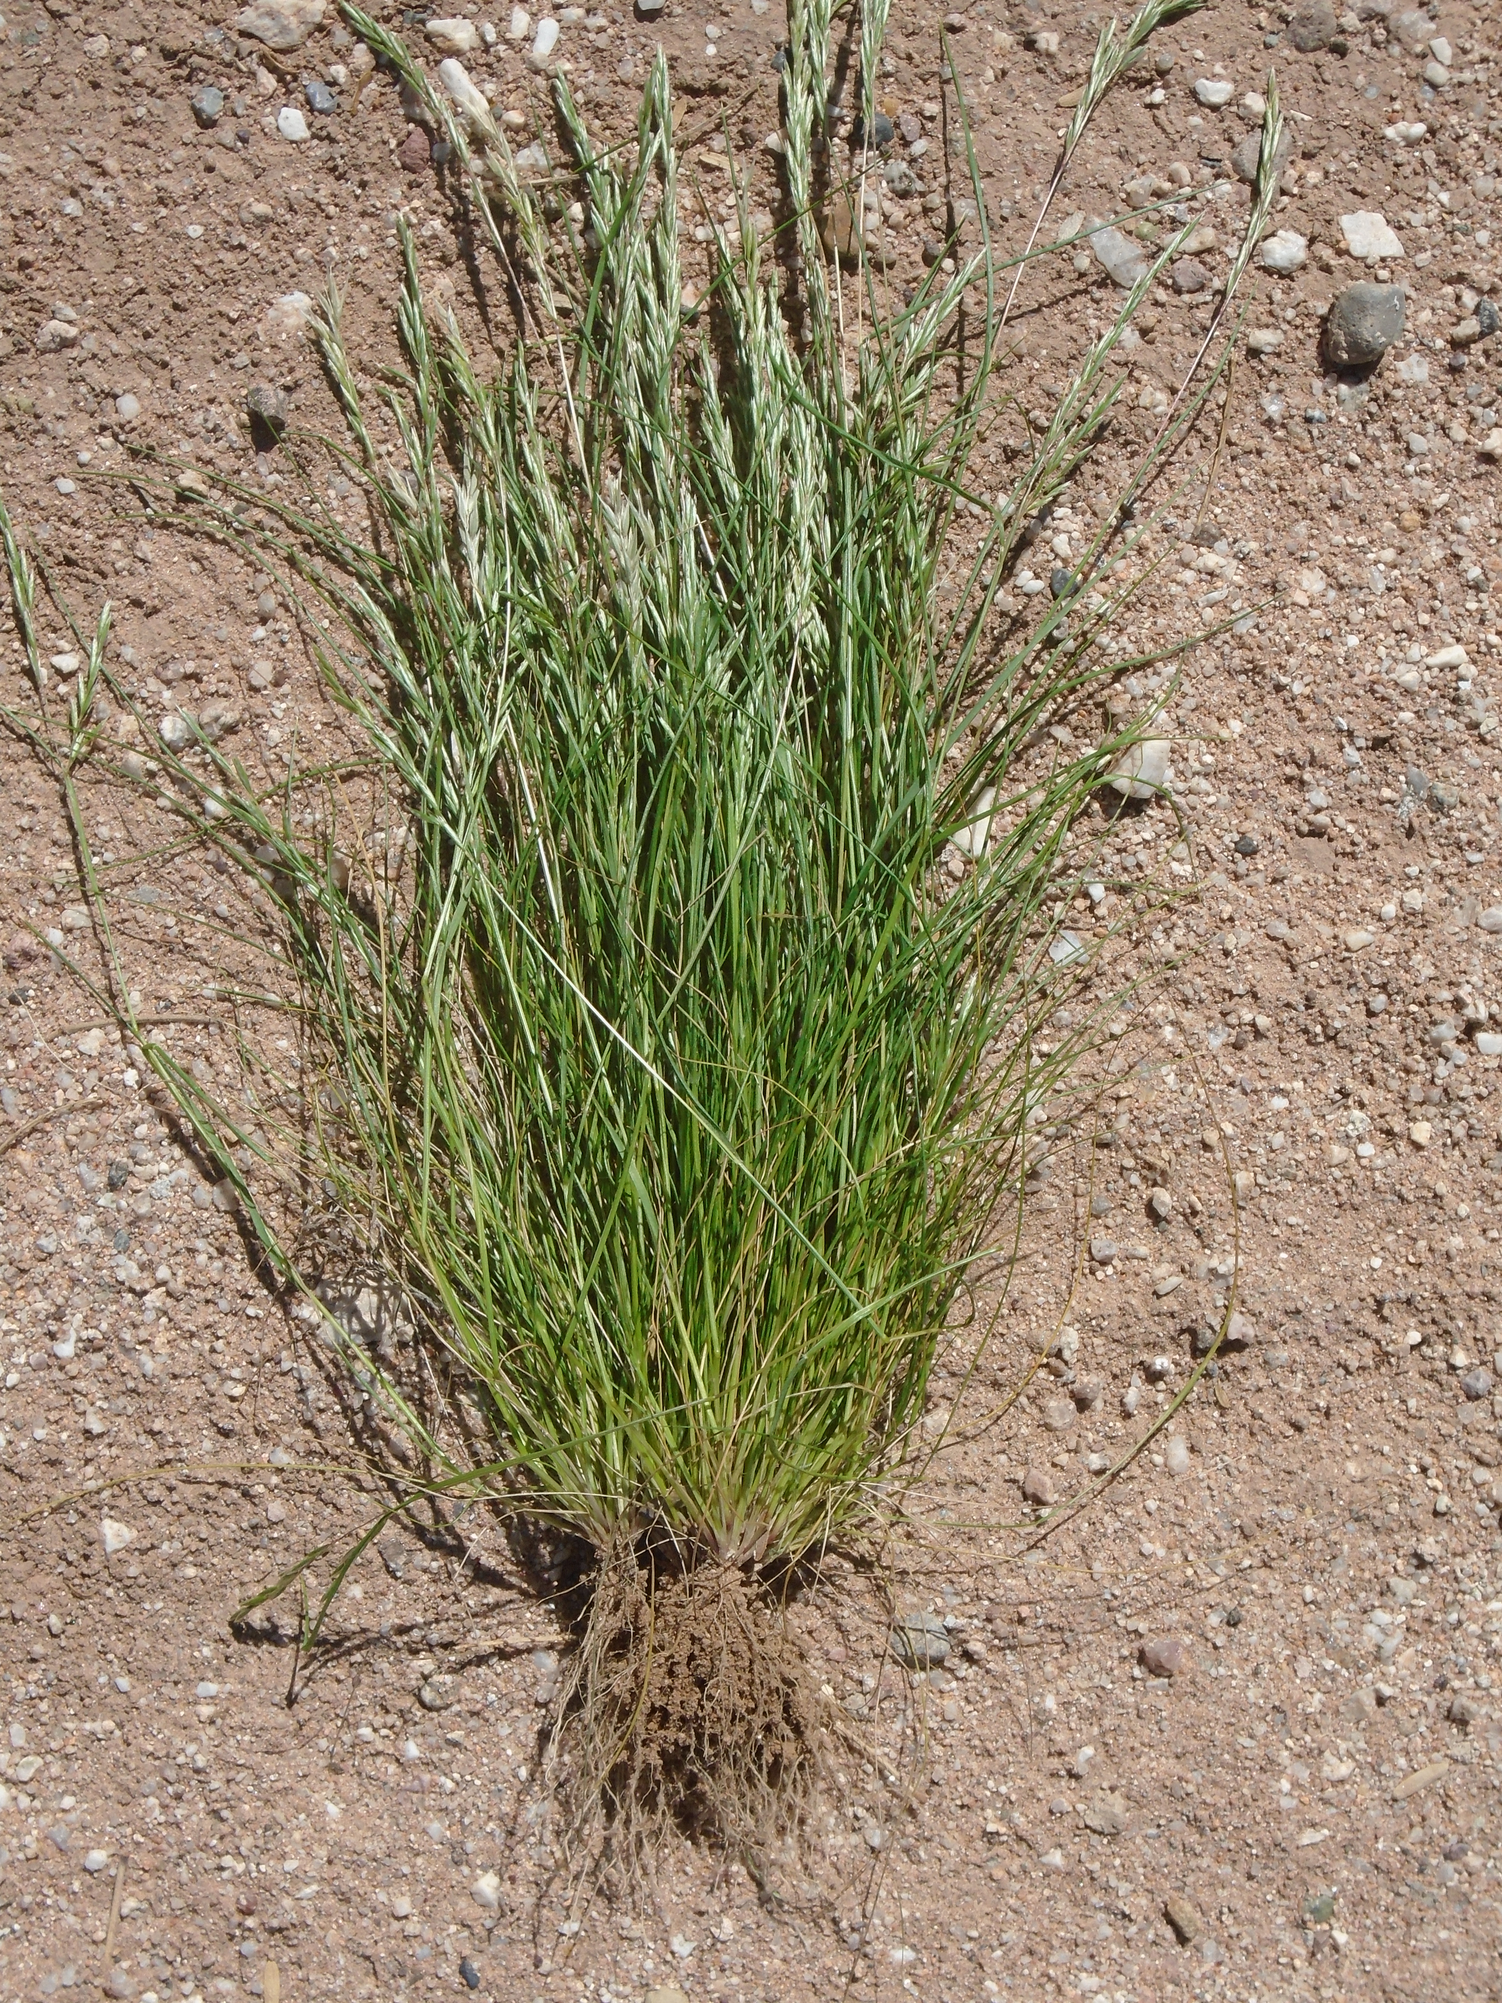

Figure 4. Note: shallow roots, yet large overall plant size.

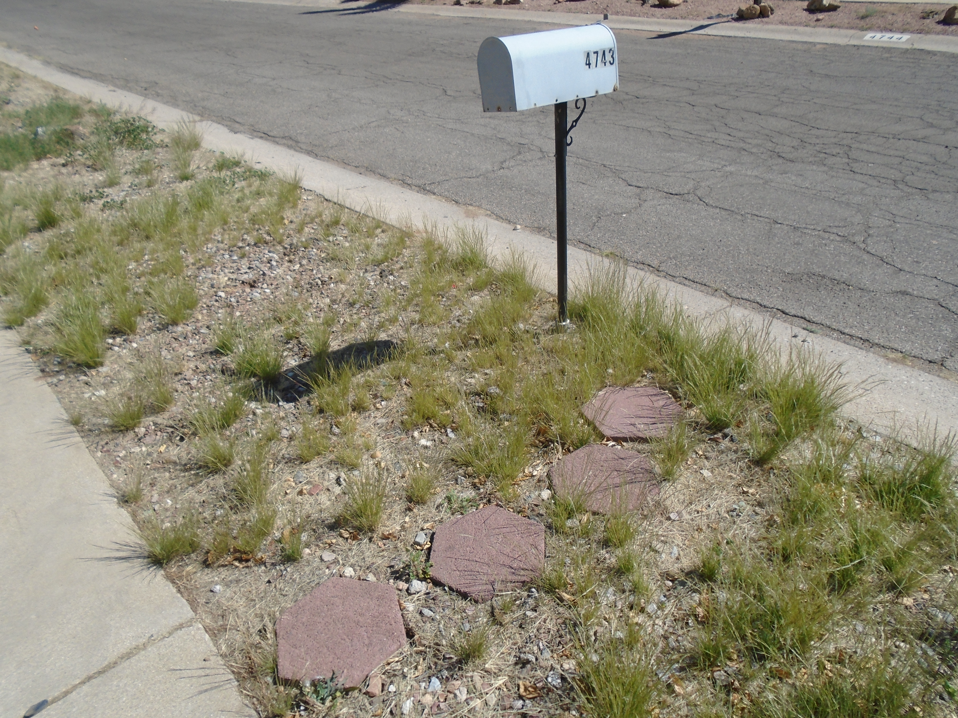
Figure 5. Monostand of Mediterraneangrass in a gravel hardscape.
Figure 6. Small plants mowed with weed-eater several times in a gravel mulch xeriscape.
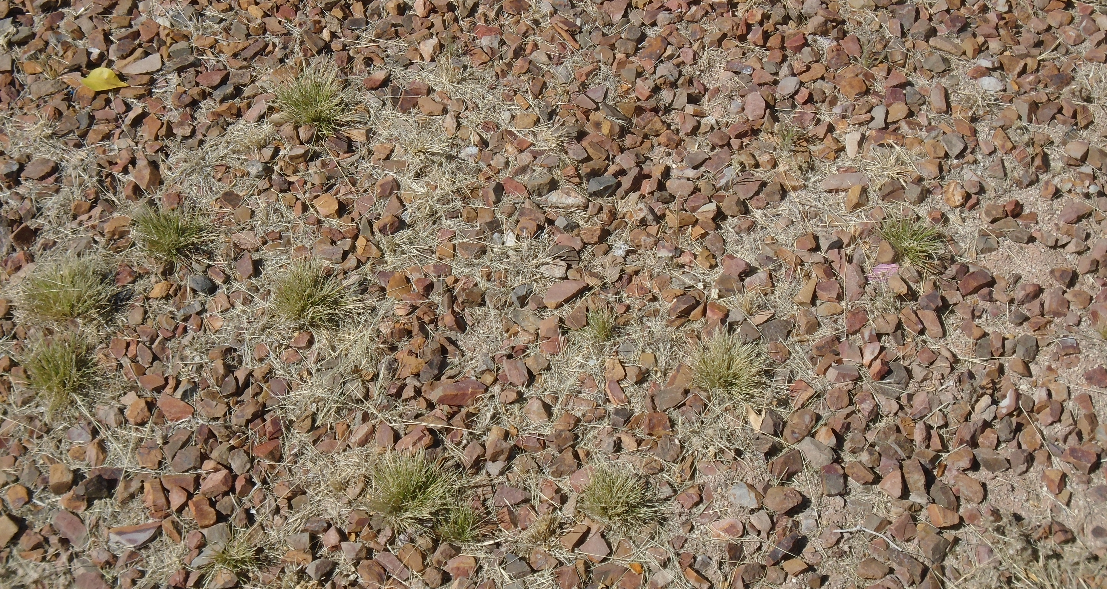

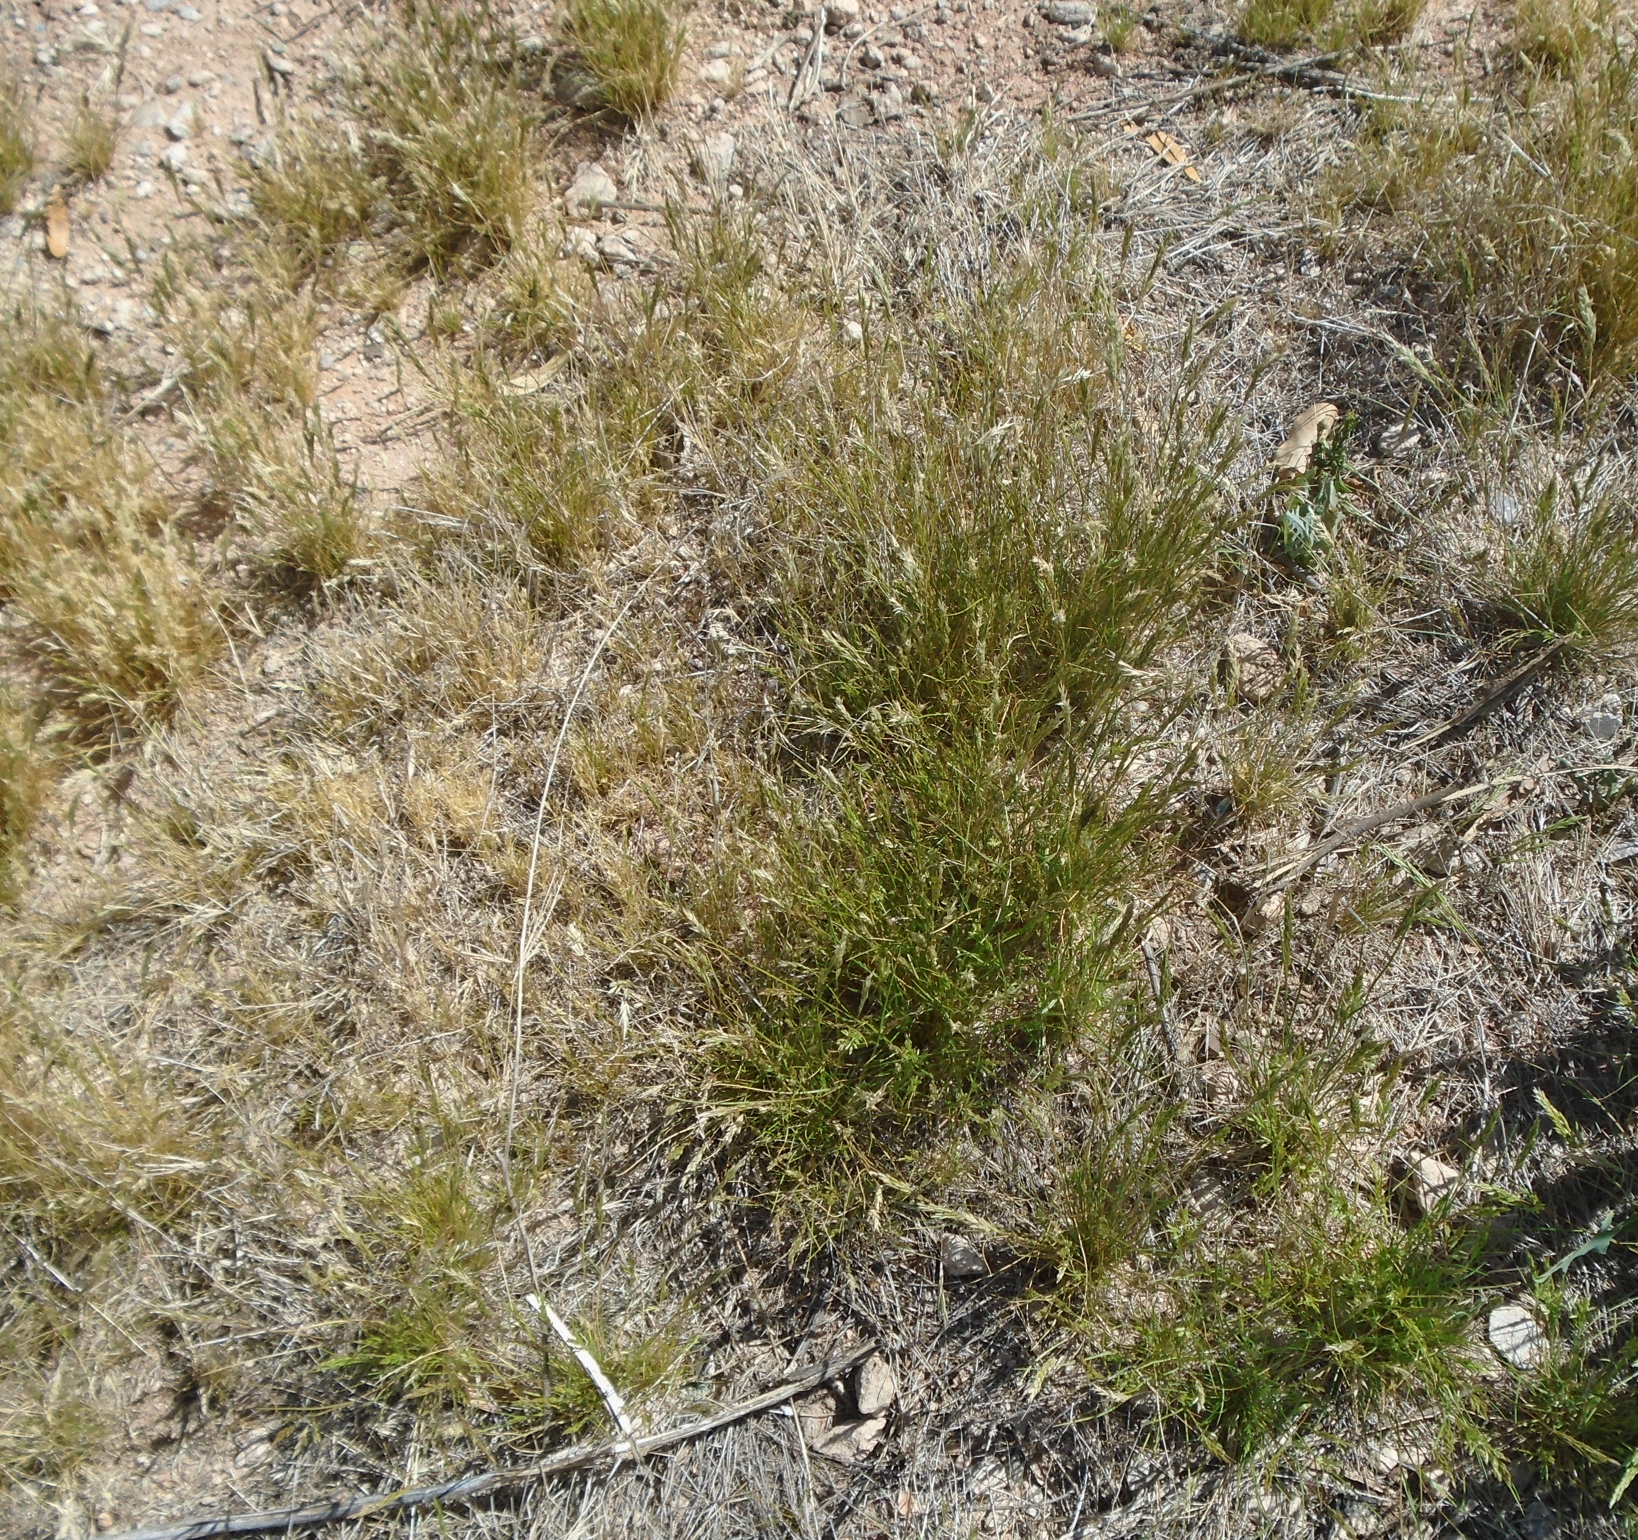
Figure 7. Contrast between late flowering (green) (right center) and
early flowering (straw brown) (left) plants of Schismus barbatus.

Product names mentioned are registered trademarks. Any products, services, or organizations that are mentioned, shown, or indirectly implied in this publication do not imply endorsement by The University of Arizona.

“Issued in furtherance of Cooperative Extension work, acts of May 8 and June 30, 1914, in cooperation with the U.S. Department of Agriculture, Jeffrey C. Silvertooth, Cooperative Extension, College of Agriculture & Life Sciences, University of Arizona. The University of Arizona is an equal opportunity, affirmative action institution. The University does not discriminate on the basis of race, color, religion, sex, national origin, age, disability, veteran status, or sexual orientation in its programs and activities”

