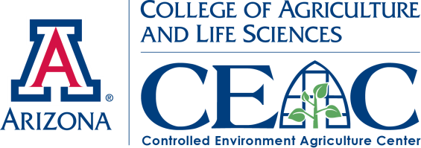 |  | News Splash  Short Course 2013  $$ SAVINGS END SOON |  | 
Valuable Workshop Activities

The Workshops are an excellent means to give hands-on, up-close, live demonstrations out of the classroom within active projects with real plants, hardware and operational greenhouse systems. Video of past workshops: http://youtube/shortcourseworkshops

The hands-on workshops accommodate all levels of knowledge of controlled environment agriculture. Attendees who are new to CEA and are interested in starting to grow crops for themselves can take the workshop titled “My First Greenhouse” taught by CEAC director Dr. Gene Giacomelli. This workshop will help attendees to understand what different greenhouse designs are best used for, along with deciding what type of climate control system and nutrient delivery system is needed depending on what crops are being grown.

Other workshops such as Dr. Murat Kacira’s “Sensors and Control Basics for CEA,” is a more specialized workshop focusing on sensors and instrumentation systems. The workshop will demonstrate how to monitor and control important environmental factors that affect plant growth and development by using sensors. Other workshops are also offered to ensure that people with all levels of knowledge of CEA can benefit from workshops that interest them.

We invite those attending electronically by the Web to supplement their Distance Education by attending Intensive Greenhouse Courses for Tomatoes and Lettuce offered each January where each day includes hands-on crop production activities in the greenhouse. See the Intensive website: https://ag.arizona.edu/ceac/2013-hydroponic-greenhouse-crop-production-intensive

Reduced Short Course & Hotel Fees End March 21st

Short Course info: http://ag.arizona.edu/ceac/2013-April-Short-Course
Reserve room now at http://www.westwardlook.com/

April 7th, 2013 will mark the start of The Controlled Environment Agriculture Center’s 12th annual Greenhouse Crop Production and Engineering Design Short Course and the third year it will be held at the beautiful Westward Look Resort. Take advantage of cheaper conference rates and a great deal on hotel rooms at the Westward Look by Thursday March 21st. This year’s edition of the short course features presentations and advice from 16 prominent controlled environment agriculture experts from around the country as well as a choice of 9 different hands-on workshops. The course has the goal to connect the theory and information given by presenters with practical hands-on experience for each participant, to help enhance understanding of the important information given during the 5-day short course.

The CEAC has prepared these 9 distinct workshops for Thursday April, 11th to accommodate many different knowledge levels and interests. Topics range from “Tomato Crop Maintenance Using High Wire Systems” to “Alternative Energy Integrated Greenhouse System.” Short Course attendees will be transported from the Westward Look to the CEAC Campus at the University of Arizona to experience and learn from the variety of greenhouse teaching & demonstration facilities. All workshops are being led by experts that specialize in the given topic and they will be available throughout the day to answer questions and discuss your specific design and operation situations.

The CEAC is dedicated to educating people on the subject of controlled environment agriculture, its applications toward improving food production and reducing environmental impact while increases its benefits to the world.

Announcements: To learn more about the 2013 Greenhouse Crop Production and Engineering Design Short Course, please visit: http://ag.arizona.edu/ceac/2013-April-Short-Course
Visit the CEAC Facebook page and tune into what is going on at the CEAC and stay in touch with us!:
http://www.facebook.com/pages/University-of-Arizona-Controlled-Environment-Agriculture-Center/152950294760506
 | The University of Arizona  College of Agriculture and Life Sciences  Department of Agricultural & Biosystems Engineering • School of Plant Sciences  1951 E Roger Rd • Tucson AZ 85719 • 520-626-9566 • http://ag.arizona.edu/ceac
Copyright © 2012 Arizona Board of Regents

